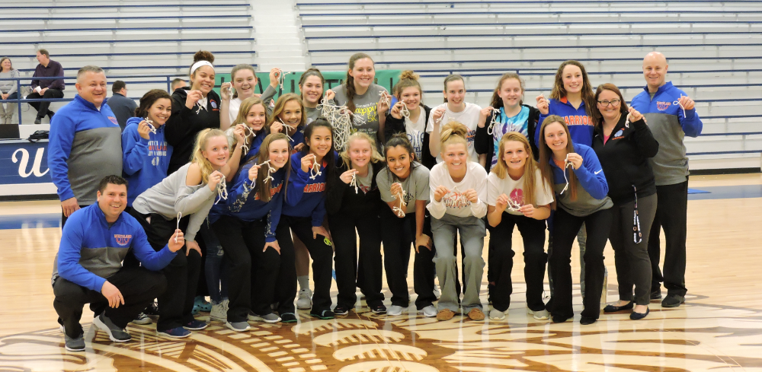

Whiteland Lady Warrior Spring Skills Camp
____________________________________________________________________________
Cost: $50.00 for All Sessions or $10 per Session
Includes: Shooting Routine with Workout Manual, Finishing Moves, Offensive Pivots, Ball Handling, Passing
Make checks payable to Whiteland Lady Warrior Basketball
When: April 3, 10, 17, 24, May 1, 8
Where: High School Aux Gym
Grade(s): Time:
Incoming 7-9 7:00pm-9:00pm
Incoming 1-6 6:00pm-7:00pm
_ _ _ _ _ _ _ _ _ _ _ _ _ _ _ _ _ _ _ _ _ _ _ _ _ _ _ _ _ _ _ _ _ _ _ _ _ _ _ _ _ _ _ _ _ _ _

Camper’s Name:____________________________________________________________
Incoming Grade: 1st 2nd 3rd 4th 5th 6th 7th 8th 9th
Contact Phone Number:___-___-______ Email Address: ________________________
Parent/Guardian Name: ________________________________

I give my permission for my child to participate in the Whiteland Lady Warrior Basketball Camp knowing it will contain vigorous physical activity that could lead to injury. To the best of my knowledge she is physically capable of performing vigorous activity. I release and hold harmless Whiteland High School and its coaches from any and all liabilities, personal injuries, and damages to or loss of personal property arising, directly or indirectly, in condition with my child’s use of facilities and equipment of the specific camp site. In the event my child is injured, I authorize the basketball staff to secure first aid and/or the services of a legally qualified physician or hospital, and agree to assume all financial obligations connected therewith.

Parent/Guardian Signature:_________________________ Date: _____________

Please Return Form To: Refer Questions To:
Lady Warrior Basketball Kyle Shipp - Head Girls’ Coach
Kyle Shipp Email:
300 Main St. kshipp@cpcsc.k12.in.us
Whiteland, IN 46184

Forms will be accepted on Day 1 of Camp
Players are welcome to attend as many as possible if they have a conflict

