From: Mr. Ange – Cache Middle School Principal

In an effort to curb the negative effects of social media, and the potential drama that often comes with it, I have attached a couple of articles that deal with this issue. Common Sense Media has listed the following apps as some of the most “dangerous”.

My hope is to inform parents of CMS students of the dangers of using these apps. Also, I seek your cooperation in helping to deal with the drama that is often associated with social media use at the middle school level.

3 Kinds of Apps That Stir Up Drama in Schools
Some social networking apps appeal to negative impulses. By Caroline Knorr12/11/2015
Topics: Cellphone Parenting, Cyberbullying, Digital Media and School
If your kid is among the 73% of teens who have access to a smartphone, you're well aware of the app obsession that can take over a brain and body in seconds. For teens, smartphones + apps = social networking. And where there's social networking, there's sure to be drama.
While a lot of social networking is harmless -- and even beneficial -- some apps are specifically designed to appeal to users' darker impulses. Confessionals, anonymous comments, incriminating photos, rumor-mongering -- that sort of thing. Worse, some apps apply location services to this already combustible mix, connecting everyone in a school and magnifying problems like cyberbullying, gossip, and physical threats.
Keep these apps on your radar, and talk to your kids about responsible social networking:
- Yik Yak. This "location aware" social networking app lets users post "anything and everything" anonymously. The brief, Twitter-like comments and photos are distributed to any 500 people using Yik Yak closest to you geographically. Anonymous threats against schools and individual students have prompted many schools to ban the app, using the company's "geo fencing" guidelines to restrict communications in a certain area. Also watch out for: Streetchat - Image Board for Schools and Colleges, Burnbook, and After School - Funny Anonymous School News for Confessions & Compliments.
- Ask.FM. This question-and-answer app lets kids pose queries and answer questions from other users. With questions like "am I pretty or ugly?," the confessional nature makes kids vulnerable to negative feedback. Bullying is a major concern, and Ask.FM has been cited as a factor in stories of teen suicide. In response to these problems, the company changed management and launched a robust safety center. Still, you have to wonder about an app that has a whole section just for law enforcement investigating criminal activity. Also watch out for: Whisper.
- Snapchat. For seemingly consequence-free communication, you can't do better than the self-destructing messaging app Snapchat. The app has gained a reputation as a "sexting" app because outgoing (and incoming) pictures, videos, and texts aren't permanently stored on devices. Still, many third-party developers have created apps that let recipients save snaps from unsuspecting senders. One of the biggest problems with Snapchat is its popularity: One teacher complained of massive class disruption when the app released an upgrade during the school day. Also watch out for: BurnNote, Slingshot.
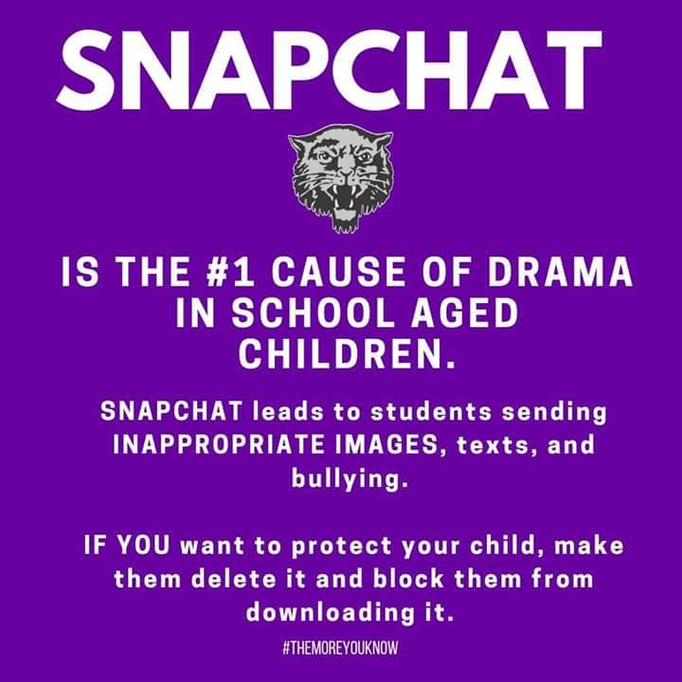
I encourage you to be aware of what your children are doing on their cell phones and what Social Media Apps they may be using. You may be surprised.
The CMS Handbook, which your child has and can be found on the CMS Website, has valuable information about the dangers of social media. It also explains school and possible legal consequences that can be imposed for misuse (pg. 7 of the CMS Handbook).
If you are aware of any social media misuse that is being used against your child at school, please report it to the CMS Office @580-429-8489. If it involves issues on social media outside of school, please notify local law enforcement.
Remember: We can’t fix what we don’t know.

