Dear Parents,
Buncombe County Schools and the Buncombe County Public Libraries are partnering to support students’ ongoing education. We share the belief that a love of books and learning is a strong foundation for student success and we are working together to provide every Buncombe County School student access to books and resources found at their public library.
Beginning October 1st, 2019, all Buncombe County School students will be able to use their Student ID number to access and borrow public library books and resources. We are calling this initiative StudentAccess.

Question: How will a student use their student ID account?
Answer: Students will use their school ID number and PIN to borrow books or access the library’s services like e-books and online research. The default PIN is the last 4 digits of the student ID number.
Question: What can a student do with a student ID account?
Answer: Student ID accounts allow students to borrow e-resources and access library databases just like any other Buncombe County Public Library card. Students can also borrow up to 10 print or audio books from the Buncombe County Public Library collection.

Question: Is the student account free?
Answer: Yes, the student account is free. There are no overdue fines for student accounts, but students are responsible for any fees on lost or damaged books.

Question: How do I sign my child up for a student ID account?
Answer: You don’t need to take any action to get a student ID account for your child. All Buncombe County Schools students from pre-kindergarten to grade 12 will automatically be enrolled in this program.

Question: What if I don’t want my child to have a student ID account?
Answer: If you do not want your child to have access to library materials, you may opt out. See the back of this document for an opt-out form you can sign and return to any Buncombe County Public Library location. Be aware that students who opt out of StudentAccess will not be able to participate in classroom use of library resources unless they have a Buncombe County Public Library card and know the full card number and PIN.

For more information, visit your local library.
This project was made possible in part by the Institute of Museum and Library Services
and the State Library of North Carolina.

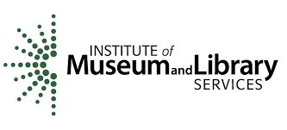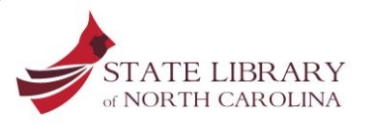

StudentAccess Parent Opt-Out Form

If you want your child to participate in StudentAccess in the 2019-2020 academic year, then you do not need to do anything. Your child will automatically be enrolled.
If you do not want your child to participate, then please complete this parent opt-out form and return it to any Buncombe County Public Library location listed below.
Child’s Name (Please print)
School
Grade
Student ID Number
Parent or Guardian’s Name (Print)
Phone Number

By signing this form, I understand my child will not have a student ID library account and PIN will be unable to participate in classroom use of library resources.

Parent/Guardian Signature Date

