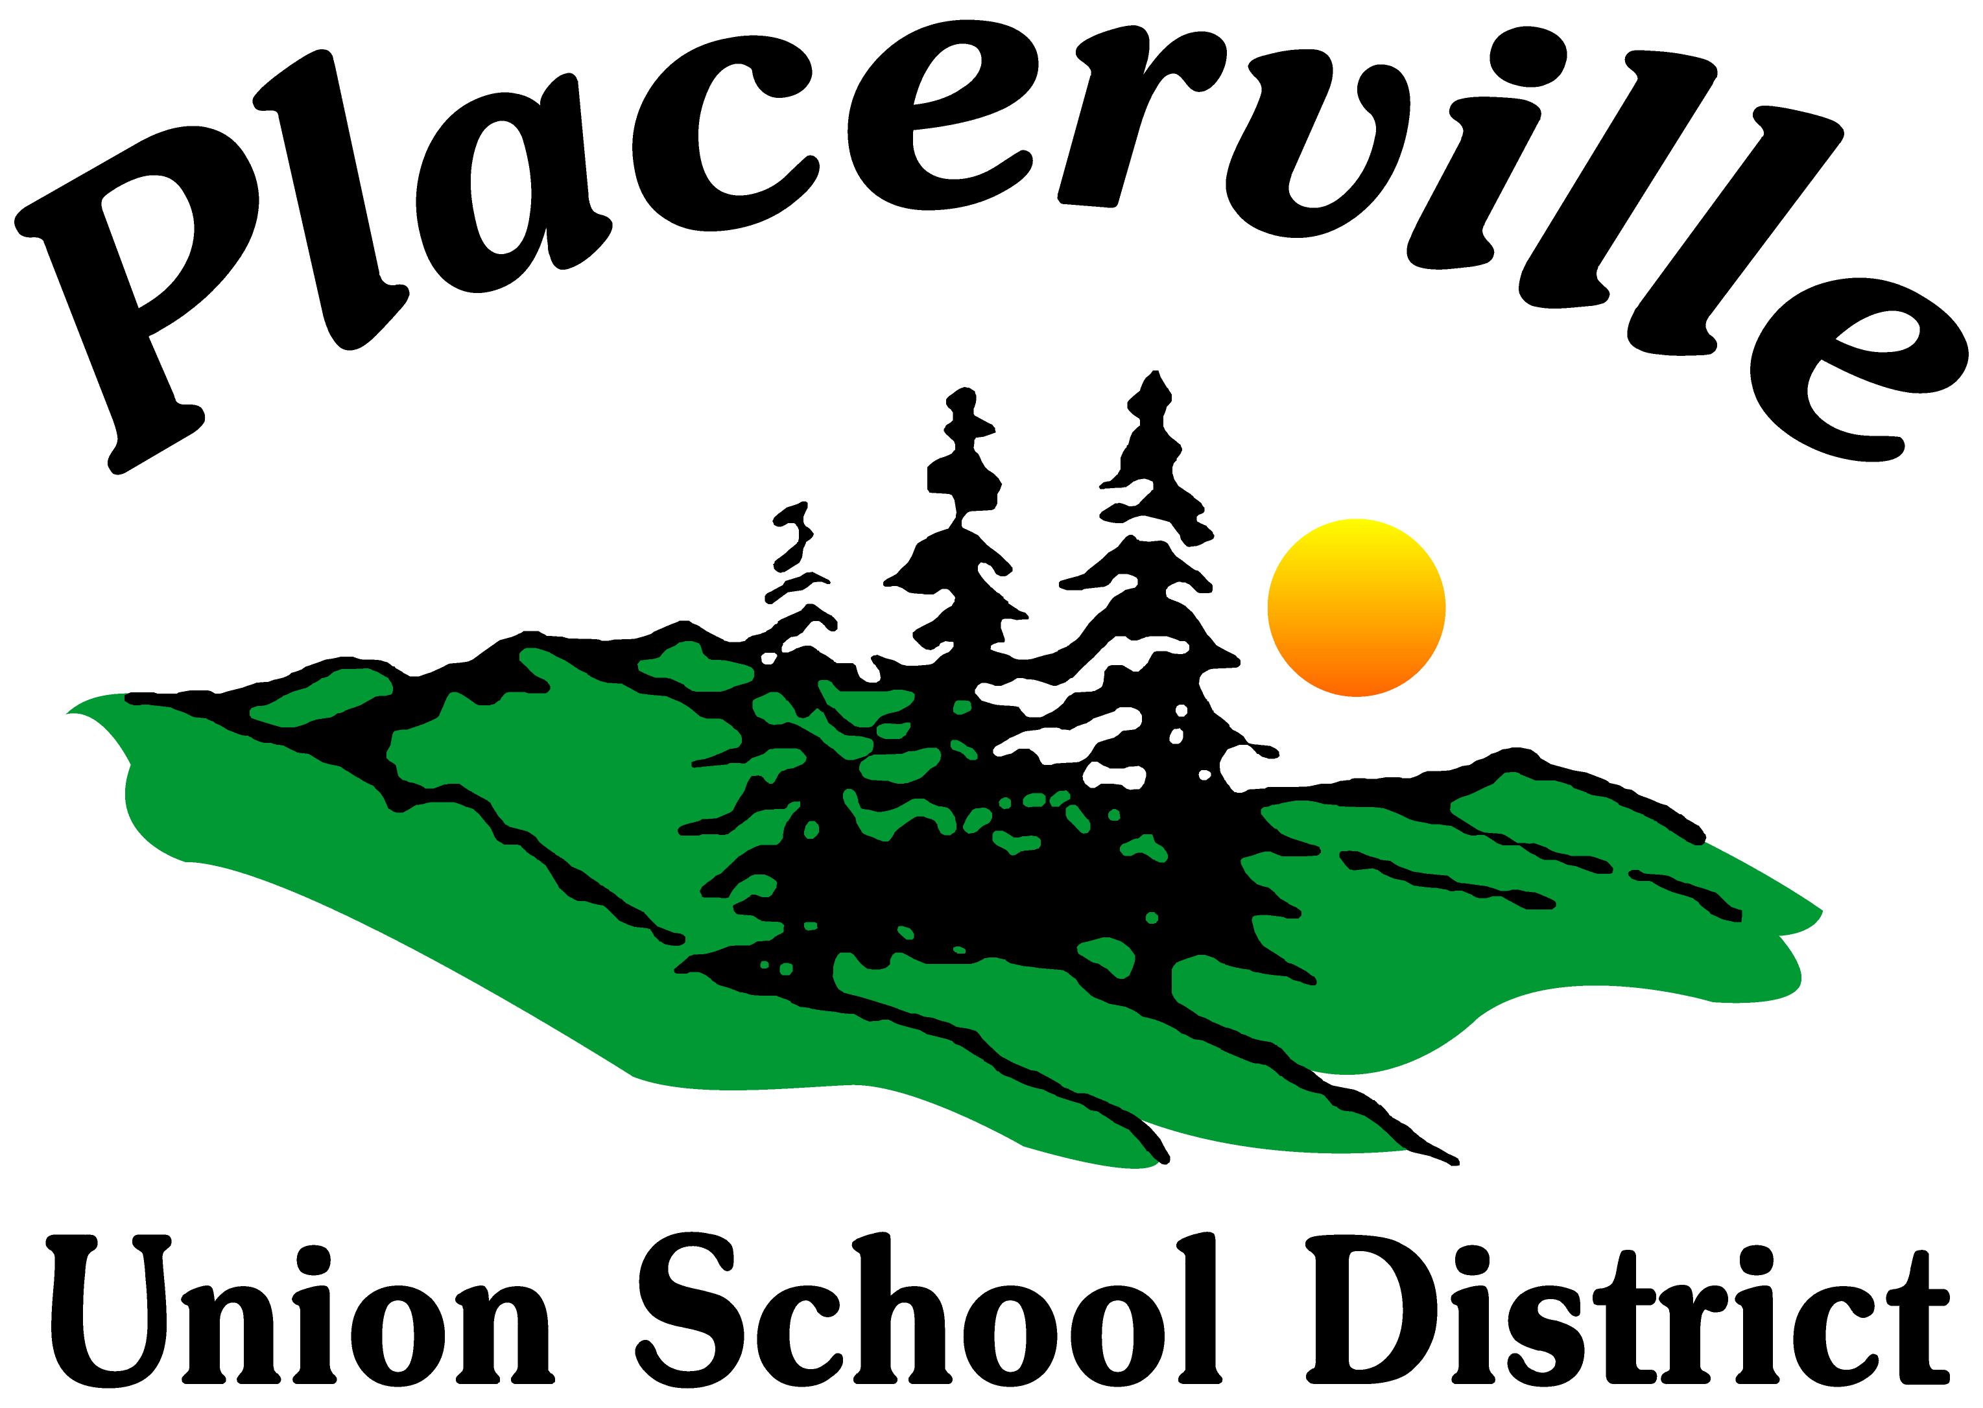
PLACERVILLE UNION SCHOOL DISTRICT
1032 Thompson Way
Placerville, CA 95667

NOTICE OF PUBLIC HEARING

SOCIAL STUDIES PUPIL CURRICULUM ADOPTION
Teachers’ Curriculum Institute
6-8 History Alive Collection
These materials are currently on display at the Placerville Union School District Office, 1032 Thompson Way, Placerville, CA 95667 during the hours of 7:30 a.m.-4:00 p.m.
DATE: Wednesday, March 13, 2019
TIME: 6:00 p.m.
LOCATION: Placerville Union School District
Board Room
1032 Thompson Way
Placerville, CA 95667

