HOOF'S & HORNS PHYSICALS AND FLEXIBILITY SCREENING

Dear Parent:

Schuyler County R-1 Schools is proud to announce that there will be, for those entering
7th grade and through 12th grade in the fall, a sports physical and flexibility screening on
March 13, 2019 conducted by Scotland County Hospital. There will be a non-refundable
$10.00 charge for the physical.

Sports physicals and flexibility screenings will start at 9:00 a.m. until completed.
Please complete the information below and sign the Consent form and complete the following information on the Physical Forms:
  - Page 1- Consent Form- Complete all information, including t-shirt size.
  - Page 2 - Complete all information, including parent/guardian signature and athlete signature at the bottom of page
  - Page 3 - Complete name and date of birth at the top. The physician will complete the rest of this page.
  - Page 4- Signature of Athlete and date.
  - Page 5 - Complete insurance information, parent/guardian signature and emergency contact information at the bottom.

Return completed forms to the office with the $10.00 no later than February 13, 2019.

YOU MUST HAVE THESE FORMS COMPLETED TO PARTICIPATE.

I give my permission for my child,
Full Name
age and grade for the next year to participate in

Hoof's and Horns physical and flexibility screening on March 13, 2019.

Date Parent/Guardian Signature

Parent/Guardian Address: Street: _

City: ___________ State: Zip Code: _
Please choose student size below. If this form is NOT returned by February 13th a T-Shirt will not be available for the student. T-shirts are adult sizes.
Small Medium __Large X-Large __ XX-Large

PRE-PARTICIPATION PHYSICAL EVALUATION
HISTORY FORM
(Note: This form is to be filled out by the patient and parent prior to seeing the physician. The physician should keep a copy of this form in the chart for their records}.

Date of Exam:
Name: |  |  |  | I Date of Birth:
Sex: | I Age: | I Grade: | I School: | I Sport(s):
Medicines and Allergies: Please list all of the prescription and over-the-counter medicines and supplements (herbal and nutritional) that you are currently taking:

D□o you have any allergies: Yes □ No □ If yes, please identify specific allergy below:
Medicines: □ Pollens: □ Food: □ Stinging Insects:
Explain "Yes" answers below. Circle questions you do not know the answer to.
5.
27,
}lo<)
,LOI ,..,,;;: .... ••!/:\[> 'XtY•••t><:Y+•• Xt•:: ,yeli)•
1. Has a doctor ever denied or restricted your participation in sports for
any reason?
2. Do you have any ongoing medical conditions? If so, please identify below: □Asthma □Anemia □Diabetes □Infections
Other:
3. Have you ever spent the nioht in the hospital?
4. Have you ever had surgery?  HEARFHEALTHQUESTIONSASOOTYOUt• ••• ,.··· | ...,:.·•-···,.,;:::::::;:<t:' | ·• \Yes>."• | ::No'>
Have you ever passed out or nearly passed out DURING or AFTER
exercise?
6. Have you ever had discomfort, pain, tightness, or pressure in your
chest during exercise?
Does your heart ever race or skip beats (irregular beats) during
exercise?
8. Has a doctor ever told you that you have any heart problems? If so, c□heck all that apply: □ A heart murmur
□High blood pressure □ A heart infection
□High cholesterol □ Other:
Kawasaki disease
9. Has a doctor ever ordered a test for your heart? (For example,
ECG/EKG, echocardiooram)
10. Do you get lightheaded or feel more short of breath than expected
during exercise?
11. Have you ever had an unexplained seizure?
12. Do you get more tired or short of breath more quickly than your friends
during exercise?
HEART.HEALTH•QUESTIONSASOUTWOURFAMIVi'.it /
13. Has any family member or relative died of heart problems or had an unexpected or unexplained sudden death before age 50 (including drowning, unexplained car accident, or sudden infant death
syndrome)?
Does anyone in your family have hypertrophic cardiomyopathy, Marian syndrome, arrhythmogenic right ventricular cardiomyopathy, long QT syndrome, short QT syndrome, Srugada syndrome, or
catecholaminergic polymorphic ventricular tachycardia?
Does anyone in your family have a heart problem, pacemaker, or
implanted defibrillator?
16. Has anyone in your family had unexplained fainting, unexplained
seizures, or near drowning? :•,.·,;=::;·1·::•::::<:,:{;(,'.:(.''.''.::·=:: ·:·:'::.;:{'.?::t:rr ¢il'
SON!::ANPJO!tffQUESTlONll' " .... |  | Y
Have you ever had an injury to a bone, muscle, ligament, or tendon
that caused you to miss a practice or a Came?
18, Have you ever had any broken or fractured bones or dislocated joints?
19. Have you ever had an injury that required x-rays, MRI, CT scan,
injections, therapy, a brace, a cast, or crutches?
20. Have you ever had a stress fracture?
21. Have you ever been told that you have or have you had an x-ray for neck instability or atlantoaxial instability? (Down syndrome or
dwarfism)
22, Do you regularly use a brace, orthotics, or other assistive device?
Do you have a bone, muscle, or joint injury that bothers you?
24. Do any of your joints become painful, swollen, feel warm, or look red?
25. Do you have any history of juvenile arthritis or connective tissue
disease?

MEOJCALQUESl" .... t>,; \•:i•):;'.;}\t:::.:,;,:,:,, ?'?  26. Do you cough, wheeze, or have difficulty breathing during or after  exercise? | Yef\ | \Nif?
Have you ever used an inhaler or taken asthma medicine?
28, Is there anyone in your family who has asthma?
29. Were you born without. Or are you missing a kidney, an eye, a testicle
(males) or spleen, or any other organ?
30, Do you have groin pain or a painful bulge or hernia in the groin area?
31, Have you had infectious mononucleosis (mono) within the last month?
32. Do you have any rashes, pressure sores, or other skin problems?
33. Have you had a herpes or MRSA skin infection?
34. Have you ever had a head injury or concussion?
35. Have you ever had a hit or blow to the head that caused confusion,
prolonged headaches, or memory problems?
36. Do you have a history of seizure disorder?
37. Do you have headaches with exercise?
38. Have you ever had numbness, tingling, or weakness in your arms or
knees after being hit or falling?
Have you ever been unable to move your arms or legs after being hit
or falling?
Have you ever become ill while exercising in the heat?
41. Do you get frequent muscle cramps when exercising?
42. Do you or someone in your family have sickle cell trait or disease?
Have you had any problems with your eves or vision?
Have you had any eve injuries?
45, Do you wear glasses or contact lenses?
Do you wear protective eyewear, such as goggles or a face shield?
Do you worry about your weight?
48, Are you trying to or has anyone recommended that you gain or lose
weight?
Are you on a special diet or do you avoid certain types of foods?
Have you ever had an eating disorder?
51. Do you have any concerns that you would like to discuss with the doctor?  ;.. V·•··• i )!;' {''};'; : ./? Ii??:"J:?,'··••:. ·.·,· <., |  | ••·No\•
Have you ever had a menstrual period?
53, How old were you when you had your first menstrual period?
54. How manv periods have you had in the last 12 months?
Explain "Yes" answers here:

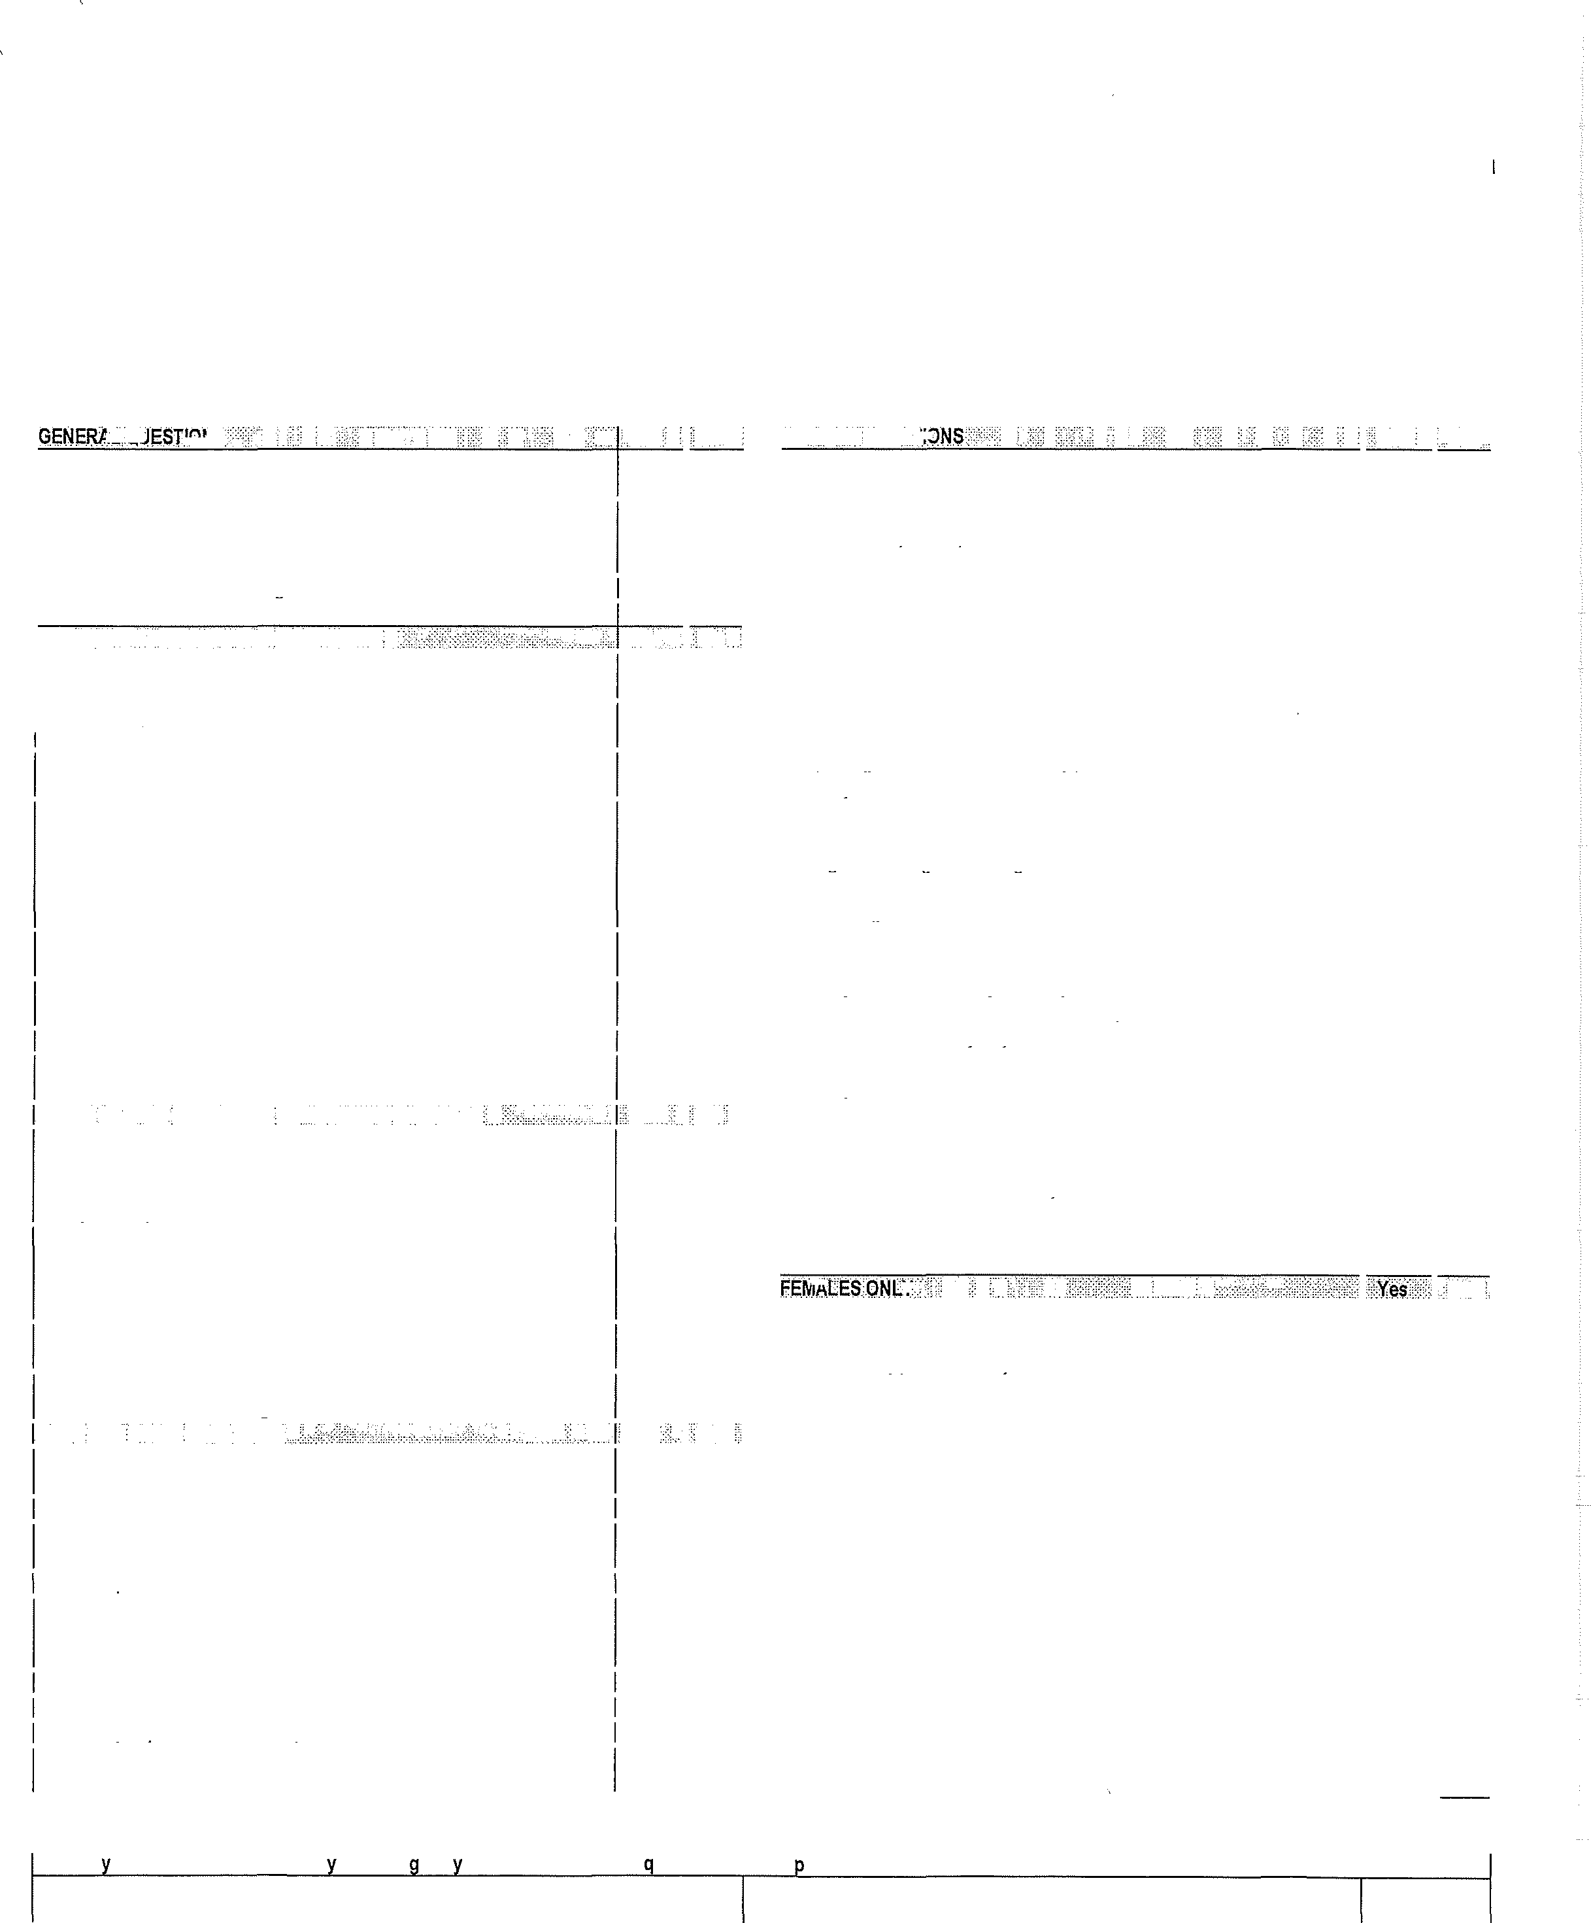
I hereby state that, to the best of my knowledge, my answers to the above questions are complete and correct.
39,
43,
44.
46,
49,
50,
14,
52,
15,
"'No?
17,
23,
40,
:t))'.)
7.
47.
Signature of Athlete: Signature of Parent(s) or Guardian:

Date:

PRE-PARTICIPATION PHYSICAL EVALUATION
PHYSICAL EXAMINATION FORM
Name: I Dale of Birth:
Physician Reminders:
- C• onsider additional questions on more sensitive issues.
  - Do you feel stressed out or under a lot of pressure?
  - Do you ever feel sad, hopeless, depressed, or anxious?
  - Do you feel safe at your home or residence?
  - Have you ever tried cigarettes, chewing tobacco, snuff, or dip?
.• During the past 30 days, did you use chewing tobacco, snuff or dip?
Do you drink alcohol or use any other drugs?
. Have you ever taken anabolic steroids or used any other performance supplements?
  - Have you ever taken any supplements to help you gain or lose weight or improve your performance?
Do you wear a seal belt, use a helmet, and use condoms?
- Consider reviewing auestions on cardiovascular svmotoms /Questions 5-14\.
EXAMINATION·• ..
. .BP: I |  | ( | I ) |  | Pulse: | Vision: R20/ | L20/ Corrected: |  | Yes |  | No
"'n, ·••::::->:: .. , ....... ·, ... ,;:··•.::;.,::.;.,.::,..::1::::2\: "'':::C.\)/•:,:,:;:  .Appearance  Marfan stigmata (kyphoscoliosis, high-arched palate, pectus  excavatum, arachnodactyly, arm span>height, hyperlaxity, myopia, MVP, aortic insufficiencv\  .Eyes/Ears/Nose/Throat |  |  |  |  | '\..,::.. NORMAL./ :,.:..\\\ | ··:: . ,;:;;;;: ·: ;:;<L ..J.• "-:'E�}fABNORMAI FINDfNGS /}l':'\;,',,;::::::::.:,.;::·:.,.> •) ,;?:','):> )/(
. Pupils equal
Hearing
Lymoh Nodes
H.earl*
- Murmurs (auscultation standing, supine, +/- Valsalva)
Location of point of maximal oulse IPMI)
P.ulses
Simultaneous femoral and radial pulses
Lungs
Abdomen
Genitourinary (males only)**
.Skin
HSV, lesions suaaestive of MRSA, tinea corooris
Neurologic- |  |  |  |  |  |  | . · . ' •T ABNORMALflNDINGS•.: t: < :;, ' .. |  |  |  | .. . .
- MUSCU.LOSKELETAL :• • :::::::;fr!?.f' ,::,:.,, :,, |  |  |  |  | ·::·:;:• '"''NORMAL}/',•·•· | /•?:'::: '/ :>:{
Neck
Back
Shoulder/arm
Elbow/forearm
Hip/thigh
Knee
Leg/ankle
FooUtoes
F•unctional
Duck-walk, sinale lea hoo
- Consider ECG, echocardlogram, and referral lo cardiology for abnormal cardiac history or exam; hConsider GU exam IfIn private setting, Having third party present is recommended.
-considercognitive evaluation or baseline neuroosvch..la..lric testin□ ifa historv...o•fsi□nificant concussion, .... ...
- Cleared for all sports without restriction.
- Cleared for all sports without restriction with recommendations for further evaluation or treatment for:
□ Not Cleared
- Pending further evaluation
- For any sports
- For certain sports (please list):
Reason:
Recommendations:
I have examined the above-named student and completed the pre-participation physical evaluation, The athlete does not present apparent clinical contraindications to practice and participate in the sport(s) as outlined above. A copy of the physical exam is on record in my office and can be made available to the school at the request of the parents. If conditions arise after the athlete has been cleared for participation, the physician may rescind the clearance until the problem is resolved and the potential consequences are completely explained to the athlete (and parents/guardians).
Name of Phvsician !fvne/orint\: I Date:
Address: 7 Phone:
SiQnature of Physician (MD/DO/ARNP/PA/Chiropractor\:

I

PRE-PARTICIPATION PHYSICAL EVALUATION
Missouri State High School Activity Association (MSHSAA) Eligibility and Authorization Statement

This application to represent my school in interscholastic athletics is entirely voluntary on my part and is made with the understanding that I have studied and understand the eligibility standards that I must meet to represent my school and that I have not violated any of them.
I have read, understand, and acknowledge receipt of the MSHSAA brochure entitled "How to Maintain and Protect Your High School Eligibility," which contains a summary of the eligibility rules of the MSHSAA. (I understand that a copy of the MSHSAA Handbook is on file with the principal and athletic administrator and that I may review it in its entirety, if I so choose. All MSHSAA by-laws and regulations from the Handbook are also posted on the MSHSAA website at www.mshsaa.org).
I understand that a MSHSAA member school must adhere to all rules and regulations that pertain to school-sponsored, interscholastic athletics programs, and I acknowledge that local rules may be more stringent than MSHSAA rules.
I also understand that if I do not meet the citizenship standards set by the school or if I am ejected from an interscholastic contest because of an unsportsmanlike act, it could result in me not being allowed to participate in the next contest or suspension from the team either temporarily or permanently.
I understand that if I drop a class, take course work through Post -Secondary Enrollment Option, Credit Flexibility, or other educational options, this action could affect compliance with MSHSAA academic standards and my eligibility.
I understand that participation in interscholastic athletics is a privilege and not a right. As a student athlete, I understand and accept the following responsibilities:
- I will respect the rights and beliefs of others and will treat others with courtesy and consideration.
- I will be fully responsible for my own actions and the consequences of my actions.
- I will respect the property of others.
- I will respect and obey the rules of my school and laws of my community, state, and country.
- I will show respect to those who are responsible for enforcing the rules of my school and the laws of my community, state, and country.
I have completed and/or verified that part of this certificate which requires me to list all previous injuries or additional conditions that are known to me which may affect my performance in so representing my school, and I verify that it is correct and complete.
Signature of Athlete: Date:

Informed Consent: By its nature, participation in interscholastic athletics includes risk of serious bodily injury and transmission of infectious disease such as HIV and Hepatitis B. Although serious injuries are not common and the risk of HIV transmission is almost nonexistent in supervised school athletic programs, it is impossible to eliminate all risk. Participants must obey all safety rules, report all physical and hygiene problems to their coaches, follow a proper conditioning program, and inspect their own equipment daily. PARENTS, GUARDIANS, OR STUDENTS WHO MAY NOT WISH TO ACCEPT RISK DESCRIBED IN THIS WARNING SHOULD NOT SIGN THIS FORM. STUDENTS MAY NOT PARTICIPATE IN MSHSAA· SPONSORED SPORT WITHOUT THE STUDENT'S AND PARENT'S/GUARDIAN/S SIGNATURE.

I understand that in the case of injury or illness requiring transportation to a health care facility, a reasonable attempt will be made to contact the parent or guardian in the case of the student-athlete being a minor, but that, if necessary, the student-athlete will be transported via ambulance to the nearest hospital.
We hereby give our consent for the above student to represent his/her school in interscholastic athletics. We also give our consent for him/her to accompany the team on trips and will not hold the school responsible in case of accident or injury whether it be en route to or from another school or during practice or an interscholastic contest; and we hereby agree to hold the school district of which this school is a part and the MSHSAA, their employees, agents, representatives, coaches, and volunteers harmless from any and all liability, actions, causes of action, debts, claims, or demands of every kind and nature whatsoever which may arise by or in connection with participation by my child/ward in any activities related to the interscholastic program of his/her school.

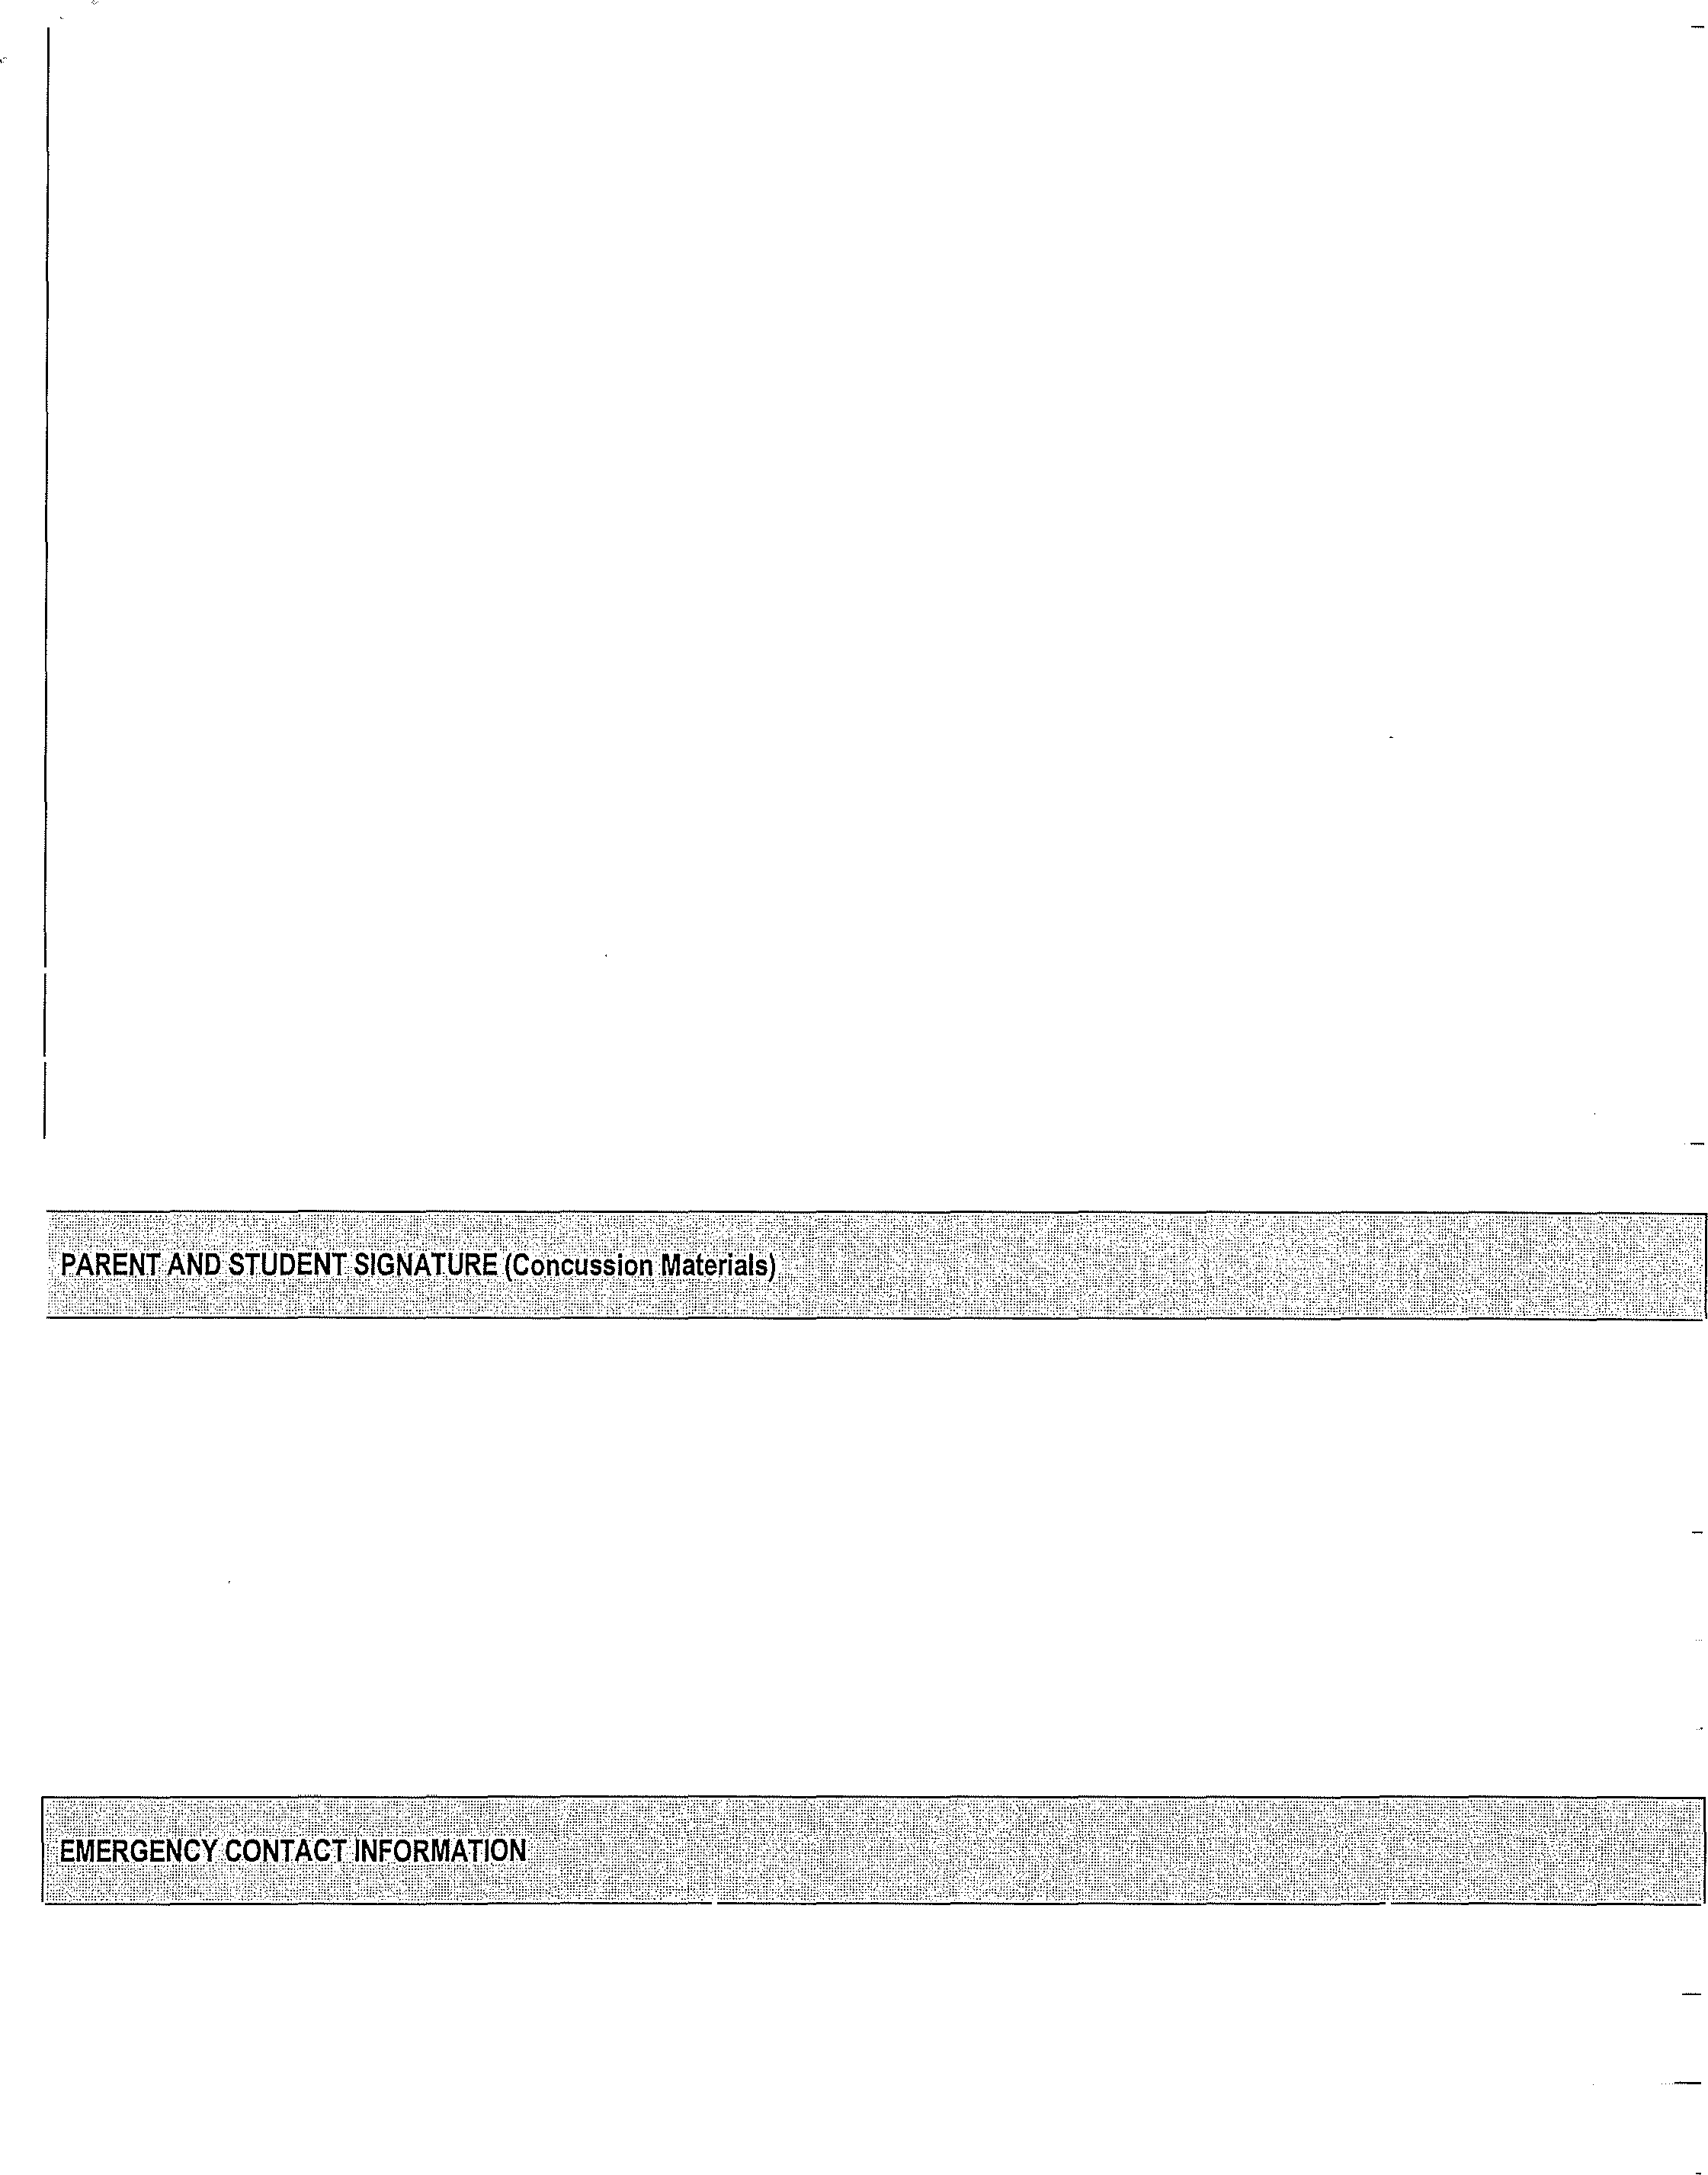
If we cannot be reached and in the event of an emergency, we also give our consent for the school to obtain through a physician or hospital of its choice, such medical care as is reasonably necessary for the welfare of the student, if he/she is injured in the course of school athletic activities. We authorize the release of necessary medical information to the physician, athletic trainer, and/or school personnel related to such treatment/care. We understand that the school may not provide transportation to all events, and permit / do not permit (CIRCLE ONE) my child to drive his/her vehicle in such a case.
To enable the MSHSAA to determine whether the herein named student is eligible to participate in interscholastic athletics in the MSHSAA member school, I consent to the release of any and all portions of school record files to MSHSAA, beginning with seventh grade, of the herein named student, specifically including, without limiting the generality of the foregoing, birth and age records, name and residence address of parent(s) or guardian(s), residence address of the student, academic work completed, grades received, and attendance data.

We confirm that this application for the above student to represent his/her school in interscholastic athletics is made with the understanding that we have studied and understand the eligibility standards that our son/daughter must meet to represent his/her school and that he/she has not violated any of them. We also understand that if our son/daughter does not meet the citizenship standards set by the school or if he/she is ejected from an interscholastic contest because of an unsportsmanlike act, it could result in him/her not being allowed to participate in the next contest or suspension from the team either temporarily or permanently.

I consent to the MSHSAA's use of the herein named student's name, likeness, and athletic-related information in reports of contests, promotional literature of the Association and other materials and releases related to interscholastic athletics.

We further state that we have completed that part of this certificate which requires us to list all previous injuries or additional conditions that are known to us which may affect this athlete's performance or treatment and we certify that it is correct and complete.

The MSHSAA By-Laws provide that a student shall not be permitted to practice or compete for a school until it has verification that he/she has basic health/accident insurance coverage, which includes athletics. Our son/daughter is covered by basic health/accident insurance for the current school year as indicated below:
Name of Insurance Company: | Policy Number:
Signature of Parent(s) or Guardian: | Date:

I accept responsibility for reporting all injuries and illnesses to my school and medical staff (athletic trainer/team physician) including any signs and symptoms of a CONCUSSION. I have received and read the MSHSAA materials on Concussions, which includes information on the definition of a concussion, symptoms of a concussion, what to do if I have a concussion and how to prevent a concussion. I will inform my school and athletic trainer/team physician immediately if I experience any of these symptoms or if I witness a teammate with these symptoms.
Signature of Athlete:
Date:
Signature of Parent(s) or Guardian:
Date:

Parent(s) or Guardian | Address | Phone Number
Name of Contact | Relationship to Athlete | Phone Number
Name of Contact | Relationship to Athlete | Phone Number

