Name: Animal:

Did You Know?

Find this box on your animal card and share something you find here!

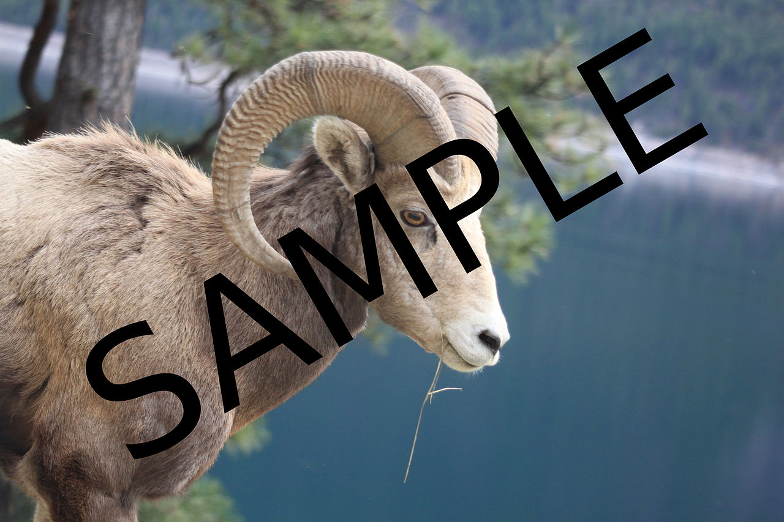

Habitat:

Food:

Behavior:

Cool Fact #1:

Cool Fact #2:

Cool Fact #3: