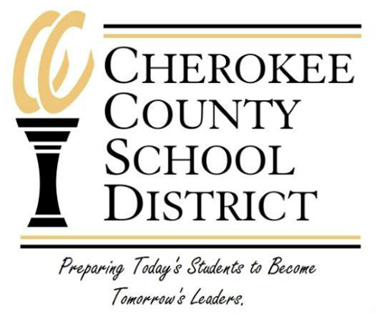

PARENTS RIGHT-TO-KNOW
Grassy Pond Elementary School
Notification Letter to Parents

Dear Parent:

In accordance with ESEA Section 1111(h)(6) PARENTS RIGHT-TO-KNOW, the Cherokee County School District is notifying every parent of a student in a Title I school that you have the right and may request information regarding the professional qualifications of your child’s classroom teacher. This information regarding the professional qualifications of your child’s classroom teachers including, at a minimum, the following:

- Whether the teacher has met State qualification and licensing criteria for the grade levels and subject areas in which the teacher provides instruction.
- Whether the teacher is teaching under emergency or other provisional status through which State qualification or licensing criteria have been waived.
- The baccalaureate degree major of the teacher and any other graduate certification or degree held by the teacher, and the field of discipline of the certification or degree.
- Whether the child is provided services by paraprofessionals and, if so, their qualifications.

If at any time your child has been taught for 4 or more consecutive weeks by a teacher not highly qualified, the school will notify you.

If you have questions, please feel free to contact your principal, Ginger Lipscomb, at the following phone number, 864-206-6671.

Sincerely,

Ginger Lipscomb

Ginger Lipscomb
Principal
ginger.lipscomb@cherokee1.org

