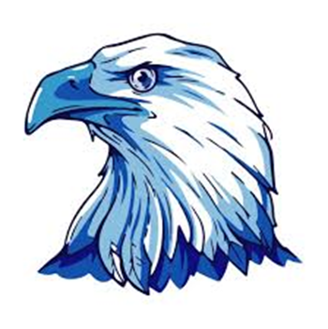
EWING MIDDLE PTO
The PTO Board is excited about all of the fun
events planned this year for our Ewing Eagles!
To be successful, the PTO needs your support.
Membership is FREE!!
Advantages of Being a PTO Member
- It builds your child’s self-esteem when they see you active at their school.
- You are better connected with school staff when you volunteer.
- You will have a voice in school activities and programs.
- Get to know your children’s friends.

Advantages of Being a PTO Member
- It builds your child’s self-esteem when they see you active at their school.
- You are better connected with school staff when you volunteer.
- You will have a voice in school activities and programs.
- Get to know your children’s friends.

---------------------------------------------------------------------------------------
EWING MIDDLE SCHOOL PTO MEMBERSHIP FORM
Research shows that not only does your involvement help your child, but also helps
the school perform better as a whole! We welcome you!!
Name: Email:
Cell: ( ) Alt. Phone ( ) May we text you: Yes No
Student(s) at Ewing Grade Relationship to Student Teacher

Volunteer Opportunities that Interest me (please circle):
- Sponsorship Opportunities
- Silent Auction
- School Beautification
- Parent/Grandparent/Family Luncheon
- Staff/Faculty Appreciation
- School Dances
- Serve on PTO Board
I can volunteer (please circle): Before School During the School Day After School

