Young cervical cancer survivor in South Carolina underscores the importance of the HPV vaccine. “The vaccine is one thing I never got,” said Halea Wylie. “I didn’t think it was one of those vaccines that was really needed because it wasn’t pushed that hard back when it first came out. Now, doctors really stress the need for it, and some parents might not understand why, but it’s very important.” Click here to watch her story: https://bit.ly/2R43EO8

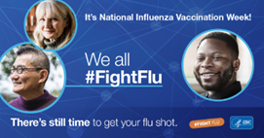
Did you know? It’s National Influenza Vaccination Week, a reminder that there’s still time to get vaccinated. When more people are protected against flu, it is less likely to spread. To learn more about benefits of flu vaccination visit: https://www.cdc.gov/flu/prevent/vaccine-benefits.htm

