Answer all my instructions – enjoy your free time when you are done!

Remember command Z will undo something you don’t want, command Y will redo something you want back, command C will copy and command V will paste.

What is your name?

What grade are you in?

What did you have for lunch?

Tell me something you learned today at school or at home - Use more than 4 words to answer!

Correct the next two sentences. Remember something under Tools will help you do this! – The kitte got cought in the power line.

the power compony had to come and get the kitte off the power line?

Make the next group of words bold. April Showers Bring May Flowers

Change the next group of words to the font Arial, size to 16 and color blue.

Wallace Wildcats Rock

Add a watermark to your paper it is under INSERT then go down to WATERMARK – hope you can find it! We have not done this my picture attached should help you!

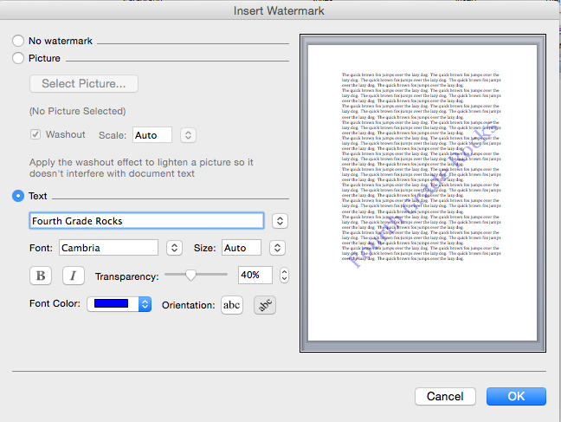

Delete my picture and add a picture to this paper.

Add a shape to this paper make it small. Remember to use INSERT

Save this page as your name rocks- example Adan rocks

