**MCTC**

**M**onroe **C**ounty **T**echnical **C**enter

Making Connections – Taking Charge

Issue

04

February

2021

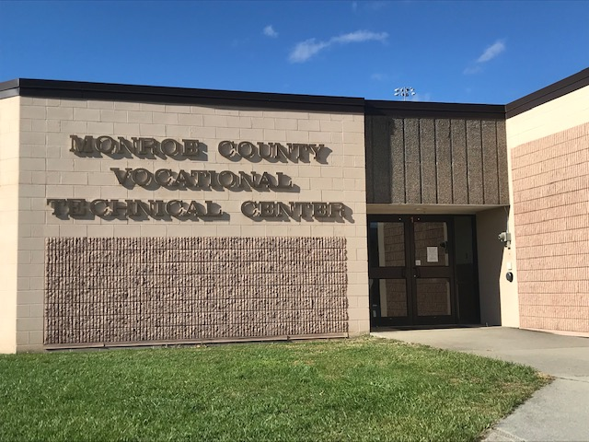



**Calendar**

**February 9**

Options Testing

**February 14**

Valentine’s Day

**February 15**

Presidents’ Day

**February 17**

Ash Wednesday

**March 14**

Daylight Savings Time begins

**March 17**

St. Patrick’s Day

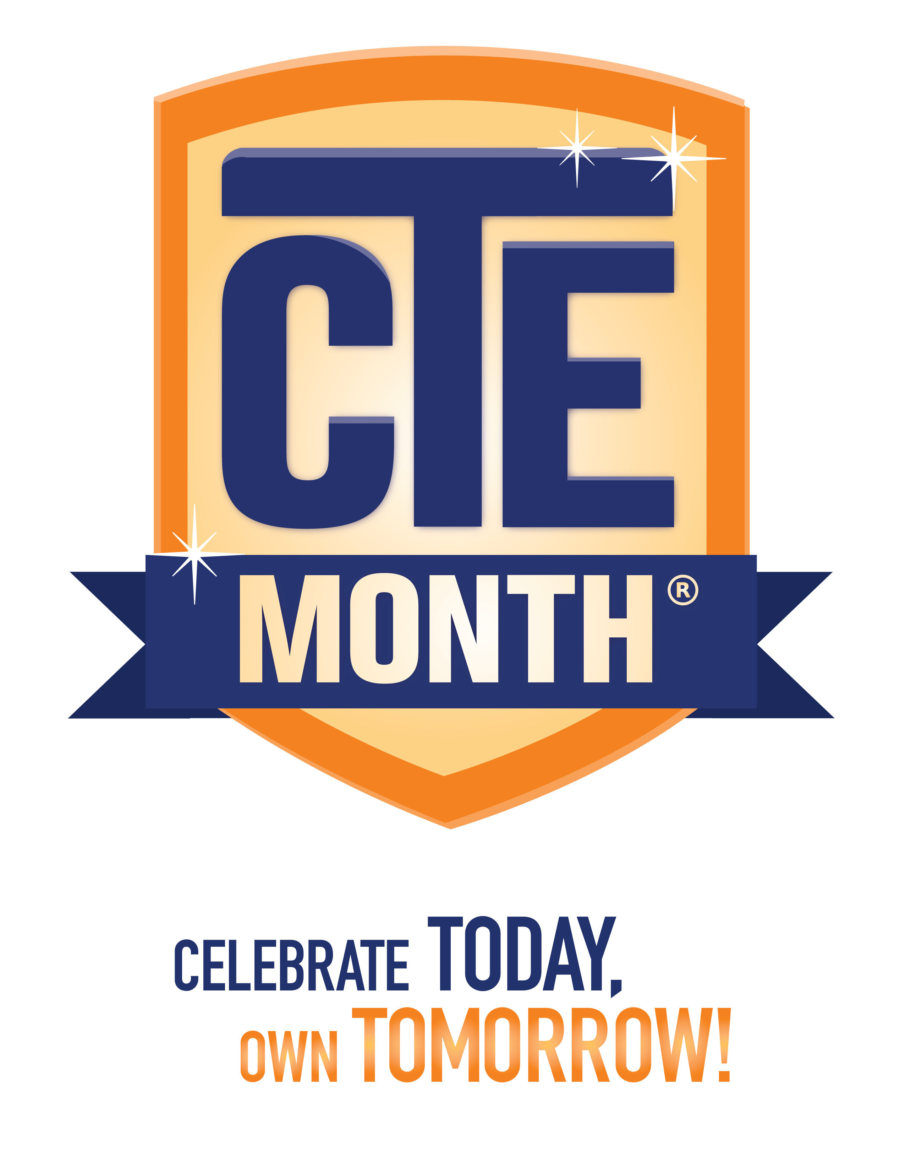

this issue

**MCTC CTE Spotlight** p. 1

**Value of CTE** p p. 2-3

**Features** p. 4

**February is . . . National CTE Month** (**®**)

**What is CTE?** Career and technical education, or **CTE**, is education that directly prepares students for high-wage, high-demand careers. CTE covers many different fields, including health care, information technology, advanced manufacturing, hospitality and management and many more. CTE encompasses many different types of education, from classroom learning to certification programs to work-based learning opportunities outside the classroom.

### Not Your Grandfather’s Vocational Education Policymakers, community leaders and businesses have become increasingly aware of CTE as a proven strategy to prepare every student for college and career success while ensuring our continued economic prosperity. Once called “vocational education” or the “industrial arts”, CTE now also encompasses high-tech in-demand skills such as robotics, information technology, and mobile app development. Even in traditional programs such as automotive repair or culinary arts, students are learning new technical, inter-personal and entrepreneurial skills to develop their future careers. As more and more students across the country look to programs that will prepare them for the jobs of tomorrow, CTE is now in high demand at both the secondary and postsecondary level.

**What is CTE Month?** Career and Technical Education Month®, or CTE Month®, is a public awareness campaign that takes place each February to celebrate the value of CTE and the achievements and accomplishments of CTE programs across the country.

The following pages highlight the value of CTE; preparing students for the workforce, college, and life beyond high school.

**CTE in West Virginia**  
Career Technical Education (CTE) programs are changing, evolving and innovating to better serve West Virginia’s needs by preparing students to help drive our success and vitality. Further, CTE is creating an educational environment that integrates core academics with real-world relevance. CTE is transforming expectations and making a difference for students, for business and industry, for West Virginia and for the global economy. This is our Simulated Workplace learning environment.

## **What is Simulated Workplace?**

The West Virginia Department of Education has worked with committee experts from numerous businesses and industries throughout West Virginia to design Simulated Workplace. This new educational initiative has been created to assist schools in implementing workplace environmental protocols that align with West Virginia workforce requirements, including random drug testing, professionalism, attendance and safety. Simulated Workplace has not only enhanced instructional delivery of career education, but has created a more engaged career and technical student. The simulated workplace environment permits students the opportunity to take ownership of their individual performance as it impacts the overall success of their education, while thriving in an authentic workplace culture. Simulated Workplace also encourages local business and industry experts to join onsite review teams to assist schools in meeting their workforce needs and expectations. Source: https://wvde.us/simulated-workplace/



# **In the Age of Coronavirus, Career-Tech Ed is More Important than Ever**

[**Advance CTE**](https://medium.com/@AdvanceCTE?source=post_page-----76bfe1c0cd09--------------------------------)

#### **[Apr 20, 2020·](https://medium.com/@AdvanceCTE/in-the-age-of-coronavirus-career-tech-ed-is-more-important-than-ever-76bfe1c0cd09?source=post_page-----76bfe1c0cd09--------------------------------)**

Career Technical Education (CTE) is more important than ever in today’s rapidly changing world. Former CTE students are heroes serving on the front lines during this global pandemic. They are healthcare workers pulling 16-hour shifts and treating our loved ones. They are manufacturing employees working tirelessly to provide life-saving supplies to hospitals, senior care facilities and grocery stores. They are educators delivering the best education possible to their students online. They are scientists racing to find a vaccine. And they are transportation, distribution, and logistics professionals working day and night so that we all have the supplies we need.

While we do not yet know the long-term impact this pandemic will have on our nation, what we do know is that education, especially CTE, will be at the center of rebuilding our economy and the lives of many Americans.

Source: <https://medium.com/@AdvanceCTE/in-the-age-of-coronavirus-career-tech-ed-is-more-important-than-ever-76bfe1c0cd09>

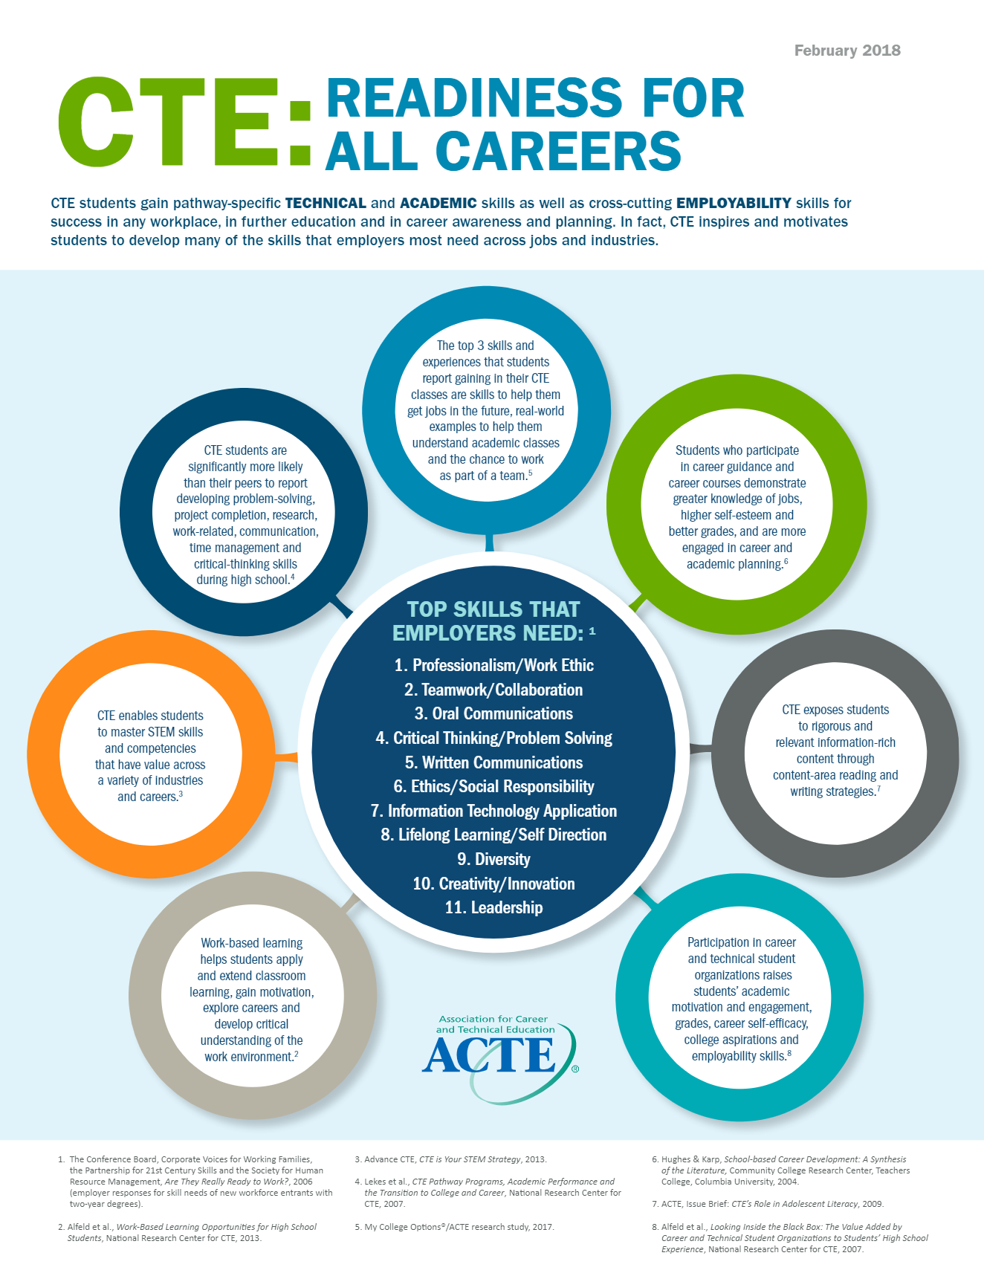

FEATURES:

**Employee of the Month**

Mrs. Lisa Carter

MCTC Secretary

[](https://www.layoutready.com/?utm_source=microsoft&utm_medium=file&utm_campaign=office_online)

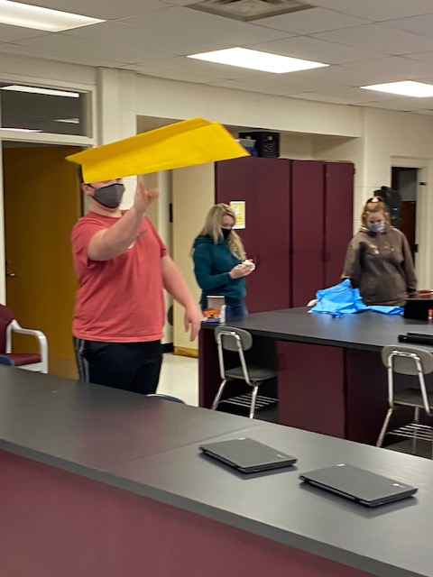

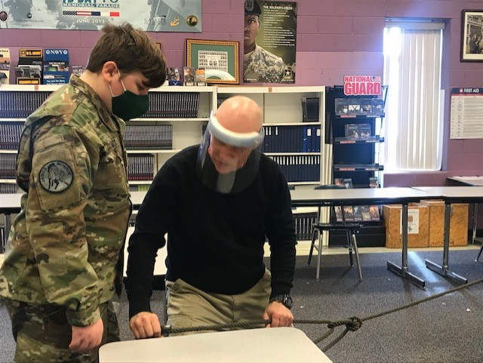

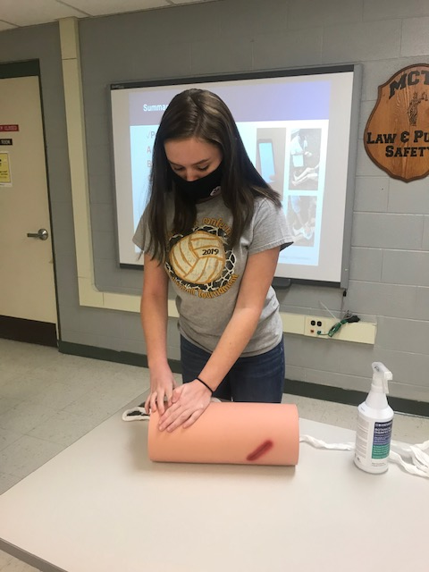

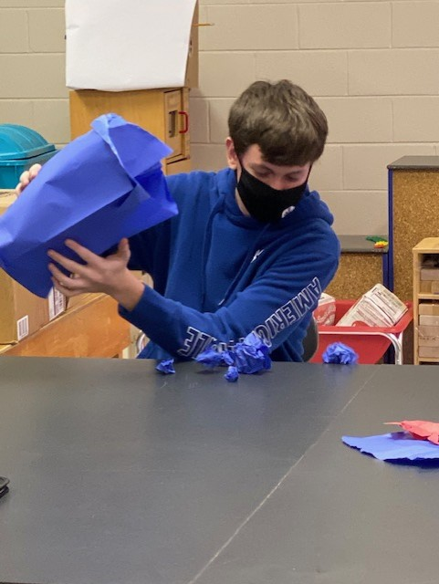



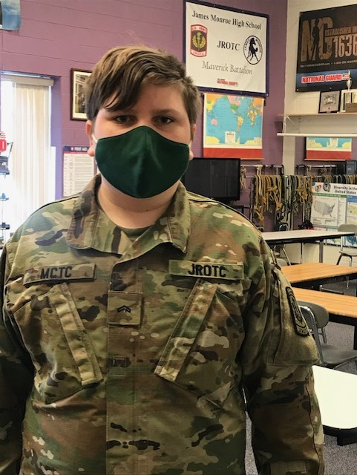





**Monroe County Technical Center**

74 James Monroe Drive, Lindside, WV 24951

304-753-9971

Tricia P. King, CTE Director

Visit us on the web: <http://monroe-k12.wvnet.edu/mctc/>

MCTC Photo Album