Lancaster County Public Schools
February 2019 Lunch Menu for;
Lancaster Primary, Middle, & High School
Monday | Tuesday | Wednesday | Thursday | Friday
1) Cheeseburger/ WG bun
Broccoli
Applesauce
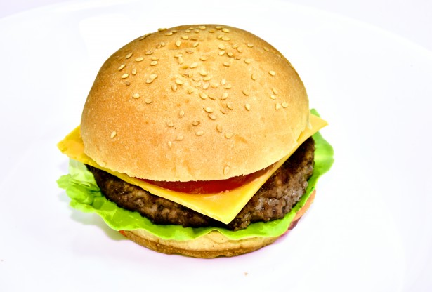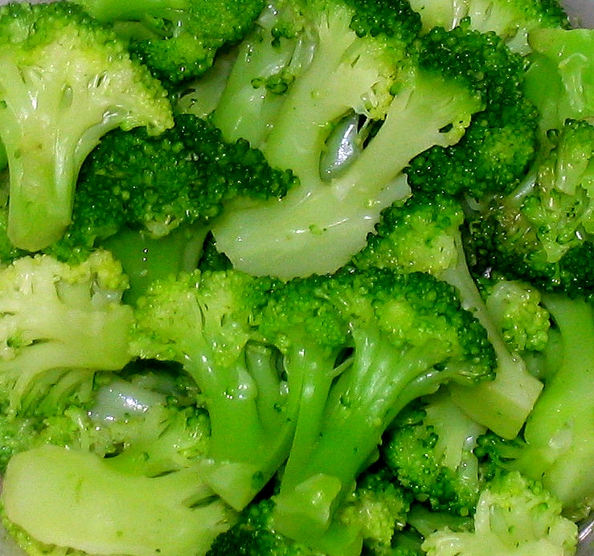

4) WG Corn Dog Nuggets  Baked Beans  Pears  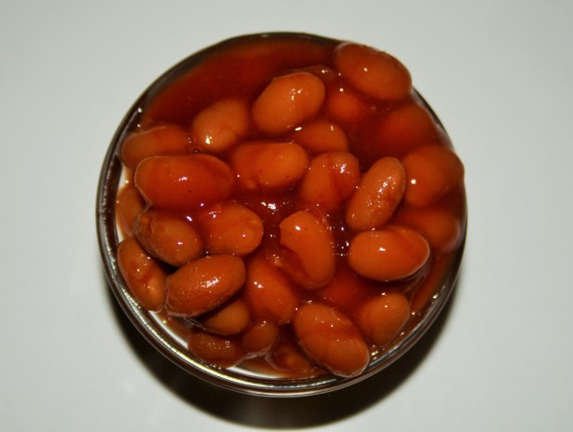 | 5) WG Chicken Nuggets  Peas  Applesauce  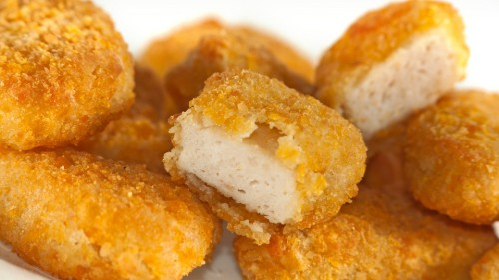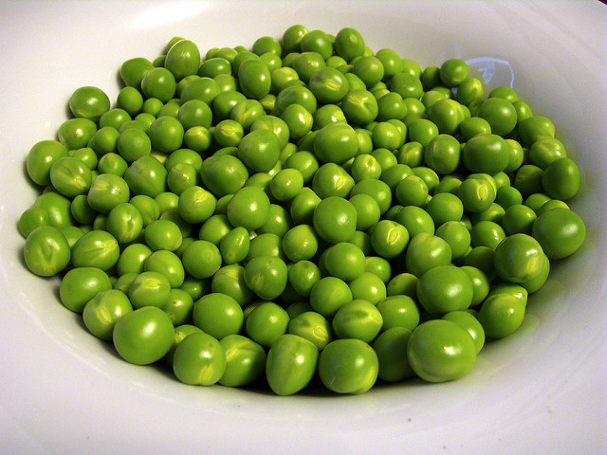 | 6) Rib-A-Que on a WG bun  Sweet Potatoes  Mixed Fruit  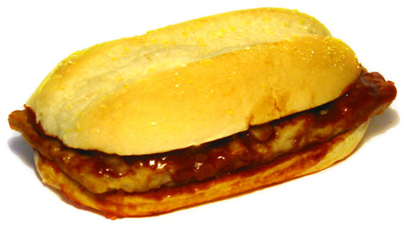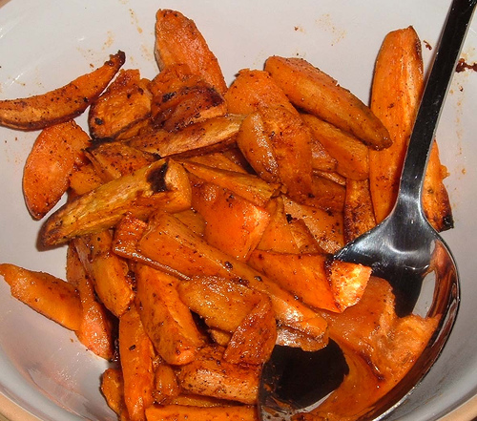 | 7) Salisbury Steak  Mashed Potatoes  Greens Beans  Peaches &WG Roll  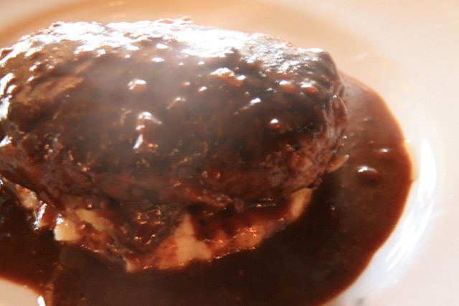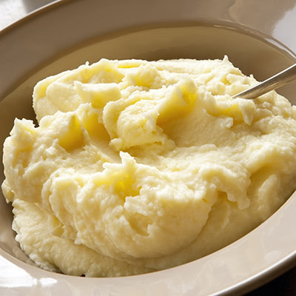 | 8) Tuna Salad  WG Bun  French Fries  Sliced Apples  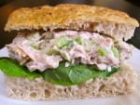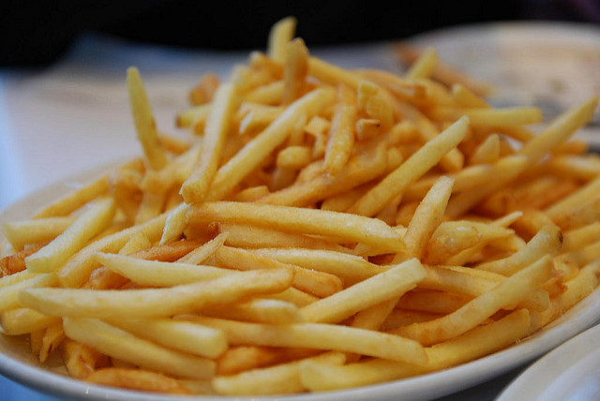
11) Chicken Fajita Wrap  Sweet Potato Gems  Sliced Apples  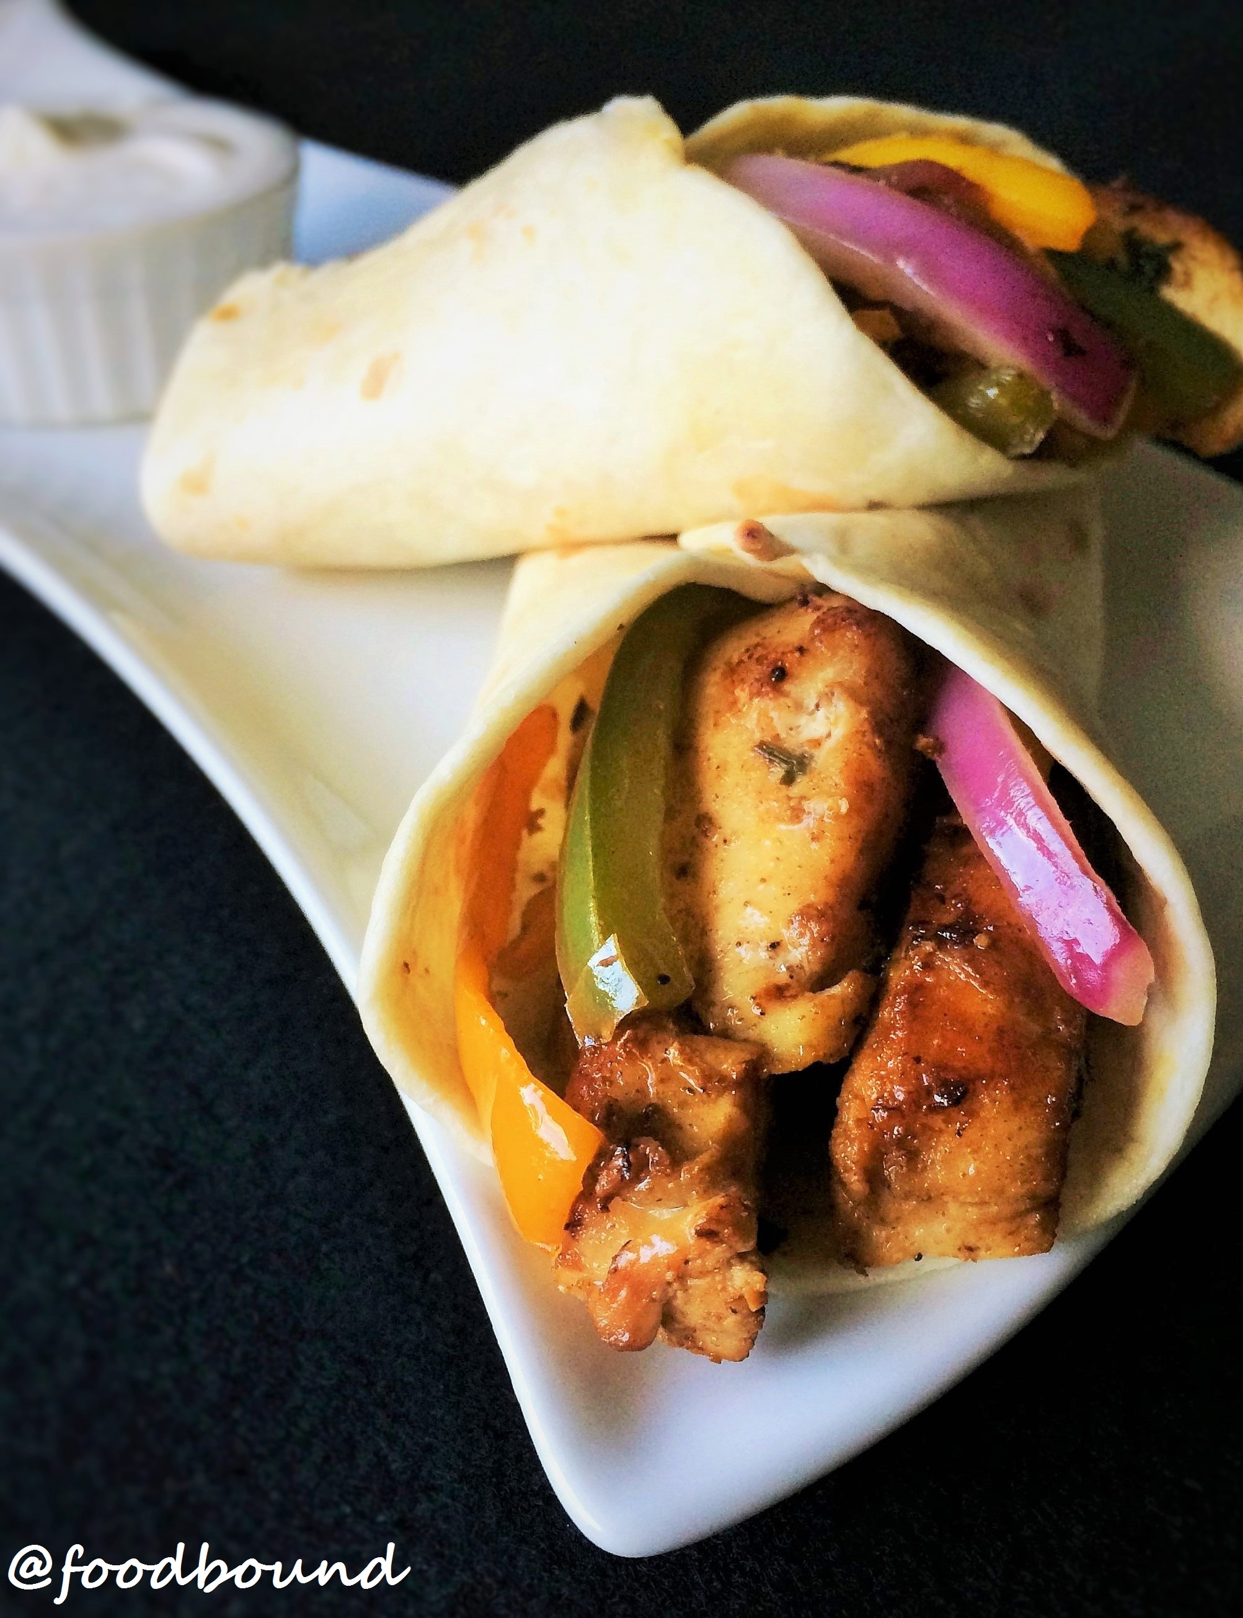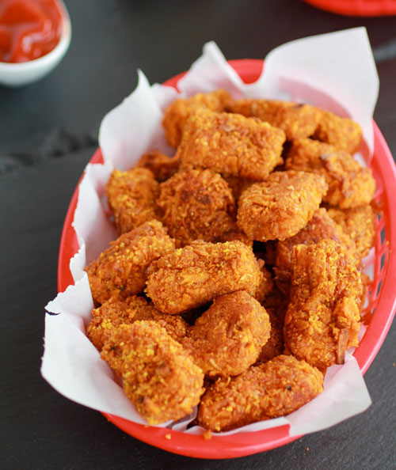 | 12) Cheeseburger/ WG bun  Baked Beans  Mixed Berry cup | 13) Bar-B-Que Chicken  Greens  WG Roll  Peach Cobbler  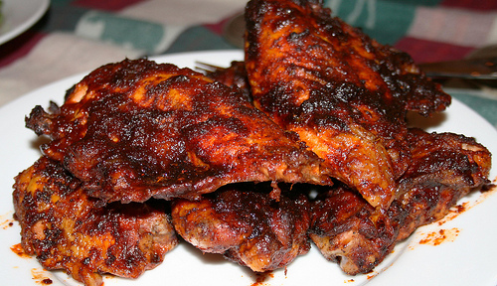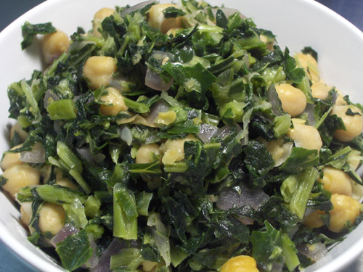 | 14) WG Cheese Pizza  Side salad  Pears  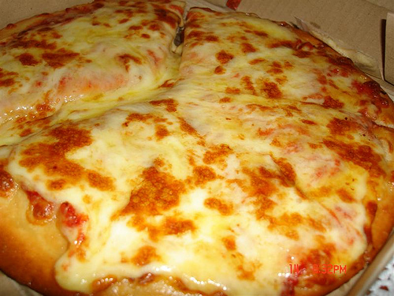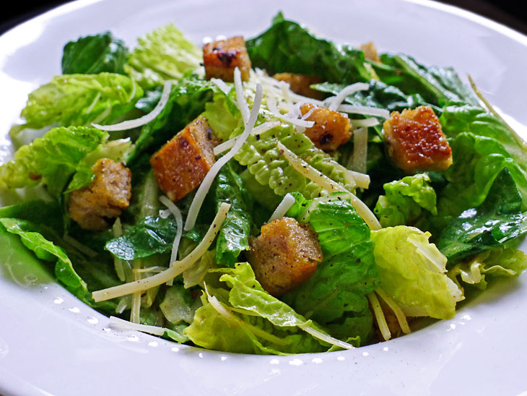 | 15) Chicken Salad  Potato Tots  Mixed Fruit  WG Sun Chips or  WG Crackers  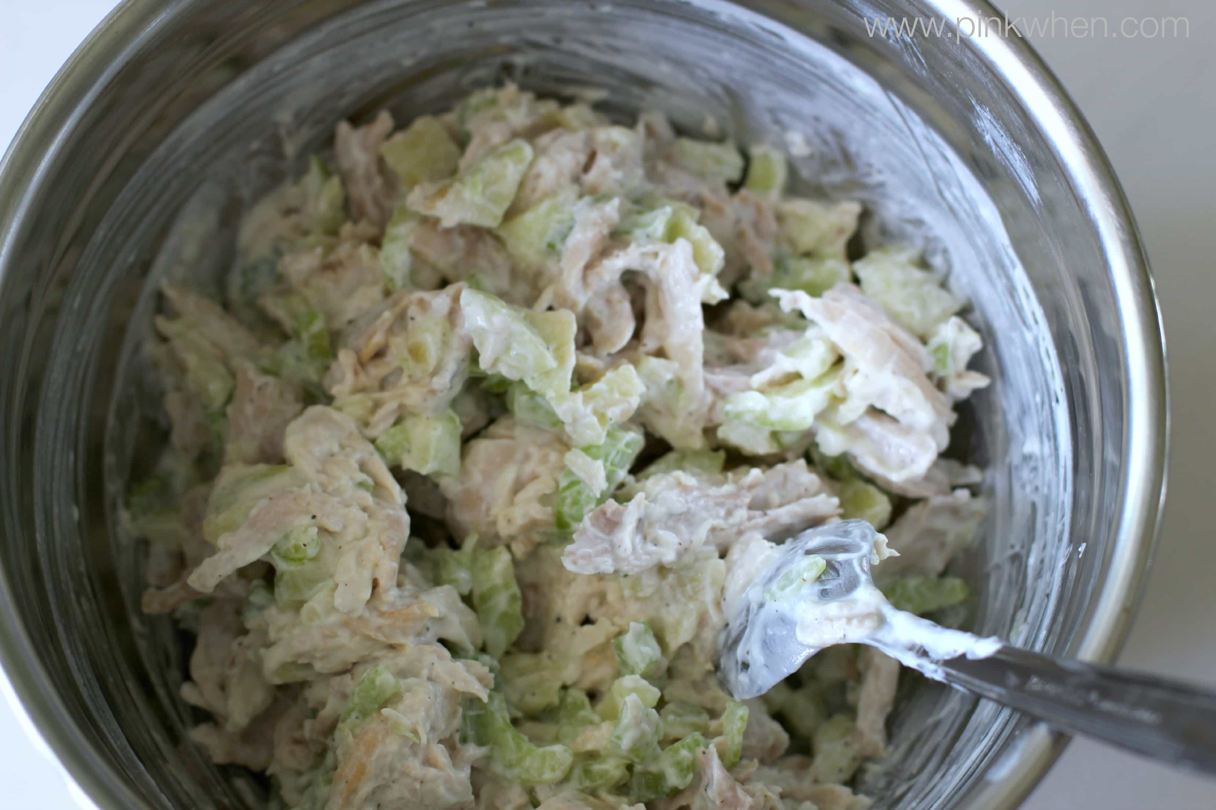
18) No School  HOLIDAY  PRESIDENT’S DAY  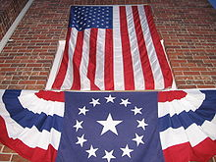 | 19) WG Corn Dog on a  stick  Baked Beans  Sliced Apples  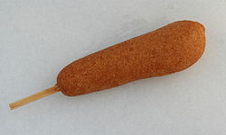 | 20) Beef Vegetable Soup  WG Cheese bites  Side salad  Applesauce  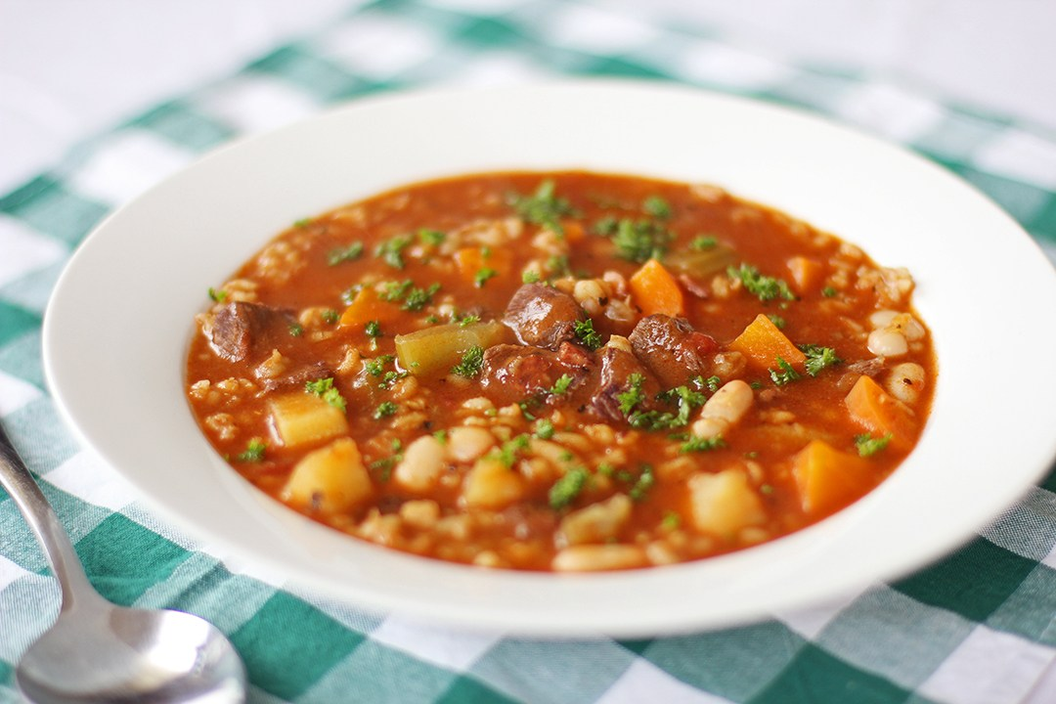 | 21) WG Personal Pan Pizza  Sweet Potato Wedges  Strawberry cup  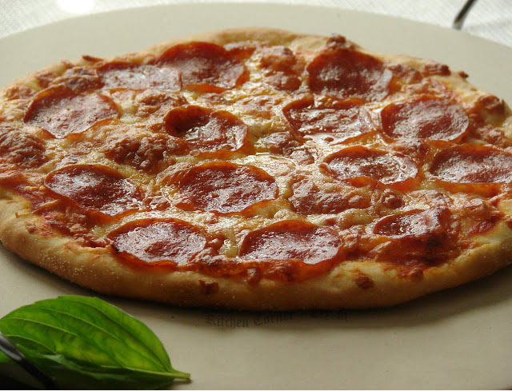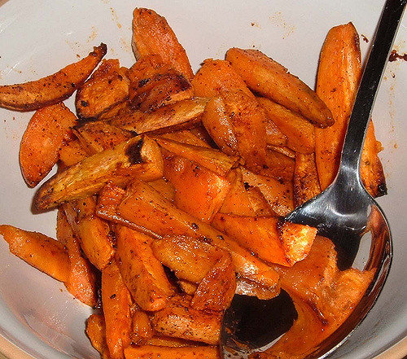 | 22) Turkey & Cheese Sub  Potato Wedges  Pears  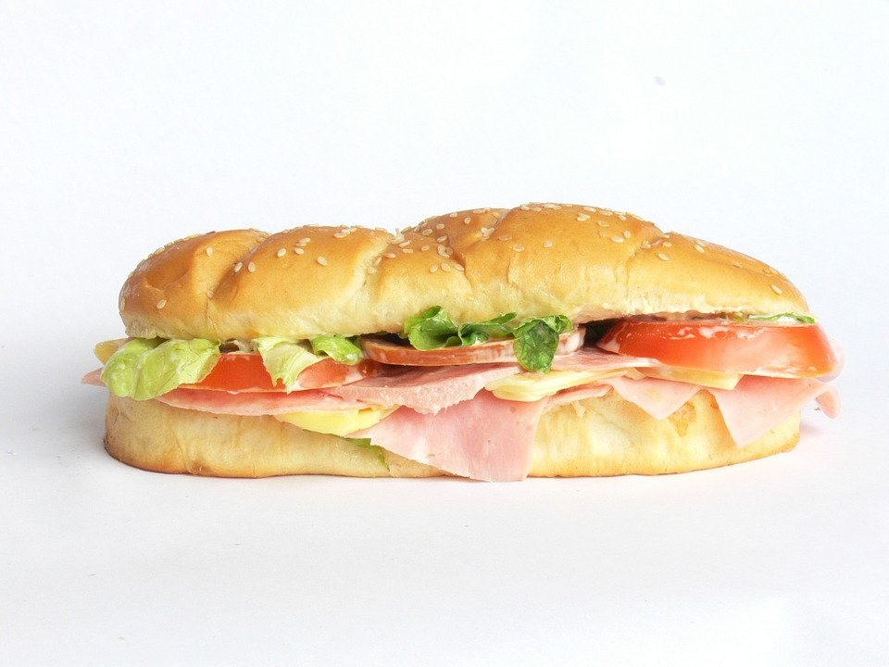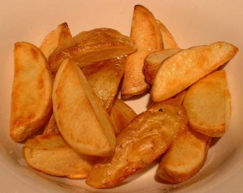
25) Hot Dog, WG Bun  Sweet Potato Wedges  Applesauce  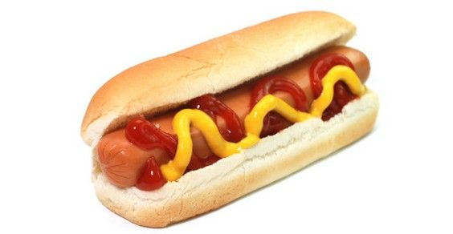 | 26) WG Chicken Patty on a  WG bun  Green Beans  Pears  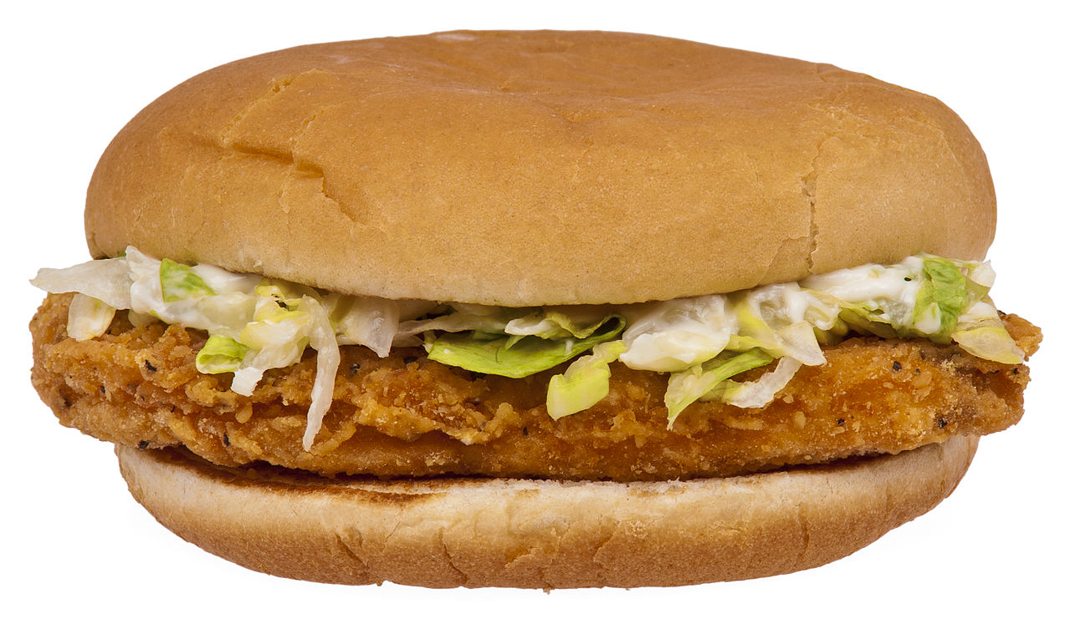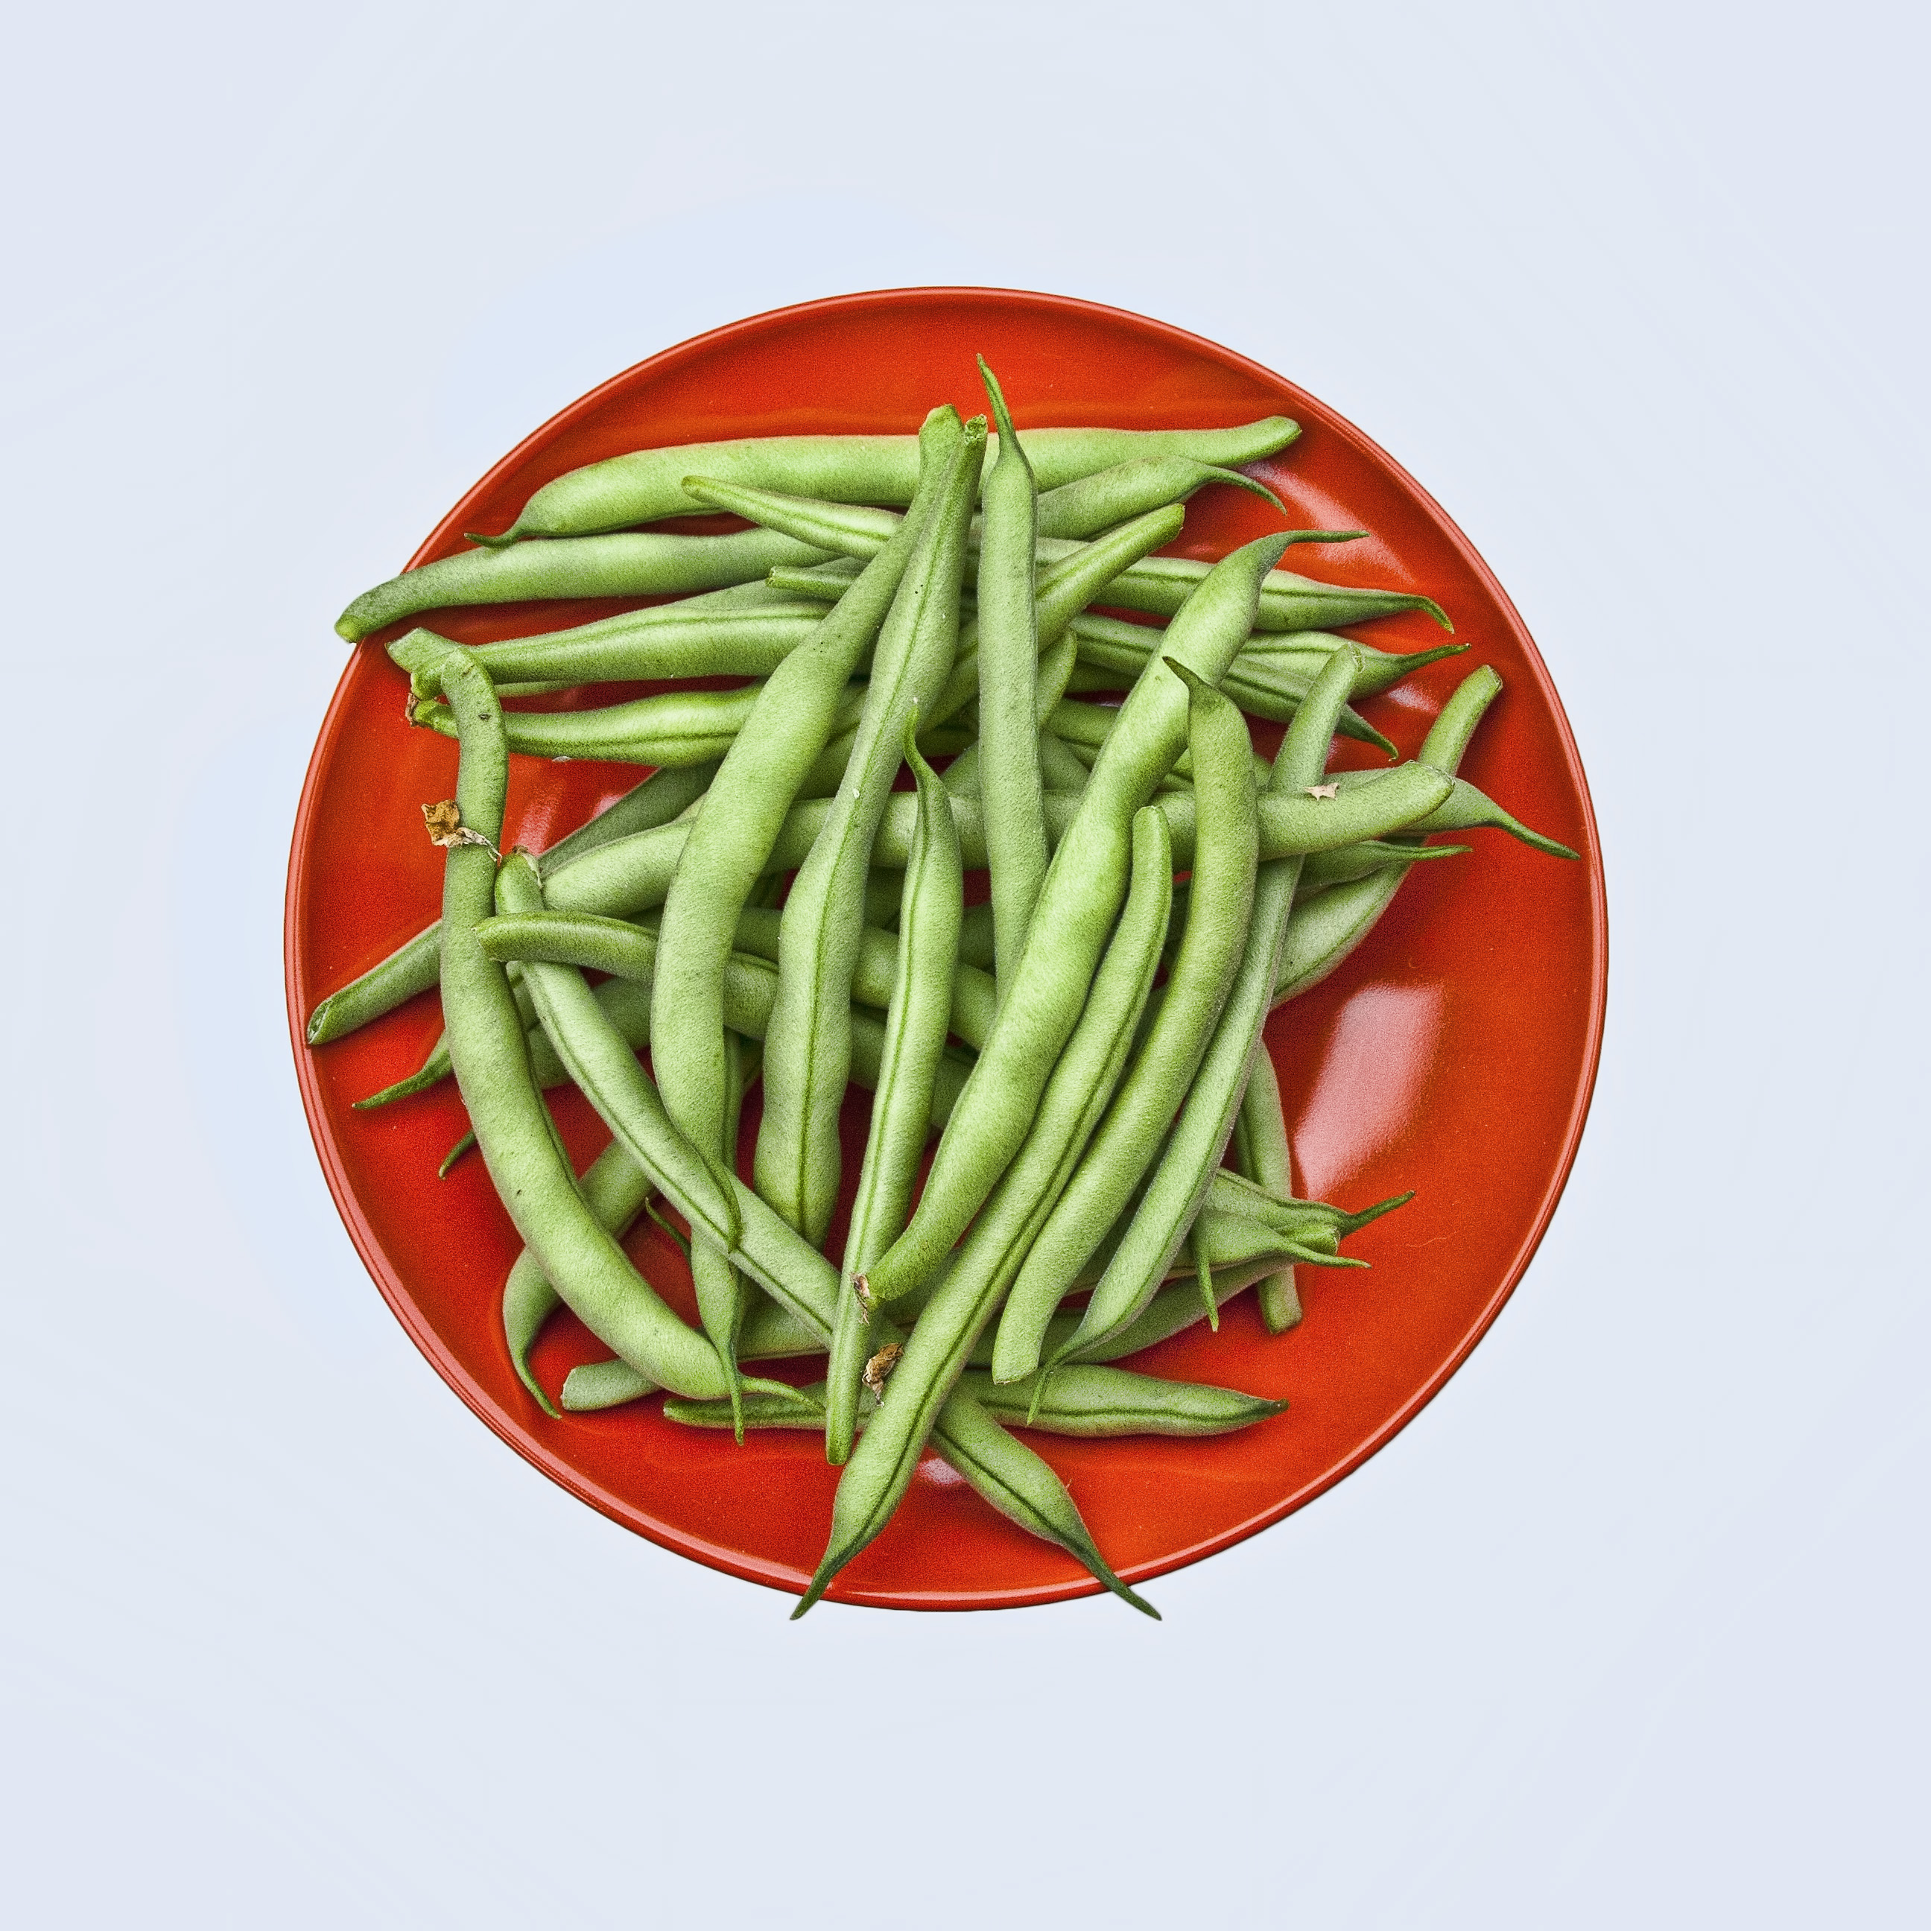 | 27) WG Orange Chicken  WG Rice  Broccoli  Peaches  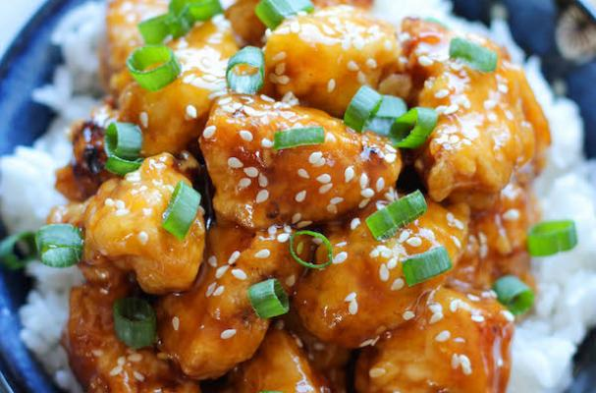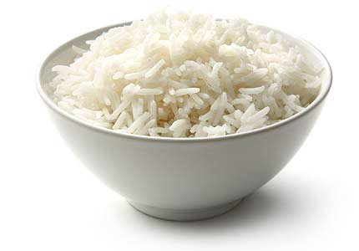 | 28) Steak & Cheese  WG Bun  Baked Beans  Peach cup  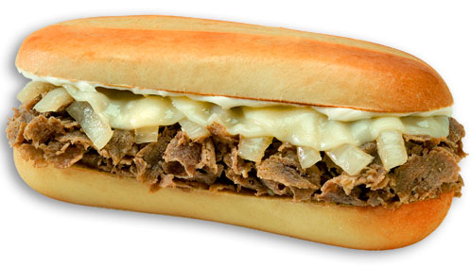 | 1 Ham Sub on WG bun  Corn  Mixed Fruit  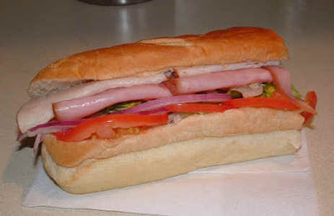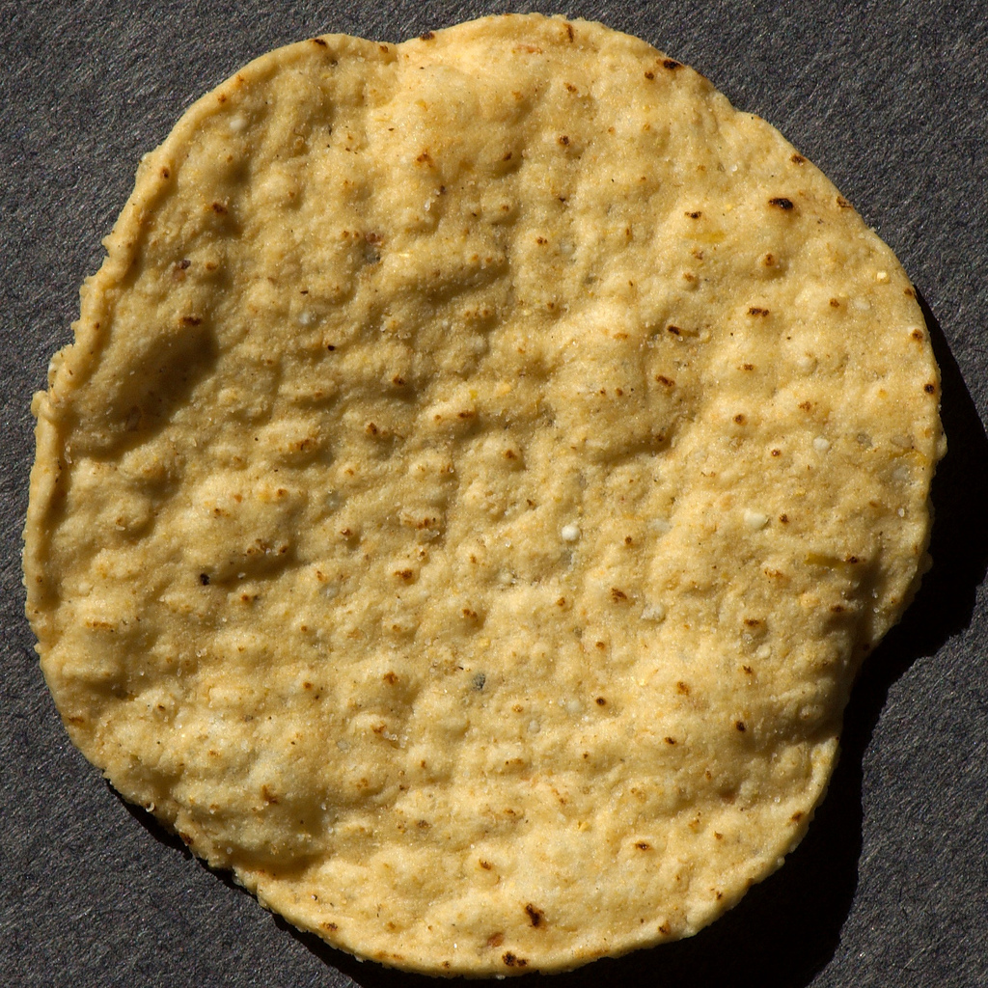
WHAT IS OFFER V SERVE, & REIMBURSEABLE MEALS?
*WE OFFER FIVE COMPONENTS FOR LUNCH; A MEAT/MEAT ALTERNATE, A VEGETABLE, A FRUIT, A WG BREAD/GRAIN, AND MILK.
STUDENT CAN CHOOSE ALL FIVE, OR THEY CAN CHOOSE 4, OR 3 COMPONENTS, BUT 1 MUST BE A FRUIT, AND OR VEGETABLE.
A REIMBURSEABLE MEAL IS THREE, OR MORE OF THESE COMPONENTS, ONE OF THEM MUST BE A FRUIT AND OR VEGETABLE.
AN EXAMPLE OF A REIMBURSEABLE MEAL: (A CHEESEBURGER, ½ or 1cup of BROCCOLI IS A REIMBURSEABLE MEAL).
ANOTHER EXAMPLE IS; (CHICKEN TENDERS, ½ or 1 cup of MIXED FRUIT, and MILK IS A REIMBURSEABLE MEAL).
ANOTHER EXAMPLE: (A SLICE OF PEPPERONI PIZZA, 1 cup of ROMINE, SPINACH SALAD IS A REIMBURSEABLE MEAL).
ANOTHER EXAMPLE: (CHICKEN NUGGETS, A WG ROLL, ½ or 1 cup of CORN, and MILK, IS A REIMBURSEABLE MEAL).
ANOTHER EXAMPLE :( HOT DOG on a WG BUN, ¾ or 11/4 cup of CARROTS, & ½ or 1 cup of APPLESAUCE, IS A REIMBURSEABLE MEAL)
*THE LARGER PORTIONS ARE REQUIRED AT THE HIGH SCHOOL LEVEL.*
(***Condiments for lunch; Catsup, Mayonnaise, Honey Mustard, Barbeque sauce, Mustard & Dressing***)
NOTE:
Due to the menu being done in advance, product shortages, or items being out of stock at the warehouse;
***THE MENU IS SUBJECT TO CHANGE WITHOUT NOTICE***
Non-discrimination Statement: In accordance with Federal civil rights law and U.S. Department of Agriculture (USDA) civil rights regulations and policies, the USDA, its Agencies, offices, and employees, and institutions participating in or administering USDA programs are prohibited from discriminating based on race, color, national origin, sex, disability, age, or reprisal or retaliation for prior civil rights activity in any program or activity conducted or funded by USDA.
Persons with disabilities who require alternative means of communication for program information (e.g. Braille, large print, audiotape, American Sign Language, etc.), should contact the Agency (State or local) where they applied for benefits. Individuals who are deaf, hard of hearing or have speech disabilities may contact USDA through the Federal Relay Service at (800) 877-8339. Additionally, program information may be made available in languages other than English.
To file a program complaint of discrimination, complete the USDA Program Discrimination Complaint Form, (AD-3027) found online at: http://www.ascr.usda.gov/complaint_filing_cust.html, and at any USDA office, or write a letter addressed to USDA and provide in the letter all of the information requested in the form. To request a copy of the complaint form, call (866) 632-9992. Submit your completed form or letter to USDA by:
(1) mail: U.S. Department of Agriculture, Office of the Assistant Secretary for Civil Rights, 1400 Independence Avenue, SW, Washington, D.C. 20250-9410;
(2) fax: (202) 690-7442; or
(3) email: program.intake@usda.gov.
This institution is an equal opportunity provider.

