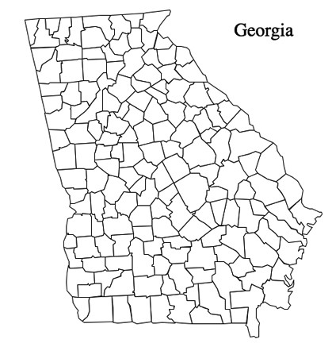

I live in the city of: My county name is:
Two famous people from Georgia are: , .
The governor is:
Three crops grown in Georgia are: , , .
Map Key: Capital/Atlanta; Where I live; President Carter’s Home Atlantic Ocean

