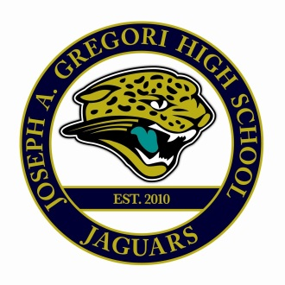
Safety Plan Component F
Joseph A. Gregori
SITE SPECIFIC DRESS CODE
(Approved by Safety Committee)

10. SITE SPECIFIC: Required Dress Code
All students will have their school ID cards accessible when they come onto campus,
while they attend class, and up until they leave school for the day.

The following items are prohibited at Joseph A. Gregori High School:

A. Red or blue hair ties in the hair or on the arms.
B. Crocheted/braided rosaries (blue or red).
C. Red/blue canvas belts/Punched out belt buckles.
D. Red/blue shoelaces.
E. Nike Cortez shoes with either red or blue.
F. No more than one item of red or blue.
G. Clothing hanging over the shoulder or hanging out of the pockets; this includes towels.
H. No solid red or blue shirts/sweatshirts.
I. Baggie Ben Davis or Dickies pants.
J. No red/blue apparel exposed under any T-shirt or collars.
K. Attire with “Nor-Cal, No-Cal, No-Cali, Nor Cali” or any reference to Cali.
L. South Pole attire.
M. Gang signs, symbols, pictures on cell phones.
N. Any professional or college sports jersey that is not appropriate team color.
O. Long socks that come up to long shorts.
R. Red or blue stars.
S. Gloves with short sleeves.
T. Bandanas, hats, hoods (beanies with Gregori colors may be worn in winter months).
U. Attire with drug paraphernalia, “Cookies” or “Tobacco”.

Modesto City School Dress Code can be found on pages 56-58
in the Conduct Code & Information Handbook.

