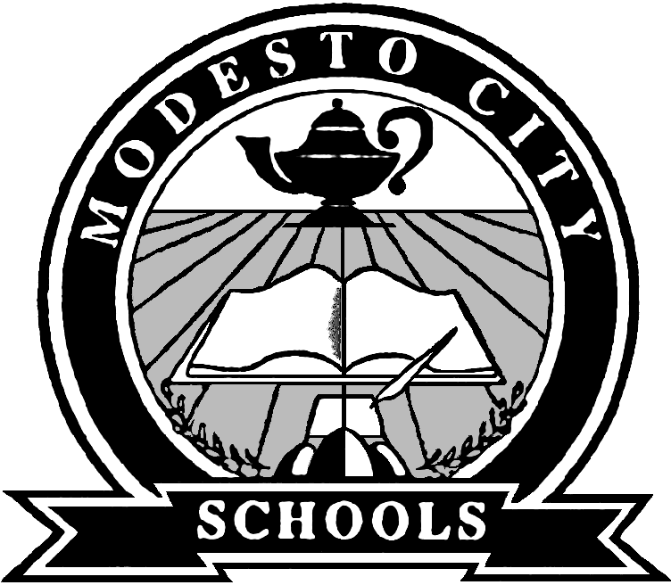
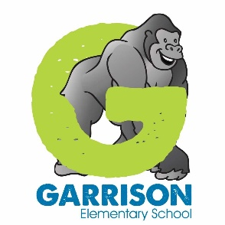
Garrison Elementary School
1811 Teresa St. Modesto, CA 95350 (209) 574-8132
Nancy Matthews, Principal Jerry Gonzaga, Vice Principal

TK-6 Expansion of In-Person Instruction Q&A - as of 2/19/21

When will this happen?
We don’t have a set date at this time, however, we anticipate that this will happen prior to spring break. We are still in the planning stages. Right now, in order to make decisions moving forward, we need to know how many students will be on campus for in-person instruction.
Why now?
With our county’s case and positivity rates declining, Public Health recently updated their guidelines which now allows for the merging of our student cohorts, just so long as we maintain desk spacing of 4 feet (minimum) and continue adhering to our health and safety protocols.
Will the schedule remain the same?
We are still working on those details. At this point in time, we need to know how many students will be on campus for in-person instruction.
How will you maintain social distancing?
Our maintenance and operations and custodial staff have carefully measured classrooms and other shared spaces to ensure the appropriate amount of physical distancing. Teachers will review appropriate spacing with students when they return to campus.
How far apart will the desks be placed?
Desks must be a minimum of 4 feet apart.
Will students be able to play on the playground?
Yes, students will be able to play on the playground with the cohort group.
We have playground ball separated by cohort as well.
What about breakfast and lunch?
Students attending school in-person may receive breakfast and lunch at no charge. Students in 100% distance learning may still participate in the meal pick-up program.
What happens if you don’t have enough space to accommodate the students that want to return?
We are still in the planning process. At this point in time, we need to know how many students will be on campus for in-person instruction.
Why is it “perhaps 4-5 days per week,” not decided on one or the other?
We are still in the planning process and working on the details. We will communicate additional information as soon as it is available. Our goal is to maximize the opportunities for in-person instruction.
How will we let you know which option we choose?
We are calling families to find out their preferences, but families can call us at 209-574-8132 or by emailing us at Matthews.n@monet.k12.ca.us
Will our student remain with the same teacher?
The plan is for every student to remain with their same teacher, however, if more students plan to return to campus than classroom social distancing allows, we may have to move students in order to maintain health and safety protocols. The protocol to address more requests for in-person instruction than a classroom can accommodate is in development.
Will I still be able to have my child come to school AND do distance learning if they are sick or we are out of town?
No, parents will be required to choose either in-person learning OR 100% distance learning from home. If your child cannot attend in-person and that’s the option you’ve chosen, they can participate in distance learning if they choose, however, they will be marked absent.
What advice do you have for families with health challenges that cannot send their students to school until family members are vaccinated?
Once you are vaccinated, reach out to the school and ask if there is space available. If space is available, you can commit to in-person instruction at that time.

