Aberdeen School District
Instructional Management Plan
2017-2018

Purpose
The purpose of this document is to outline the instructional model, curriculum, and strategies that the Aberdeen School District utilizes in an effort to achieve instructional success as defined by the state and federal accountability models. This document will provide an overview of the following:
- The District’s Curriculum
- The District’s Instructional Model.
- Data sources used to evaluate the curriculum and student achievement.

Table of Contents

Topic Page Number
District Instructional Planning Team | 3
Mission, Beliefs and Goals | 3
MS Accountability Standards | 4
Links to Curriculum Documents | 5
Curriculum Alignment Summary | 8
Multi-Tiered System of Support | 9
Behavior Screenings and Support | 12
Positive Behavior and Intervention Support | 13

District Instructional Planning Team 2017-18
- Jeff Clay-Superintendent
- Willie Brandon-Special Education Director
- Temeka Shannon-Curriculum and Federal Programs Director
Aberdeen Elementary School: Olivia Ulbrich, sDawn Smith, Joyce Loftin, Amy Bell, Joanna Damron, Evette Ware, Angela Brown, Samantha Elizondo and Amanda Rogers
Belle-Shivers Middle School: Stephanie Deveans, Lashunda Coleman, Valerie Bailey and Karen Poindexter and Zellerie Cox
Aberdeen High School: Kammie Miller, Karen Howard and Tracy Fair
Mission of the Aberdeen School District
The mission of the Aberdeen School District is to provide a quality education for every child every day in a safe, supportive environment where there is respect for individual differences and community values.
Beliefs
In pursuit of our Mission, we are guided by a set of core beliefs that is the foundation of our educational practices:

- Every child is a unique individual who deserves respect and the opportunity to learn, grow, continually improve, and succeed in both academic and extracurricular areas.
- We foster a climate of high expectations and the understanding that diversity of gender, physical or mental ability, culture, and background is a strength to be respected.
- Every child will be encouraged, motivated, and challenged to set ambitious yet realistic goals in which the standards of performance are clear and consistent and the conditions for learning are modified and differentiated.
- Parent, school, and community support are critical to the child’s success, and building relationships among these groups will be crucial for achieving our common vision.
- Students’ optimum opportunities to learn occur in a safe, nurturing environment.
- The culture of the school and community will be one that strongly encourages the setting of high expectations, the modeling of principled behavior, the acceptance of personal responsibility, and the display of professional, personal integrity, and honesty as the best example for students’ growth into responsible citizens.
- The administration, faculty, staff, students, parents, and stakeholders will hold high expectations for student learning and will model initiative and persistence as they help students achieve those expectations, demonstrating teamwork, open and honest communication, and congenial collaboration.

MOTTO: The Right Way, Every Day, the Bulldog way!
Goal 1: Provide consistent, quality instruction
Goal 2: Expand and strengthen family and community engagement
Goal 3: Provide a quality education for every child, every day in a safe supportive environment
where there is respect for individual differences.
Mississippi Accountability Standards

Standard 20
The school district implements an instructional management system that has been adopted by the school board. (MS Code 37-3-49 (2) (a-c) and 37-3-49 (5) (SB Policy 4300.

Standard 20.1
The instructional management system includes the competencies and objectives required in the curriculum frameworks approved by the State Board of Education that are available to all teachers in each school. (Districts meeting the highest levels of performance are exempted.)

Standard 20.2
The instructional management system includes a tiered instructional model in accordance with State Board of Education Policy 4300, including academic interventions, behavioral interventions, and Literacy-Based Promotion Act requirements.

The Aberdeen School District strategically plans and actively works to ensure alignment of its written, taught, and assessed curricula so that students reach their highest level of personal success and graduate ready for college and/or a career. As a district, we constantly reflect and make the needed adjustments so that students have access to not only quality, but relevant educational experiences that contain the rigor necessary for success.

CURRICULUM
The curriculum is what is taught to students. The curriculum director provides each administrator with a list of current frameworks. Each school administrator is responsible for the supervision of curriculum to ensure it is delivered to the highest quality. ASD will utilize all of the standards, competencies, and objectives found in the most recent Mississippi College and Career Readiness Standards, the Mississippi Curriculum Frameworks, and the Career and Technical Education Curricula. These documents are the key components to the Instructional Management Plan.

Hard copies of these documents are located in the Office of the Curriculum Director. In addition, each school and teacher has the documents relative to the instructional programs and teaching responsibilities.

Links to Curriculum Documents:
Mississippi College-and Career-Readiness English Language Arts 2016 Standards https://districtaccess.mde.k12.ms.us/curriculumandInstruction/MississippiCurriculu
mFrameworks/ELA/2016-MS-CCRS-ELA.pdf

Mississippi College-and Career-Readiness Standards Mathematics 2016 https://districtaccess.mde.k12.ms.us/curriculumandInstruction/Mathematics%20Resour ces/MS%20CCSSM%20Framework%20Documents/2016-MS-CCRS-Math.pdf

Mississippi Science Framework 2010 http://www.mde.k12.ms.us/docs/curriculum-and-instructions-library/2010-scienceframework.pdf?sfvrsn=4

Mississippi College-and-Career-Readiness Standards for Science 2018 (2017 pilot year) http://www.mde.k12.ms.us/docs/elementary-education-and-reading-library/2018ms_ccrs---sci_k-12_final-20170502.pdf?sfvrsn=2

Mississippi Social Studies Framework 2011 http://www.mde.k12.ms.us/docs/curriculum-and-instructions-library/2011-mississsippisocial-studies-framework.pdf?sfvrsn=4

Advanced Placement College Board – AP Central (links to College Board Course Descriptions and Overview) http://apcentral.collegeboard.com/apc/public/courses/descriptions/index.html

Mississippi Business and Technology Framework 2014 https://districtaccess.mde.k12.ms.us/curriculumandInstruction/Business%20and%20Tec hnology1/Forms/AllItems.aspx?RootFolder=%2FcurriculumandInstruction%2FBusiness%
20and%20Technology1%2FNew%20BTE%20Framework&FolderCTID=0x012000999DB07 FE64EEE42A99207FB66CD5B8F&View={8836F78F-E763-4001-859F-7BF960F8346A}

Career and Technical Education Mississippi State University Research and Curriculum Unit (links to course curriculum downloads)
http://www.rcu.msstate.edu/Curriculum/CurriculumDownload.aspx

Mississippi World Languages Framework Foreign Language 2016 https://districtaccess.mde.k12.ms.us/curriculumandInstruction/MississippiCurriculumFr ameworks/Foreign%20Language/2016-MS-World-Languages-Framework.pdf

Health 2012 Contemporary Health (K-8) http://www.mde.k12.ms.us/docs/curriculum-and-instructions-library/contemporaryhealth-(k-8).pdf?sfvrsn=0
2012 Contemporary Health (9-12) http://www.mde.k12.ms.us/docs/curriculum-and-instructions-library/contemporaryhealth-(9-12).pdf?sfvrsn=2
Library Media 2017 Mississippi School Library Guide and Resources http://www.mde.k12.ms.us/docs/elementary-education-and-reading-library/ms-schoollibrary-guide-2017-(2)-20170307.pdf?sfvrsn=2

Physical Education 2013-2014 Mississippi Physical Education Framework http://www.mde.k12.ms.us/docs/curriculum-and-instructions-library/mississippiphysical-education-framework.pdf?sfvrsn=0

Visual and Performing Arts Framework 2003 Mississippi Frameworks http://www.mde.k12.ms.us/docs/curriculum-and-instructions-library/genintro.pdf?sfvrsn=2

Early Childhood 2013 Early Learning Standards for Classrooms Serving Three-Year Old Children https://districtaccess.mde.k12.ms.us/curriculumandInstruction/EarlyChildhood/3-yearold-standards.pdf

2013 Early Learning Standards for Classrooms Serving Four-Year Old Children https://districtaccess.mde.k12.ms.us/curriculumandInstruction/EarlyChildhood/4-yearold-standards.pdf

INSTRUCTION 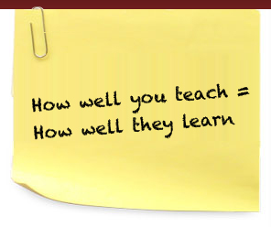
Instruction is the “how” the curriculum is delivered. A variety of research and evidence based strategies are used for both small and whole group and more specifically individualized instruction for those students who exhibit a need. A curriculum team is has been formed this year to think, pair and share ideas to maximize instruction with the intent of building stronger students academically in each grade. Professional development provided at the local and state levels help teachers and administrators develop instructional strategies and introduce research-based practices to expand their knowledge base.

Various computer-assisted resources are used throughout the district to help teachers and students with instructional needs. Technology based instruction is vital for appropriate instruction due to the fact that all required testing by the state of MS is online. The technology coordinator works with students, teachers and administrators in using instructional technology as a tool to effectively meet the needs of the students.

ASSESSMENT
ASD utilizes a triangulated approach to student assessment. The District believes that assessments provide timely information about student achievement and teacher effectiveness. Data from assessments are used to plan and differentiate instruction. School and district level assessments are given to gauge progress and effectiveness. Students are tested at strategic increments throughout the school year. The district utilizes the following assessments:
The following school-level assessments are used for Universal Screening, Progress Monitoring, Diagnostic Assessments, Instructional Planning, State Assessments, Graduation Requirements, etc.:
- Renaissance STAR reading and math (K-3)
- Classroom assessments
- MKAS2 (Kindergarten Readiness Assessment and 3rd Grade Reading Gate)
- Classworks (4th-8th)
- NWEA MAP (KG-8) (Measures of Academic Progress)
- MAAP (MS Academic Assessment Program) STATE ASSESSMENT
- AP Exams
- Accelerated Reader (K-8)
- Carnegie Units (completion of course requirements for high school graduation)
- Case 21 (4th-8th ELA, Math and Science)
(Algebra I, Biology, U.S. History and English II)
- ACT (11TH)

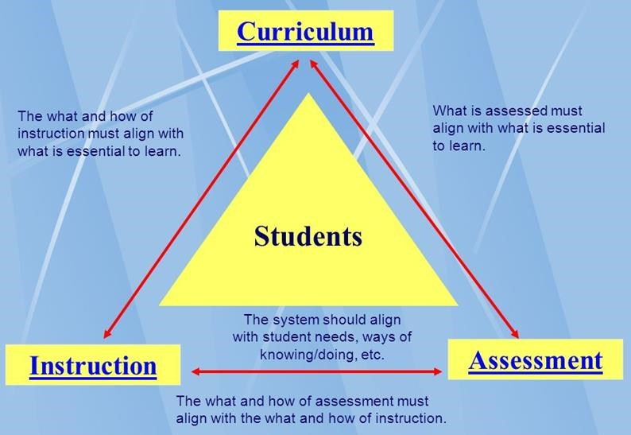

CURRICULM ALIGNMENT SUMMARY
ASD will do the following to ensure curriculum/instructions/assessments align
- The curriculum in ASD will be based on the MS Department of Education most recent framework/standards, including the MS and College and Career Readiness Standards. These standards are posted on ASD’s website.
- Professional Learning Communities (PLC) times documented with sign in sheets and agendas are used to align curriculum, instruction and assessment. Teachers are expected to conduct ongoing evaluation of the effectiveness of their instruction in relation to the expectations of the measurable outcome.
- Curriculum drives the instructions and data evaluates the instruction. Diagnostic assessments and screeners identify gaps in learning/instruction.
- Technology is used to support instruction appropriately and timely.
- Principals continuously monitor the effectiveness and alignment of curriculum, instruction and assessment by systematically reviewing lesson plans, providing structured feedback, and implementing processes to hold teachers accountable.

The following efforts ensure all teachers are using the current curriculum frameworks:
- The Curriculum Coordinator gives the most up-to-date Mississippi Department of Education Current Framework/Standards listing to all principals and assistant principals.
- The principals and assistant principals give each teacher his/her most up-to-date Mississippi Department of Education Current Framework/Standards.
- All instruction must be aligned with and follow the current curriculum. Teachers are provided with links to the current frameworks/standards, and these frameworks/standards are used to create pacing guides, assessments, and lesson plans.
- Administrators ensure that current curriculum objectives are posted daily by teachers and referenced in daily lesson plans.
- During observations (formal and informal), administrators check to ensure that the posted objectives are aligned to the current curriculum, that lessons are meaningful, and all activities are aligned to the current curriculum frameworks/standards.
- Administrators ensure that weekly lesson plans reflect links to the current curriculum.
- PLC times (documented with minutes and agendas) are used to further align curriculum, instruction, and assessments with current curriculum frameworks/standards.

MS Accountability Standard 20.2 The instructional management system includes a tiered instructional model in accordance with State Board of Education Policy 4300, including academic interventions, behavioral interventions, and Literacy-Based Promotion Act requirements.

MULTI TIERED SYSTEM OF SUPPORT (MTSS)
Aberdeen School District’s Multi-Tiered System of Support (MTSS) is an educational process that matches instructional, behavioral, and intervention strategies and supports to student needs. It includes a Response to Intervention (RtI) three-tier model of instruction, a dyslexia screening for kindergarten and first grade students, and a Literacy Based Promotion plan. Students’ movement throughout the Tier Process will be determined by reviewing data which indicates academic or behavior progress.
Tier I includes quality instruction and positive behavioral supports for all students designed to ensure students graduate ready for college and/or a career. Tier I instruction is aligned with the current Mississippi frameworks and provided by highly qualified teachers using research and/or evidence based instructional strategies. Schools use a universal or school-wide screening of all students to identify students who may need additional instructional and/or behavioral support to be successful.

Students who are not successful in Tier I and who show some risk of not meeting grade level academic and/or behavioral standards will receive additional Tier 2 supplemental instruction and/or behavioral supports and will be progress-monitored to determine if the intervention is successful. Tier II interventions provide an increased level of intensity for small groups of students in addition to the core instruction. Goals are established and progress monitoring is routinely done (bi-weekly, monthly, or as set by the intervention protocol) to determine if the intervention is helping the student. If progress is not made, the student is referred to the Teacher Support Team (TST) for Tier III supports.

Each school has a Teacher Support Team (TST) led by the principal or principal’s designee whose task is to review academic and behavioral data of students who are not being successful. The TST makes recommendations for Tier III interventions and meets periodically to review students’ progress. Universal screening, identification of needs, providing supplemental instruction or interventions, and progress monitoring are all components of our RtI process. At Tier 3, research or evidence-based academic and behavioral interventions are individualized to meet the specific needs of each student. Weekly progress monitoring data is reviewed to determine if the intervention is being successful, if it needs to be continued or modified, or if the student needs to be referred for a comprehensive evaluation.
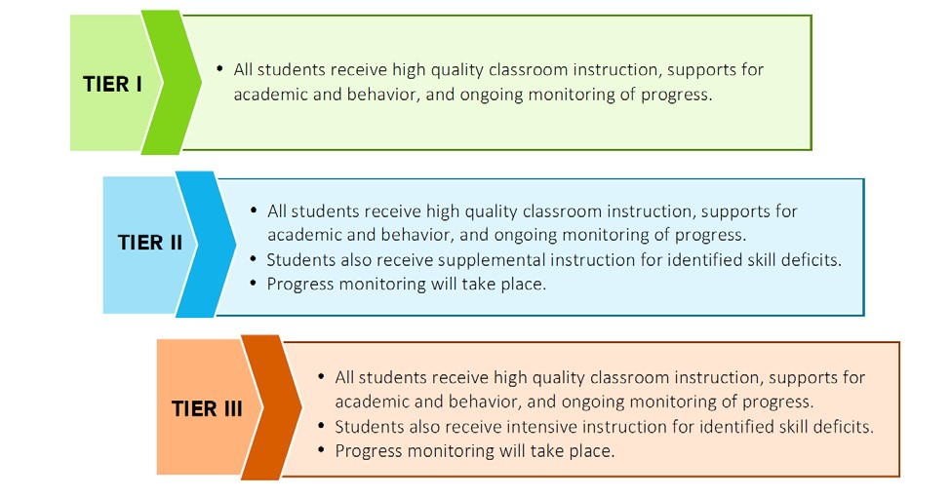

In accordance with the Literacy-Based Promotion Act of 2013, each public school student who exhibits a substantial deficiency in reading at any time, as demonstrated through: a. performance on a reading screener approved or developed by the MDE, or b. through locally determined assessments and teacher observations conducted in Kindergarten and Grades 1 through 3, or c. through statewide end-of-year assessments or approved alternate yearly assessments in Grade 3, must be given intensive reading instruction and intervention immediately following the identification of the reading deficiency. A student who was promoted from Grade 3 to Grade 4 under a good cause exemption of the Literacy-Based Promotion Act must be given intensive reading instruction and intervention. The intensive intervention must include effective instructional strategies and appropriate teaching methodologies necessary to assist the student in becoming a successful reader, able to read at or above grade level, and ready for promotion to the next grade.
A dyslexia screener must be administered to all students during the spring of their kindergarten year and the fall of their first grade year. The screening must include the following components: a. Phonological awareness and phonemic awareness; b. Sound symbol recognition; c. Alphabet knowledge; d. Decoding skills; e. Encoding skills; and f. Rapid naming (quickly naming objects, pictures, colors, or symbols (letters or digits) aloud.
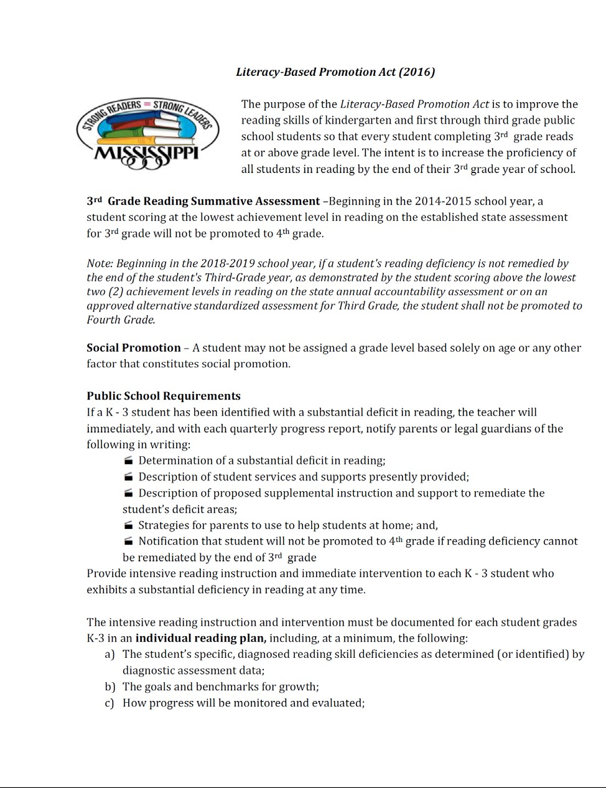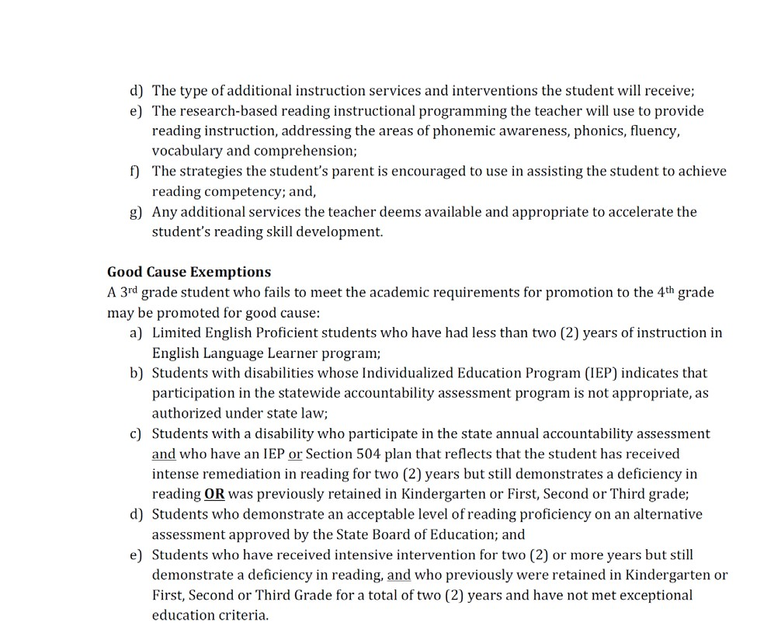
Behavior Screening and Supports
ASD understands that in order for learning to take place, an environment free from distractions and conducive to learning is a necessity. ASD uses the Nicholas Behavior Screener (NBC) to screen students twice a year and devise a behavioral plan to meet their individual needs.

- The NBC is a web- based program in which teachers are able to complete the screening device online and results/ scores are calculated through the web- based system. Additionally, a web- based database provides year- to- year student tracking. The district’s current screening device is paper- based and each student’s results must be individually calculated and that data is individually inputted to an excel chart which does take a considerable amount of time.

- The NBC provides a Behavior Screening Report with recommendations, which would be highly beneficial to teachers as Tier I, interventions/ supports. Additionally, it would provide School Psychologists, Behavior Specialists, and Counselors what interventions/ supports were effective or ineffective when developing Tier II interventions/ supports or when conducting a Functional Behavior Assessment. The district’s current screening device does not provide any type of report.

- The NBC provides data summaries at the district level, school level, and class level, which would be useful information/ data for district administrators, building- level administrators, and classroom teachers. The district’s current database is able to provide this information; however, it can only be completed using excel which is extremely time consuming as all data must be inputted individually.

- Concerning special education evaluations, the NBC would provide additional data in assisting the Multidisciplinary Evaluation Team in determining appropriate IDEA eligibility and assisting Individualized Education Program Committee’s with data in determining appropriate special education services.

- One of the most important features of the NBC is that it will immediately notify building- level administrators when a student is in need of emergency intervention. The district’s current screening device does not provide this feature.

It is administered in October and February of each school year; it is completed for all students in the district; it is able to serve as a progress monitoring tool in which the classroom teacher is able to complete the screening as many times as deemed warranted; however, the screening results are not quantifiable meaning that no type of score is provided from students.

Each school implements a Positive Behavioral Intervention Support (PBIS) system, which acknowledges positive behavior. Students who do not respond positively to the PBIS program will be provided additional behavioral supports. Tier II and III documentation will provide evidence of each school’s TST efforts. These supports can include, but are not limited to, establishing clear behavioral goals with meaningful rewards and consequences for behavior, providing peer or adult mentors, check-in/check-out systems of accountability, etc. Teachers are also expected to complete a Classroom Behavior Profile to determine Internalizing and Externalizing Behaviors. This profile is completed three times per year.

Positive Behavioral Interventions & Supports (PBIS)
What is PBIS?
PBIS is intervention practices & organizational systems for establishing the social culture, learning and teaching environment, and individual behavior supports needed to achieve academic and social success for ALL students.

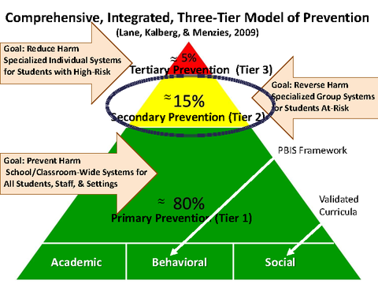
Primary
- Preventing the development of new cases of problem behaviors for all students and staff, across all settings (i.e., school-wide, classroom, and non classroom settings)
Secondary
- Reducing the number of existing cases of problem behaviors by establishing efficient and rapid responses to problem behavior
Tertiary
- Reducing the intensity and/or complexity of existing cases of problem behavior that are resistant to primary and secondary prevention efforts

Traditional Discipline vs. PBIS
Traditional Discipline | PBIS
Focus: Student’s problem behavior | Focus: Systems perspective to address identified needs
Goal: Stop undesirable behavior | Goal: Academic & social success(replacement skills)
Method: Primarily uses punishment(reactive) | Method: Alters environments, utilizes teaching & instruction, employs reinforcement procedures, & data management tracking system(proactive)

