Spring 2023 Survey Links and QR Codes

Employee Survey:

https://survey.k12insight.com/r/lL0wzU

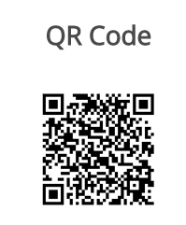

3-4 Student Survey:

https://survey.k12insight.com/r/CYnIn0

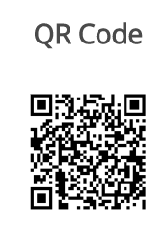

5-12 Student Survey:

https://survey.k12insight.com/r/J6A1DS

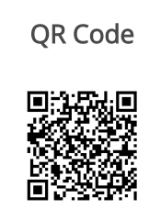

Community Survey:

https://survey.k12insight.com/r/OTFHvJ

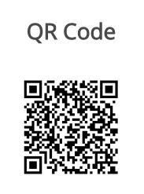

Parent Survey:

https://survey.k12insight.com/r/ICjBAt

