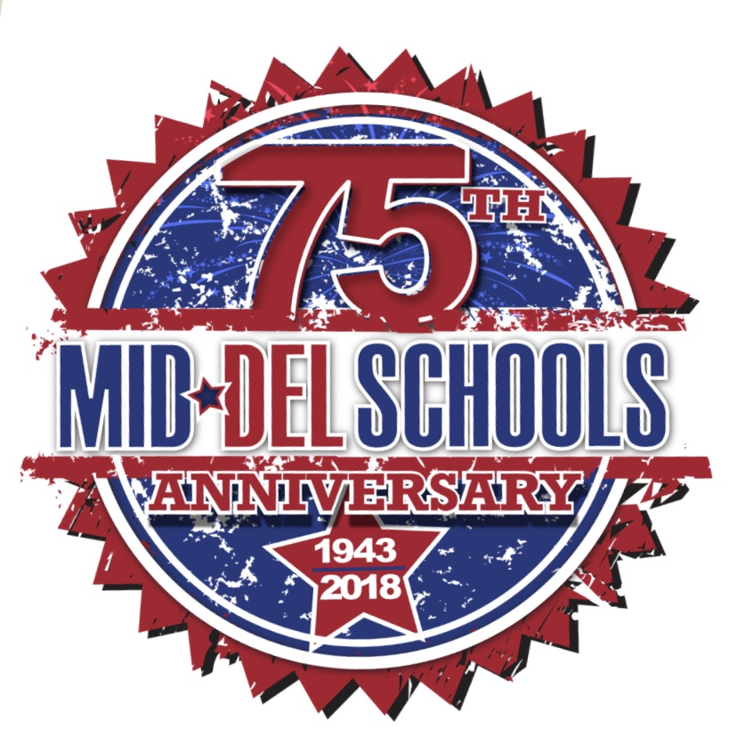
SOLDIER CREEK ELEMENTARY
February 2019

Monday | Tuesday | Wednesday | Thursday | Friday
1
Tiger Pride Rally
@ 9:30 in the gym

4  Natural Notes Practice  Starts back up for Spring! | 5  100TH DAY OF SCHOOL  Debate Practice  3:45-5:00 | 6  Natural Notes Practice  Counselor’s Day | 7  CAMS 5th grade  Pre-Enrollment in POD  @ 9:30  CAMS PRE-AP Parent Night at CAMS  @ 6pm  Debate Practice  3:45-5:00  Scholastic SPRING  BOOK FAIR  7th – 15th  Botball Training  3:30-5:00 | 8  Natural Notes Practice  9th (SATURDAY)  Debate Tourney  @ SC 9-12pm  Popcorn Day
11  Scholastic SPRING  BOOK FAIR  7th – 15th | 12  Parent Teacher Conference Evening  4pm – 7pm | 13  Natural Notes Practice  Scholastic SPRING  BOOK FAIR  7th – 15th | 14  Valentines Parties  PreK “Q & U” Wedding @ 2:30pm  Botball Training  3:30-5:00 | 15  Natural Notes Practice  Scholastic SPRING  BOOK FAIR  (Last Day!)
18  NO SCHOOL  *PRESIDENT’S DAY | 19  Parent Teacher Conference Evening  4pm – 7pm | 20  Natural Notes Practice | 21  CAMS 5th grade Pre-Enrollment on Computer in POD  @ 9:15am  Botball Training  3:30-5:00  Chess Practice/AM | 22  Natural Notes Practice  Popcorn Day
25  Natural Notes Practice | 26  SPRING PICTURE  DAY on stage | 27  Natural Notes Practice  Marathon Kids  3:30-4:30 | 28  MATH NIGHT  @ SC  5:30-7:00pm  Chess Practice/AM  Botball Training  3:30-5:00 | March 1st  Dr. Seuss Tiger Rally @ 9:30 in the gym

