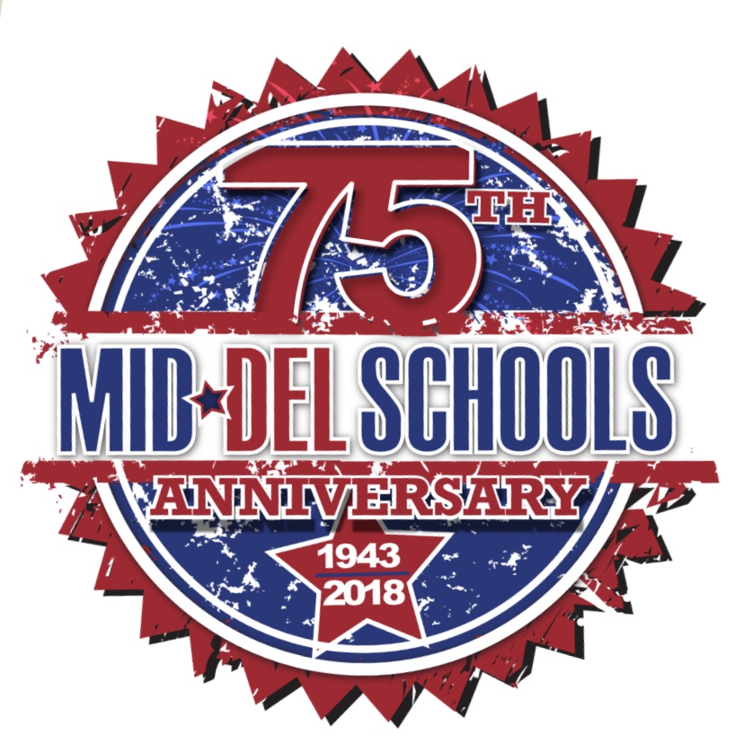
SOLDIER CREEK ELEMENTARY
January 2019

Monday | Tuesday | Wednesday | Thursday | Friday
 | 1 | 2 | 3 | 4
7  Professional Development Day for Teachers  NO SCHOOL | 8  Classes Resume for  2019  Start of the 3rd nine weeks  Debate Practice  3:45-5:00 | 9 | 10  Debate Practice  3:45-5:00  Botball Training  3:30-5:00 | 11  Popcorn Day
14 | 15  Debate Practice  3:45-5:00  Botball Training  3:30-5:00 | 16 | 17  Class/Group Picture Day!  Debate Practice  3:45-5:00  Botball Training/Parent Meeting  3:30-5:00 | 18  *19th (Saturday)  Mid-Del Botball Challenge  8am-12pm  @MWC Elem.
21  NO SCHOOL  Martin Luther King Jr. Day | 22  Debate Practice  3:45-5:00 | 23  Marathon Kids  3:30-4:30 | 24  Debate Practice  3:45-5:00  Botball Training  3:30-5:00 | 25  Popcorn Day
28 | 29  Debate Practice  3:45-5:00 | 30 | 31  Debate Practice  3:45-5:00 | February 1st  Tiger Rally  @ 9:30am in Gym

