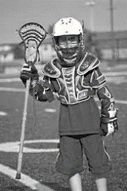
Boys Youth Lacrosse
7 Years of Age – High School
Registration is NOW OPEN!
www.champaignlacrosse.com
Champaign County Lacrosse Club is a non-profit lacrosse club dedicated to developing outstanding skills and sportsmanship in a safe, positive and fun environment.
- Do I need to know how to play? No. Come and learn a new sport!
- How long is the season? March through early-June.
- Where do we practice? Seaman Field by Champaign Centennial H.S.
- Where can I get more information? (217) 714-7975 CCLAXClub
champaigncountylax@gmail.com www.champaignlacrosse.com
JOIN US! Lacrosse Clinics February 3rd /17th Parent meeting February 24th Coaching Class- March 2nd /3rd

