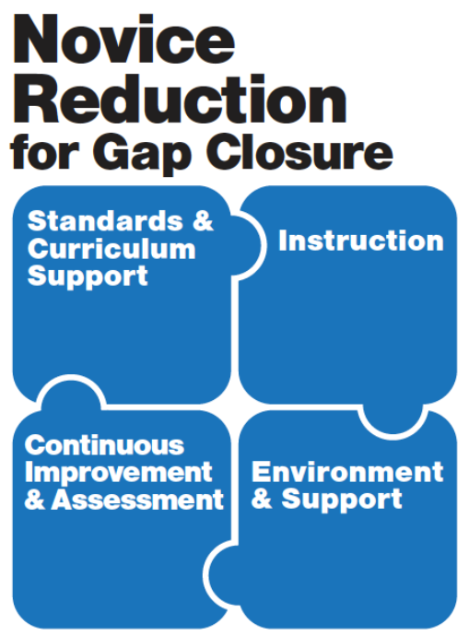 | Continuous Improvement Planning Cycle  Phase 2:  Needs Assessment  *This is a generalized planning tool, not specific to a grade span. Content within the workbook is not locked and, therefore, is fully adaptable.

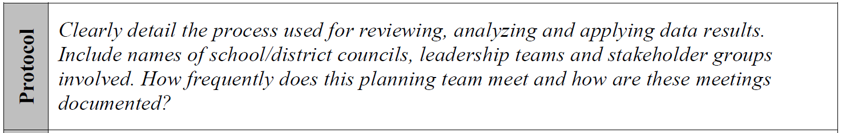
Step 1: Protocol
List the name and position of each member of the planning team involved in the Phase 2 – Needs Assessment. Additional members beyond 10 can be added to this sheet, as needed. Remember, it is important that your Core Team remain constant through this process, but it is understandable that additions to the team may be needed as you move through the phases of the cycle of continuous improvement.
Team Member Name | Shareholder Position
Tonya Lewis | Teacher
Jamee Markwell | Teacher
Amy Young | Teacher
Heather Stevens | Teacher
Tiffany Lewis | Teacher
Elizabeth Guthrie | Teacher
Chelsie Dagnan | Teacher
Traci Lausier | Teacher
Linda Hoskins | Teacher
Angela Wagner | Teacher
Keri Legrand | Teacher
Mark Bradford | Teacher
Maintain active logs of planning sessions with your team members. The table below can assist you in capturing this documentation in a concise manner.
Date | Team Members Present | Meeting Duration | Location Site
10/24/2017 | All teachers listed above. | 3:30-4:15 | Sandy Hook Elementary
*Please adjust table for more space if needed.
Describe your team’s process in reviewing and analyzing data sources: What sources did you utilize in your data review and analysis? How did you apply your data findings to determine your needs? (i.e. How did you prioritize your “work”?) *This step is best completed after all analysis has been finished.

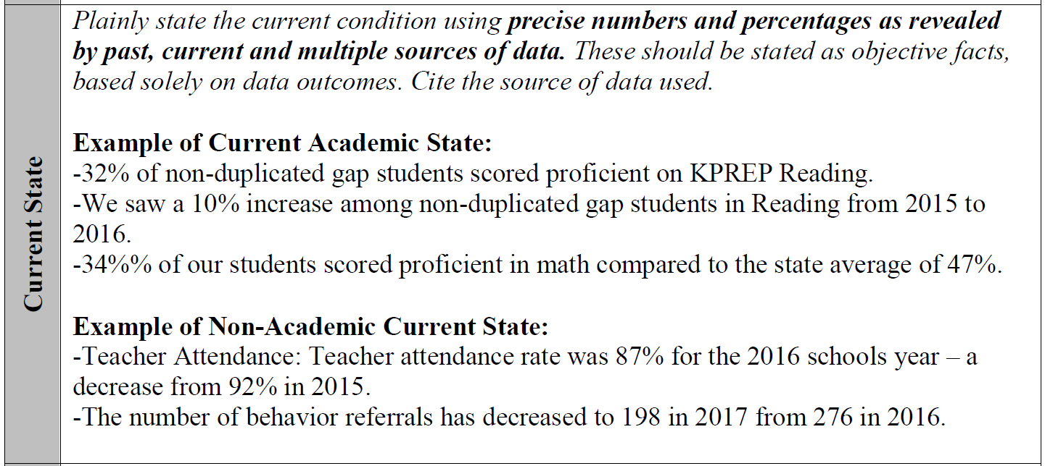
Step 2: Identifying the Current State
To complete this portion of current state identification, several data tools have been provided within this section of the Phase 2 – Needs Assessment Workbook. If your school/district already has an established data review process that is systematic, repeatable and recognizable by your team’s shareholders, you may utilize that system and its tools to review and analyze your quantitative academic and non-academic data. The data tools provided in this workbook are not all-inclusive of the multiple measures available to schools and districts for analysis.
District Data Disaggregation Tool:
Kindergarten Readiness
CCR
Graduation Rate

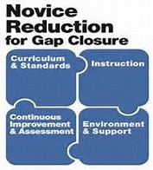
Brigance: Kindergarten Readiness
All Student District Data

 | 2014-2015 | 2015-2016 |  | 2016-2017
Enrollment | 61 |  | 38 |  | 33
# Tested | 60 |  | 37 |  | 33
Participation Rate | 98.4 |  | 97.4 |  | 100
Not Ready | 30 |  | 30 |  | 22
Kindergarten Ready | 30 |  | 7 |  | 11

Understanding CCR Information
District Average 15-16
State Average 15-16
Was the Delivery Target Met for 15-16? | YES / NO
District Average 16-17
State Average 16-17
Was the Delivery Target Met for 16-17? | YES / NO

Understanding Graduation Rate Information
District Average 15-16
State Average 15-16
Was the Delivery Target Met for 15-16? | YES / NO
District Average 16-17
State Average 16-17
Was the Delivery Target Met for 16-17? | YES / NO

District/School Data Disaggregation Tool:
Gap

Understanding Gap Information Reading Math
Total # of students with an IEP scoring below proficiency | 18 | 24
Total # of students F/R Lunch Scoring below proficiency | 72 | 81
Total # of African American students scoring below proficiency | 0 | 0
Total # of Two or More Races students scoring below proficiency | 0 | 0
Total # of English Learners students scoring below proficiency | 0 | 0
Total # of American Indian students scoring below proficiency | 0 | 0
Total # of Hispanic students scoring below proficiency | 0 | 0
Total Number of students in the Non-Duplicated Gap Group scoring below proficiency | 71 | 81
Gap Group Students with an IEP: # Gap Students P/D | 12 | 6
Gap Group F/R Lunch: # Gap Students P/D | 44 | 35
Gap Group African American: # Gap Students P/D | 0 | 0
Gap Group Two or More Races: # Gap Students P/D | 0 | 0
Gap Group English Learners: # Gap Students P/D | 0 | 0
Gap Group American Indian: # Gap Students P/D | 0 | 0
Gap Group Hispanic: # Gap Students P/D | 0 | 0
Total Number of students in the Non-Duplicated Gap Group P/D | 46 | 36

District/School Data Disaggregation Tool:
Proficiency – Converting Percentages into Numbers

15-16/16-17
Reading
Novice | Apprentice | Proficient | Distinguished
29.5/29.6 | 26/30.3 | 33.6/33.6 | 11/6.6
Mathematics
Novice | Apprentice | Proficient | Distinguished
30.1/27 | 43.2/42.1 | 24/28.3 | 2.7/2.6
Science
Novice | Apprentice | Proficient | Distinguished
Social Studies
Novice | Apprentice | Proficient | Distinguished
19.5/17.5 | 39/35 | 29.3/42.5 | 12.2/5
Writing
Novice | Apprentice | Proficient | Distinguished
32.9/40 | 32.9/32.5 | 32.9/25 | 1.3/2.5

District/School Data Disaggregation Tool:
Proficiency – Notable Changes in Data since Previous Year

Reading
Novice | Apprentice | Proficient | Distinguished
+ / - / no change __+.1______ | + / - / no change __+4.3____ | + / - / no change ________ | + / - / no change _-4.4___
Mathematics
Novice | Apprentice | Proficient | Distinguished
+ / - / no change ___-3.1____ | + / - / no change __-1.1_____ | + / - / no change __+4.3______ | + / - / no change _-.1____
Science
Novice | Apprentice | Proficient | Distinguished
+ / - / no change ________ | + / - / no change ________ | + / - / no change ________ | + / - / no change _______
Social Studies
Novice | Apprentice | Proficient | Distinguished
+ / - / no change ___-2_____ | + / - / no change ___-4_____ | + / - / no change ___+13.2__ | + / - / no change ___ -7.2_
Writing
Novice | Apprentice | Proficient | Distinguished
+ / - / no change ____+7.1__ | + / - / no change ___-.4_____ | + / - / no change ___-7.9____ | + / - / no change ___+1.2_

Nonacademic Data Review
School Year 2015-2016

 | Student Attendance | Teacher Attendance | Suspensions |  | Retentions | Behavior Referrals | Expulsions | Other
 |  |  | In-school | Out of School
July |  |  | 0 | 0 |  | 0 | 0
August | 95.56% |  | 0 | 0 |  | 12 | 0
September | 93.94% |  | 0 | 1 |  | 11 | 0
October | 92.07% |  | 0 | 3 |  | 11 | 0
November | 92.03% |  | 0 | 3 |  | 5 | 0
December | 91.28% |  | 0 | 1 |  | 9 | 0
January | 93.94% |  | 1 | 0 |  | 5 | 0
February | 89.87% |  | 0 | 0 |  | 1 | 0
March | 88.63% |  | 0 | 0 |  | 2 | 0
April | 94.93% |  | 0 | 3 |  | 7 | 0
May |  |  | 0 | 0 |  | 2 | 0
June |  |  | 0 | 0 |  | 0 | 0
OVERALL | 92.32 |  | 1 | 11 | 13 | 65 | 0

School Year 2016-2017

 | Student Attendance | Teacher Attendance | Suspensions |  | Retentions | Behavior Referrals | Expulsions | Other
 |  |  | In-school | Out of School
July |  |  | 0 | 0 |  | 0 | 0
August | 95.39% |  | 0 | 3 |  | 6 | 0
September | 92.85% |  | 0 | 0 |  | 11 | 0
October | 93.81% |  | 0 | 1 |  | 7 | 0
November | 92.99% |  | 0 | 1 |  | 14 | 0
December | 92.19% |  | 0 | 1 |  | 2 | 0
January | 91.95% |  | 0 | 0 |  | 6 | 0
February | 90.18% |  | 0 | 0 |  | 4 | 0
March | 92.29% |  | 0 | 0 |  | 10 | 0
April | 93.89% |  | 0 | 2 |  | 7 | 0
May | 90.7% |  | 0 | 3 |  | 7 | 0
June |  |  | 0 | 0 |  | 0 | 0
OVERALL | 92.82% |  | 0 | 11 | 14 | 74 | 0

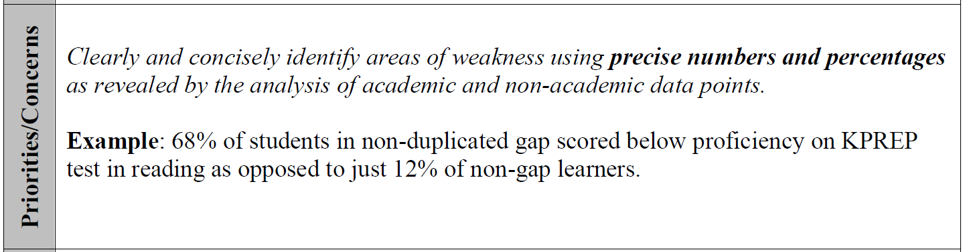
Step 3: Determining Priorities and Concerns
Using the findings from your quantitative academic and non-academic data review, use the data questions listed below to explain your current “as is” and next steps to increase proficiency and address gap closure.
District Data Disaggregation Tool:
Using Data Questions to Define the As-Is- State of Student Achievement in Your School/District

- What does the data tell us?

- What does the data not tell us?

3. What are the causes for concern?

- What are our projected next steps to increase proficiency and close gaps in achievement?

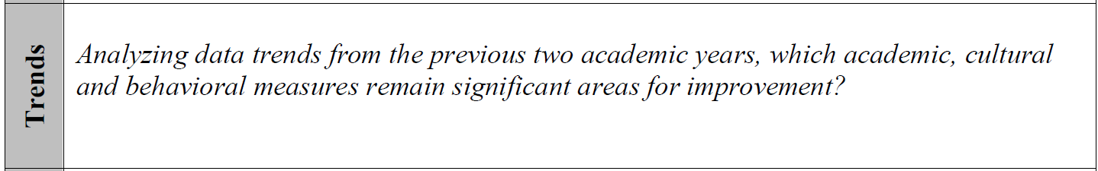
Step 4: Identifying Your Data Trends
To dig deeper into your “as is” state, it is important to consider how performance has fared across time. Using the School Report Card for your school/district, present your data to make your trends more visual. This data display and analysis assists you in the beginning steps of “systems thinking.”
Example

To enter data into the chart, place your cursor on the chart and right click. A window will open. Select “Edit Data,” then select “Edit Data in Excel” from the window as well. This will allow you to enter the data into the chart easily. The chart has been created to graph as you enter data.

To enter data into the chart, place your cursor on the chart and right click. A window will open. Select “Edit Data,” then select “Edit Data in Excel” from the window as well. This will allow you to enter the data into the chart easily. The chart has been created to graph as you enter data.

To enter data into the chart, place your cursor on the chart and right click. A window will open. Select “Edit Data,” then select “Edit Data in Excel” from the window as well. This will allow you to enter the data into the chart easily. The chart has been created to graph as you enter data.

To enter data into the chart, place your cursor on the chart and right click. A window will open. Select “Edit Data,” then select “Edit Data in Excel” from the window as well. This will allow you to enter the data into the chart easily. The chart has been created to graph as you enter data.

To enter data into the chart, place your cursor on the chart and right click. A window will open. Select “Edit Data,” then select “Edit Data in Excel” from the window as well. This will allow you to enter the data into the chart easily. The chart has been created to graph as you enter data.

To enter data into the chart, place your cursor on the chart and right click. A window will open. Select “Edit Data,” then select “Edit Data in Excel” from the window as well. This will allow you to enter the data into the chart easily. The chart has been created to graph as you enter data.

To enter data into the chart, place your cursor on the chart and right click. A window will open. Select “Edit Data,” then select “Edit Data in Excel” from the window as well. This will allow you to enter the data into the chart easily. The chart has been created to graph as you enter data.

To enter data into the chart, place your cursor on the chart and right click. A window will open. Select “Edit Data,” then select “Edit Data in Excel” from the window as well. This will allow you to enter the data into the chart easily. The chart has been created to graph as you enter data.

Cultural Trends – Use the space provided to describe the trends for this data measure. Remember, you analyzed this data in the Continuous Improvement Diagnostic - Phase 1: TELL Survey. Use those findings to describe the changes evident across time. You may also utilize Val-Ed survey information here, if available.

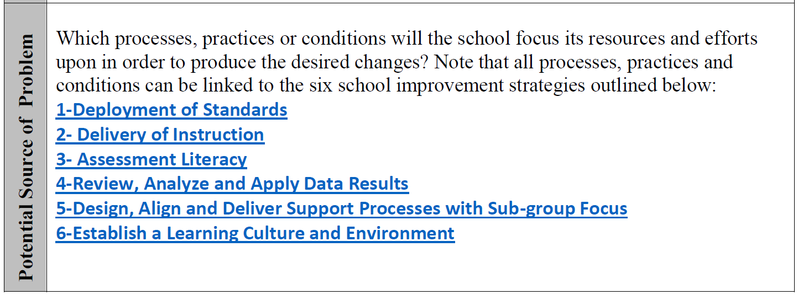

It is important to remember that student data is ONLY the reflection of current conditions of the KEY PROCESSES in schools/districts. In order to target work to the appropriate systemic area(s), teams MUST consider what needs repaired and where it falls within the scope of the school/district: the work (process), the worker (practice), or the workplace (condition).

As you think about each question within the Key Core Work Processes, provided on the following six (6) pages of this workbook, consider these guiding questions: What is working well? Are these items monitored and evaluated for effectiveness? Do we know if this practice is impacting ALL students in EVERY classroom?

As you work through the six (6) Key Core Work Processes, KCWPs, use the following system to analyze your current “as is” state within EACH of the KCWPs.

- If you can solidly respond with a definitive “yes,” then highlight those questions GREEN. This means systems are in proper alignment and have continuous monitoring methods in place.
- If there are practices that are not systematically in place throughout your building/district, or are otherwise spotty, then you are in the implementation stage and you should highlight these questions YELLOW.
- Lastly, there are some items within each question that may NOT be on the radar as of the present time. This could be due to “will” levels, skill levels, or a combination of both – essentially it is not on the front burner. If this is so, then highlight these items RED/PINK.
- Working well, monitored and evaluated for effectiveness
- Impacting all students in every classroom
- Not systematically in place
- Implementation is spotty
- More conversations needed
- Not on the radar as of right now due to “will” and/or skill levels,
- Not a priority at this time. This may be due to prerequisite activities MUST occur beforehand.

CLASSROOM EVALUATION OF KENTUCKY DEPARTMENT OF EDUCATION KEY CORE WORK PROCESSES FOR NOVICE REDUCTION

Design and Deploy Standards
KEY ELEMENTS OF THIS PROCESS | GUIDING QUESTIONS FOR QUALITY PRACTICE | EVIDENCE OF PRACTICE BEING IN PLACE
The Kentucky Academic Standards ensure that all districts and schools have access to the same outline of expectations. The Kentucky Academic Standards are in Kentucky statute as what is to be taught. It is imperative that schools continually assess, review, and revise school curricula to support the assurance that all students have the knowledge, skills, and dispositions for future success. Standards and curriculum are fundamental to each and every student. | - What is the assurance the current curriculum is valid (e.g., aligned to state/essential standards, components that support the instruction and assessment, paced with accuracy)?  - What monitoring systems are in place to ensure the curriculum is taught at a high level of fidelity (e.g., complete document is consistently used by all staff, the intent of the standard is preserved)  - What processes do teachers use to create clear and precise learning targets for students?  - What systems are in place for teachers to readjust the curriculum (content and pacing) to meet student needs based on assessment results (formative and summative)?  - What is the established protocol for reviewing and revising the curriculum beyond pacing (e.g., how often, who, what is completed)?  - How is the process for vertical curriculum work ensured, including introduction, development, and mastery of standards?
__LEVERAGE Greatest Impact on NR
__CONCERN Most 5 4 3 2 1 Least

CLASSROOM EVALUATION OF KENTUCKY DEPARTMENT OF EDUCATION KEY CORE WORK PROCESSES FOR NOVICE REDUCTION

Design and Deliver Instruction
KEY ELEMENTS OF THIS PROCESS | GUIDING QUESTIONS FOR QUALITY PRACTICE | EVIDENCE OF PRACTICE BEING IN PLACE
All schools and districts are to ensure their instructional program is intentional and of the highest quality. Tier I is the highly effective, culturally responsive, evidence-based core instruction, provided to all students in the classroom. Teachers must implement evidence-based curriculum and/or strategies with fidelity for both academic and behavioral instruction. It is the responsibility of the teacher to determine how a student learns best. | - What systems/processes do teachers have in place to ensure Tier I instruction and assessments meet the intent of the adopted standards?  - What systems of collaboration are in place in order to meet the Tier I educational needs of all students?  - What is the protocol for ensuring Tier I and Tier II instructional needs are met and next steps for improvement are identified?  - How does the teacher monitor the learning before, during, and after instruction? (Explicit Instruction)  - What process is in place to ensure your students have an understanding of learning expectations (e.g., learning targets, goal setting, purpose) and know the criteria for success?  - What is the process classroom teachers use when measuring instructional effectiveness based on student data?  - How does the teacher ensure lessons are designed with students’ cultural, social, and developmental needs in mind?  - How do teachers determine the most appropriate and effective high yield strategies in order to ensure congruency to the intent of the learning target?  - What system is in place to ensure students take responsibility for their own learning?  - How does the teacher ensure cognitive engagement versus passive or active engagement?  - What strategies and programs are implemented in classrooms and how do you measure their effectiveness on student achievement?
__LEVERAGE Greatest Impact on NR
__CONCERN Most 5 4 3 2 1 Least
CLASSROOM EVALUATION OF KENTUCKY DEPARTMENT OF EDUCATION KEY CORE WORK PROCESSES FOR NOVICE REDUCTION

Design and Deliver Assessment Literacy
KEY ELEMENTS OF THIS PROCESS | GUIDING QUESTIONS FOR QUALITY PRACTICE | EVIDENCE OF PRACTICE BEING IN PLACE
Classroom Assessment for Student Learning emphasizes assessment for learning strategies and:  1. Provides effective targeted, penalty free practice for students  2. Enables students to take responsibility for their own learning  3. Improves student motivation and enables students to be in control of their own learning  4. Improves student achievement (The previous three result in improved student achievement)  5. Moves from a grading culture to a learning culture (Engaging students in activities automatically moves attention away from grading to learning) | - How do teachers ensure the creation of a balanced assessment system?  - What is the teacher’s system of keeping the stakeholders informed of assessment results?  - How are the validity of assessments (formative and summative) monitored to ensure congruency to the standards/targets?  - What processes are used by teachers to deconstruct standards to ensure learning targets are congruent to the standards and are the laser focus of instruction?  - Describe the process teachers use to make learning targets clear for students?  - How do teachers determine which assessment design will best evaluate the level of student learning? (selected response, written response, performance assessment, personal communication)  - What type of feedback is given to students on their progression of learning?  - How do teachers utilize formative and summative information for increased student achievement?  - How do teachers monitor and evaluate the use of assessment results to guide instruction and determine the grouping of students?  - How do teachers monitor and evaluate achievement as related to the learning target and standards?  - How does the grading system communicate student learning accurately?  - What systems do teachers have in place so that students can communicate how they track and evaluate their progress and set goals?
__LEVERAGE Greatest Impact on NR
__CONCERN Most 5 4 3 2 1 Least
CLASSROOM EVALUATION OF KENTUCKY DEPARTMENT OF EDUCATION KEY CORE WORK PROCESSES FOR NOVICE REDUCTION

Review, Analyze, and Apply Data
KEY ELEMENTS OF THIS PROCESS | GUIDING QUESTIONS FOR QUALITY PRACTICE | EVIDENCE OF PRACTICE BEING IN PLACE
Schools and districts must have a repeatable/uniform system for knowing the data. School leaders must ensure a uniform way of examining and interpreting all of the data that is in their schools in order to determine priorities for school success. Likewise, teachers must have an established system for examining and interpreting all of the data that is in their classrooms (e.g., formative, summative, benchmark, and interim assessment data) in order to determine priorities for individual student success. | - How do teachers use these different types of assessment to ensure a balanced approach:  Formative  Summative  Interim  - How do teachers ensure that assessments are of high quality and aligned to the rigor of the standards, resulting in quality data?  - What questions are teachers trying to answer with the data that they collect?  - What systems are in place to ensure that student data is collected, analyzed, and being used to drive classroom instruction?  - How do teachers use data to determine students’ needs (e.g., movement through the tiers of intervention, grouping/regrouping, teacher placement, scheduling)?  - What system is in place for teachers to monitor students’ progress on standards in order to know when they have achieved mastery?  - How do students know where they are in their own progression of learning?  - What systems are in place to ensure that students are actively involved in knowing their own data and making decisions about their own learning?  - What processes are in place to ensure students have a voice in the monitoring/evaluation of classroom improvement cycles?
__LEVERAGE Greatest Impact on NR
__CONCERN Most 5 4 3 2 1 Least
CLASSROOM EVALUATION OF KENTUCKY DEPARTMENT OF EDUCATION KEY CORE WORK PROCESSES FOR NOVICE REDUCTION

Design, Align, Deliver Support Processes
KEY ELEMENTS OF THIS PROCESS | GUIDING QUESTIONS FOR QUALITY PRACTICE | EVIDENCE OF PRACTICE BEING IN PLACE
School leaders must establish a model to monitor and evaluate effectiveness in order to improve problems and improve the system rather than function under crisis management. Continuous improvement uses data to improve work processes to support student learning. The alignment of CSIPs should include the use of resources to support best practice strategies. Resources are aligned to needs in order to make all systems work together for continuous improvement and success. A system is in place to monitor student data regularly and to ensure a continuous improvement model that monitors what is working. | - What processes do teachers currently have in place that ensure behavioral interventions are taking place and monitored to meet the needs of all students?  - How do teachers positively reinforce desired behaviors?  - What system or processes are in place to ensure appropriate academic interventions are taking place to meet the needs of all students?  - What data is monitored and evaluated to ensure high levels of teacher effectiveness and student learning?  - What data points inform modification to curriculum and instructional practices?  - How does the school leadership (teachers and leaders) measure the effectiveness of current programs and initiatives implemented in classrooms and school?  - How does school leadership ensure that resources are aligned with the needs identified in the CSIP and will effectively address those needs?  - What system is in place to involve multiple stakeholders (e.g., teachers, staff members, parents, students, community partners) in CSIP planning and measuring of progress toward attaining the goals?  - How do stakeholders determine which best practice strategies (e.g., interventionist, Read 180, ALEKS, modifications to schedules) will meet the identified needs of the students?
__LEVERAGE Greatest Impact on NR
__CONCERN Most 5 4 3 2 1 Least

CLASSROOM EVALUATION OF KENTUCKY DEPARTMENT OF EDUCATION KEY CORE WORK PROCESSES FOR NOVICE REDUCTION

Establishing Learning Culture and Environment
KEY ELEMENTS OF THIS PROCESS | GUIDING QUESTIONS FOR QUALITY PRACTICE | EVIDENCE OF PRACTICE BEING IN PLACE
The environment in which students learn and the support they are offered to meet their individual needs is just as important as solid curriculum, instruction, and systems of continuous improvement. Students need to know they are safe and their needs will be met, no matter what those needs are. This is how you know that your environment is one that creates support for positive behavior. Schools must ensure students are learning at the optimal level in a safe learning environment. | - How does school leadership ensure everyone in their school building operates under a unified definition of cultural responsiveness?  - How do teachers ensure that their classrooms are culturally responsive to student needs?  - What systems do teachers have in place to address culture in their classrooms?  - How do teachers’ behavior systems support an environment where everyone feels safe and wants to learn?  - What system is in place to address reports of bullying in the school and individual classrooms?  - What processes do teachers have in place to identify potential bullies and those at risk of being bullied?  - What supports are currently in place to assist students in decision making in regard to behavioral needs/goals?  - What processes are in place to communicate with parents in order to address barriers to learning?  - What processes are in place to communicate with students in order to address barriers to learning?
__LEVERAGE Greatest Impact on NR
__CONCERN Most 5 4 3 2 1 Least

Select the Key Core Work Process being assessed through this analysis:
- Design and Deploy Standards  - Design and Deliver Instruction  - Design and Deliver Assessment Literacy |  |  |  | - Review, Analyze and Apply Data  - Design, Align and Deliver Support Services  - Establishing Learning Culture and Environment
Supporting Evidence | Strengths |  |  |  | Weaknesses | Supporting Evidence
Supporting Evidence | Opportunities |  |  |  | Threats | Supporting Evidence

Using the following questions, complete the SWOT analysis on the KCWPs that you identified as your area(s) of concern/weakness on the preceding page. The SWOT is an analysis tool that is used to assist schools/districts in understanding their STRENGTHS and WEAKNESSES, and additionally assists in the identification of OPPORTUNITIES open to the school/district and THREATS that the school/district might need to be prepared to face as they plan next steps to address improvement needs.

Internal  Consideration  Factors | Favorable | Unfavorable
 | Strengths | Weaknesses
 | - What advantages does your school or district have?  - What do you do better than others?  - What unique capabilities and resources do you possess?  - What do others perceive as your strengths? | - What could you improve?  - What should you avoid?  - What do your competitors do better than you?  - What can you improve given the current situation?  - What do others perceive as your weaknesses?
External  Consideration  Factors | Opportunities | Threats
 | - What trends or conditions may positively impact you?  - What opportunities are available to you? | - What obstacles do you face?  - What are your competitors doing that may impact you?  - Do you have solid financial support?  - What impact do your weaknesses have on the threats to you?

Once you have completed your SWOT analysis, it is time to take a closer look at where the “action for improvement” is needed. The following graphic was provided within the Continuous Improvement Diagnostic – Phase 1 Workbook and should look familiar to you. As you review your SWOT, consider each of these action areas, and classify each of your SWOT responses as one of these work needs. Mark your identification at the end of each response within your SWOT analysis.

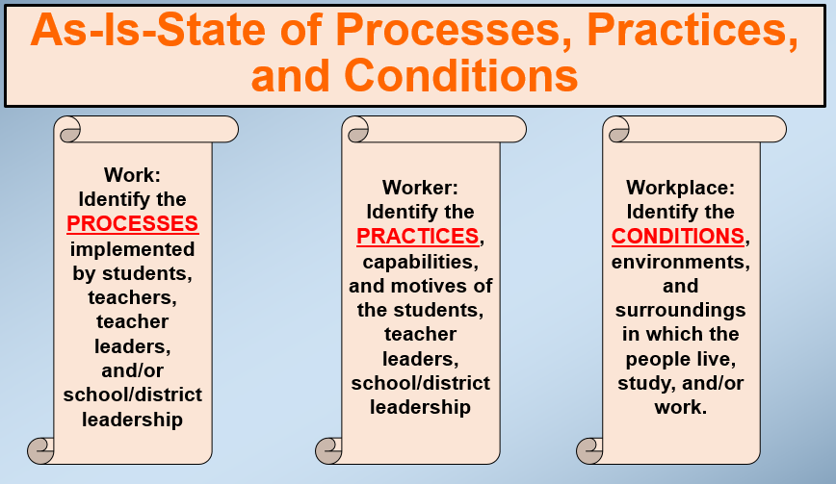

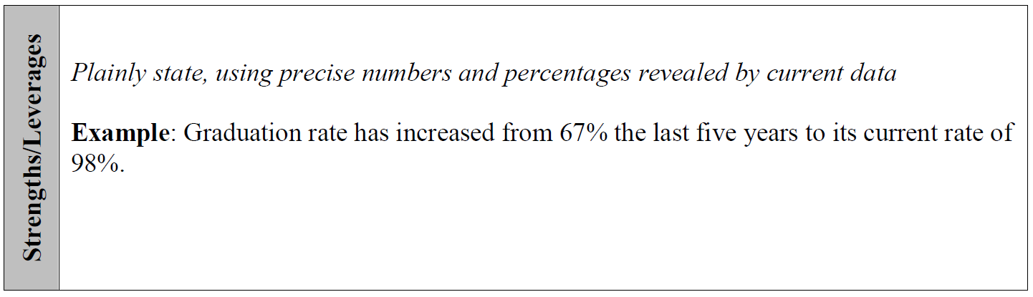
Step 5: Identifying Your Strengths/Leverages
Using the findings from your qualitative and quantitative review, use the data questions listed below to explain your current “as is” and existing strengths to celebrate as you work towards proficiency or as you redefine excellence in order to sustain high performance levels of academic success.
District Data Disaggregation Tool:
Using Data Questions to Define the As-Is- State of Student Achievement in Your School/District

- What are the causes for celebration?

- What are your strengths as you move forward with making continuous improvement a “living” entity in our school/district operations?

This page has been provided for additional narrative regarding your data and next steps.

