Monday | Tuesday | Wednesday | Thursday | Friday
3 Cinnamon Raisin Bagel, Fruit, Juice, Milk  Cheesy Chicken Tortilla Soup  WG Breadstick  Seasoned Green Beans  Orange Pepper Strips w/Dip  Fresh Fruit  Frozen Fruit Cup  Milk | NATIONAL TACO DAY  4 Breakfast Burrito, Fruit, Juice, Milk  Tacos  Sour Cream and Salsa  Corn on the Cob  Refried Beans  Fresh Fruit  Pineapple Chunks  Milk | 5 Cinnamon Toast, Fruit, Juice, Milk  Hot Ham and Cheese  Tater Tots  Cooked Broccoli  Fresh Fruit  Peaches  Milk | 6 Cereal, Banana, Juice, Milk  Corndog  Sweet Potato Fries  Cucumber Slices w/Dip  WG Chips  Fresh Fruit  Mandarin Oranges  Milk | 7 French Toast Sticks, Fruit, Juice, Milk  Pizza  Peas  Carrots w/Dip  Blueberry Cobbler  Pears  Milk
10 Egg Patty, Toast w/Butter & Jelly, Sausage, Fruit, Juice, Milk  FUNYUNS Crunch Burger  French Fries  Broccoli w/Dip  Fresh Fruit  Applesauce  Milk | 11 Strawberry Pancake Yogurt Parfait, Juice, Milk  Lasagna  WG Roll  Glazed Carrots  Mixed Vegetables  Fresh Fruit  Mixed Fruit  Milk | 12 Cinnamon Toast Crunch Breakfast Bar, Fruit, Juice, Milk  Chicken Legs  Mashed Potatoes  WG Roll  Baked Beans  Fresh Fruit  Pineapple Chunks  Milk | 13 Banana Bread, Fruit, Juice, Milk  Chicken Quesadillas  Salsa and Sour Cream  Corn  Cherry Tomatoes w/Dip  Fresh Fruit  Pears  Milk | 14 Mini Waffles, Fruit, Juice, Milk  Pepperoni Roll  Seasoned Green Beans  Cauliflower w/Dip  Jell-o w/Fruit  Fresh Fruit  Milk
17 Chicken Biscuit, Fruit, Juice, Milk  Chili  Cornbread  Baked Potato  Green Beans  Fresh Fruit  Pineapple Chunks  Milk | 18 Cereal Bar, Yogurt, Fruit, Juice, Milk  Crispy Chicken Sandwich  Tomato and Lettuce  Tater Tots  Spinach  Fresh Fruit  Applesauce  Milk | 19 Fruit Strudel, Fruit, Juice, Milk  Vegetable Soup  Grilled Cheese  Carrots w/Dip  Cheese Stick  Fresh Fruit  Mixed Fruit  Milk | 20 Strawberry Cream Cheese Bagel, Fruit, Juice, Milk  Macaroni and Cheese  Cucumber Slices w/Dip  Cooked Broccoli  Yogurt  Fresh Fruit  Peaches  Milk | 21  NO STUDENTS
24  NO STUDENTS | 25 Cinnamon Roll, Fruit, Juice, Milk  Scrambled Eggs  Sausage Patty  WG Biscuit  Hash Browns  Grape Tomatoes  Cooked Apples  Fresh Fruit  Milk | 26 Nutri- Grain Bar, Yogurt, Fruit, Juice, Milk  Hotdog w/Chili  Cole Slaw  French Fries  Baked Beans  Fresh Fruit  Mandarin Oranges  Milk | 27 Cereal, Banana, Juice, Milk  Meatball Sub  Sweet Potato Tots  Green Pepper Strips w/Dip  Fresh Fruit  Applesauce  Milk | 28 WG Pop-Tarts, Fruit, Juice, Milk  Salisbury Steak  Mashed Potatoes  Broccoli Parmesan  WG Roll  Orange Sidekick  Fresh Fruit  Milk
31 Pancakes w/Syrup, Fruit, Juice, Milk  Fish Sticks  Creamy Coleslaw  French Fries  Seasoned Green beans  Halloween Cookie  Fresh Fruit  Pineapple Chunks  Milk | Birthday Popcorn OCTOBER 19   | Grades 6-12 are Offer vs. Serve Guidelines on back of menu.  OCTOBER 4TH IS NATIONAL TACO DAY!  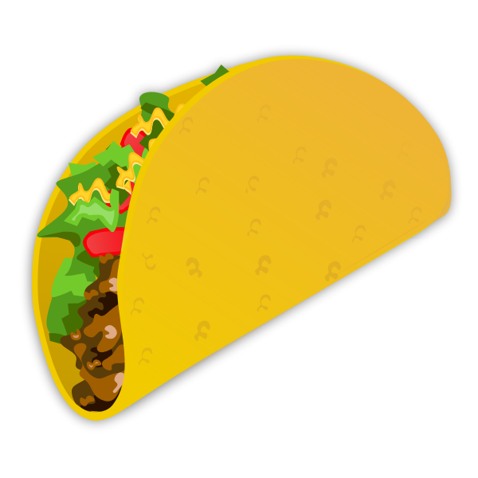 | GARDEN BAR OFFERED EVERYDAY!  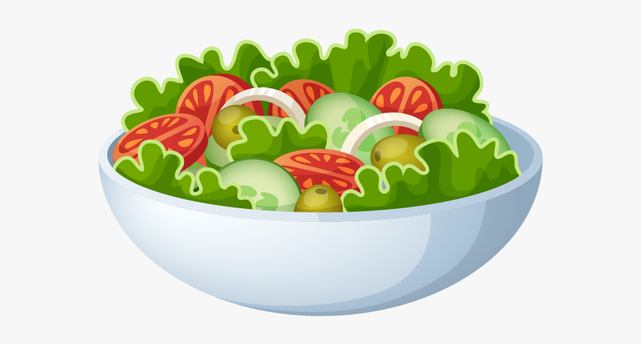 | 

