Monday | Tuesday | Wednesday | Thursday | Friday
Garden Bar Offered Every day!  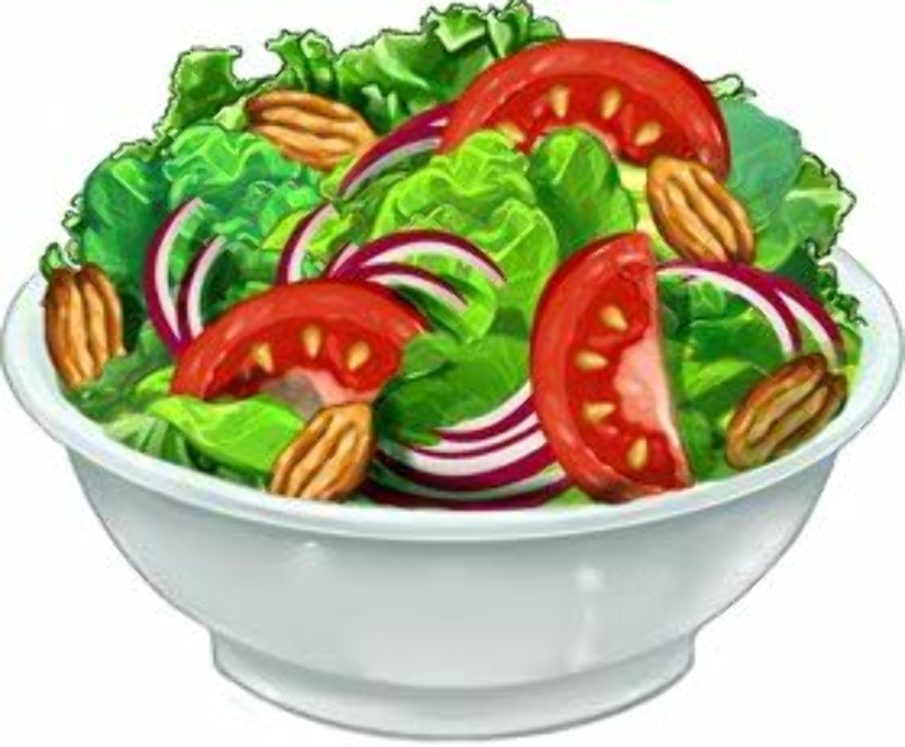 |   Birthday Popcorn  September 21   | Grades 6-12 are Offer vs. Serve  Guidelines on back on Menu.  Menu Subject to Change. | 1Cereal Varity, Banana, Juice, Milk  Pork Barbecue  Creamy Coleslaw  Glazed Carrots  Applesauce  Fresh Fruit  Milk Variety | 2 WG Donut, Fruit, Juice, Milk  Salisbury Steak  Mashed Potatoes  WG Roll  Grape Tomatoes  Pineapple Chunks  Fresh Fruit  Milk Variety
5   | 6 Pancake & Sausage Sandwich, Fruit, Juice, Milk  Fish Sandwich  Tartar Sauce  French Fries  Mixed Vegetables  Fresh Fruit  Mixed Fruit  Milk Variety | 7 WG Muffin, Cheese Stick, Fruit, Juice, Milk  Spaghetti w/Meatballs  WG Breadstick  Corn  Green Beans  Fresh Fruit  Peaches  Milk Variety | 8 Pop-Tarts, Fruit, Juice, Milk  Chicken Quesadilla  Sour Cream & Salsa  Refried Beans  Grape Tomatoes w/Dip  Fresh Fruit  Pears  Milk Variety | 9 WG Biscuit w/Butter and Jelly, Fruit, Juice, Milk  Corndog  Sweet Potato Waffle Fries  Broccoli w/Dip  Chocolate Chip Cookie  Fresh Fruit  Pineapple Chunks  Milk Variety
12 Mini Waffles, Fruit, Juice, Milk  Chicken Nuggets  Mac and Cheese  Green Beans  Red Pepper Strips w/Dip  Fresh Fruit  Mixed Fruit  Milk Variety | 13 Chicken Biscuit, Fruit, Juice, Milk  Ham and Cheese Hoagie  Lettuce and Tomato  Baked Beans  WG Chips  Broccoli w/Dip  Fresh Fruit  Mandarin Oranges  Milk Variety | 14 Blueberry Bread, Fruit, Juice, Milk  Open Face Roast Beef Sandwich  Mashed Potatoes w/Gravy  Glazed Carrots  Fresh Fruit  Pineapple Chunks  Milk | 15 Cereal Bar, Fruit, Juice, Milk  Pizza  Corn on the Cob  Spinach  Fresh Fruit  Applesauce  Milk Variety | 16 French Toast Sticks, Fruit, Juice, Milk  Scrambled Eggs  WG Biscuits w/Butter & Jelly  Sausage  Hash Brown Potatoes  Grape Tomatoes  Cooked Apples  Fresh Fruit  Milk Variety
19 Breakfast Pizza, Fruit, Juice, Milk  Pigs in a Blanket  Tater Tots  Baked Beans  Applesauce  Fresh Fruit  Milk Variety | 20 Fruit Strudel, Fruit, Juice, Milk  Sloppy Joe  Creamy Coleslaw  Corn  WG Chips  Fresh Fruit  Mixed Fruit  Milk Variety | 21 Bagel w/Cream Cheese, Fruit, Juice, Milk  Chicken Stir Fry  Fried Rice  Black Bean Salad  Yogurt Cup  Fresh Fruit  Pineapple Chunks  Milk | 22 Jumpstart, Banana, Juice, Milk  Cheeseburger  Lettuce and Tomato  French Fries  Carrots w/Dip  Fresh Fruit  Peaches  Mike Variety | 23 Sausage Biscuit, Fruit, Juice, Milk  Beanie Weenies  WG Breadstick  Sweet Potato Bites  Broccoli w/ Cheese  Fresh Fruit  Applesauce  Milk Variety
26 Breakfast Tornados, Fruit, Juice, Milk  Brown Beans  Cornbread  Spinach  Baked Potato  Fresh Fruit  Pears  Milk Variety | 27 Biscuits and Sausage Gravy, Fruit, Juice, Milk  Grilled Chicken Sandwich  Tater Tots  Carrots w/Dip  Goldfish Crackers  Fresh Fruit  Peaches  Milk Variety | 28 WG Donut, Fruit, Juice, Milk  Tomato Soup  Grilled Cheese  Cucumber Slices w/Dip  Yogurt Cup  Fresh Fruit  Applesauce  Milk Variety | 29 Hard Boiled Egg, Toast w/Butter and Jelly, Fruit, Juice, Milk  Chicken Strips  Scalloped Potatoes  Glazed Carrots  Fresh Fruit  Mixed Fruit  Milk Variety | 30 Cinnamon Roll, Fruit, Juice, Milk  Pepperoni Roll  Corn  Green Beans  Cheese Stick  Fresh Fruit  Mandarin Oranges  Milk Variety

