

Charles Willis

14050 Highway 18 West

Raymond, MS 39154

Office (601) 857-8016

cwillis@hinds.k12.ms.us

**DEPARTMENT OF ATHLETICS**

**HINDS COUNTY SCHOOL DISTRICT**

________

**Clear Bag Policy**

In the interest of enhancing existing security measures at athletic events hosted by the Hinds County School District, a security policy has been implemented regulating the the type of bag that may be carried into sports venues.  
  
 · Bags that are clear plastic, vinyl or PVC and do not exceed 12" x 6" x 12";  
 · One-gallon clear plastic freezer bags (Ziploc bag or similar); and  
 · Small clutch bags, with or without a handle or strap, that do not exceed 4.5" x 6.5" (approximately the size of a hand).  
 · An exception will be made for medically necessary items after proper inspection at a gate designated for this purpose.  
  
Prohibited bags include, but are not limited to: purses larger than a clutch bag; briefcases; backpacks, cinch bags, and fanny packs that are not clear and/or exceed the size restriction; luggage of any kind; computer bags/cases; camera bags/cases; binocular bags/cases or any bag larger than the permissible size.

Fans will continue to be able to carry items allowed into athletic venue ia a permissible clear bag, such as binoculars and cameras.

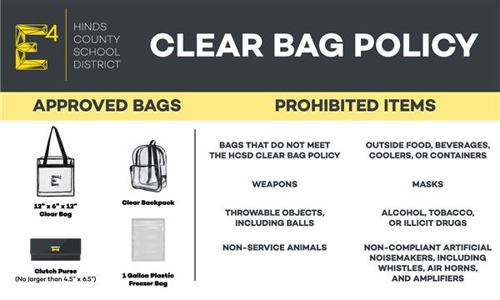

**FREQUENTLY ASKED QUESTIONS  
  
*How does the new policy improve public safety?***The clear bag is easily searched and significantly reduces faulty bag searches. It also supports the Department of Homeland Security's "If You See Something, Say Something" campaign.  
  
***Do I have to put everything I'm carrying into the permissible bags?***No. Fans are limited only to the type of bags carried into athletic venues, not items that they may normally bring to a game that fit in pockets or clutch bags (e.g., keys, makeup, feminine products, comb, phone, wallet, credit cards). Fans may carry a blanket over their arms, and binoculars and/or camera around their necks or in their hands without the case. Fans may also use the clear bag and clutch to carry these items and other permissible items. Every member of the family may carry in a permissible bag. ***What about diaper bags?***Diapers and non-medically necessary items for babies and young children must be carried in a clear bag. Each member of a family, including children, would be allowed to carry an approved clear bag and a clutch purse into athletic venues.  
 ***How many bags may each person bring into the sporting venue?***One large clear bag - either a one-gallon Ziploc style bag or the 12" x 6" x 12" clear bag - plus a small clutch that does not exceed 4.5" x 6.5". The small clutch allows privacy for small personal items and also is easily searched.  
  
***May fans carry cameras, binoculars, smart phones or tablets separately from what they put in a clear bag?***Yes. A phone, binoculars or cameras may be carried into the facility as long as it is not in its own bag.  
  
***What about bringing blankets in cold weather?***Fans will be able to bring blankets by tossing them over a shoulder or arm. ***If I have certain items that I need to bring into the athletic facility for medical reasons and they won't fit in the clear bag, what do I do?***There will be designated entrances to allow screening of these bags and medically necessary items.  
  
***Are all purses prohibited?***No. Small clutch purses, with or without a handle or strap, that do not exceed 4.5" x 6.5" are permitted along with either the 12" x 6" x 12" clear tote bag or the one-gallon freezer bag. Fans are encouraged not to bring any bags, but the policy has been created to balance fan needs with improved public safety and convenience.  
  
***Does this bag policy apply to credentialed individuals (e.g., media, staff)?***There will be an exception specifically for "credentialed" individuals who bring bags that do not meet the policy guidelines. However, their bags will still be searched prior to entry, and only bags that pass the inspection will be allowed into the stadium.