Cluster: **Transportation and Logistics**

Program of Study:

**Transportation and Logistics**

**Related Courses:**

____ Power and Ag Mechanics

____ Electricity

____ Engineering Applications

____ Intro to Business

____ **Microsoft Office I**

____ **Accounting**

____ **Customer Service**

Bolded courses have dual credit agreements.

**General Education Dual Credit Courses:**

**4 Year College Offerings:**

___ **Honors English**

___ **Senior Year Math**

___ **CAPP Communications**

___ **Psychology**

___ **Sociology**

To determine how courses will transfer to the university you plan to attend please check: https://www.wisconsin.edu/transfer/wizards/

**Technical College Offerings:**

___ **Written Communications**

___ **College Math**

___ **Research and Inquiry**

___ **Psychology**

___ **Sociology**

Some credits may not be awarded until you enroll at a Technical College

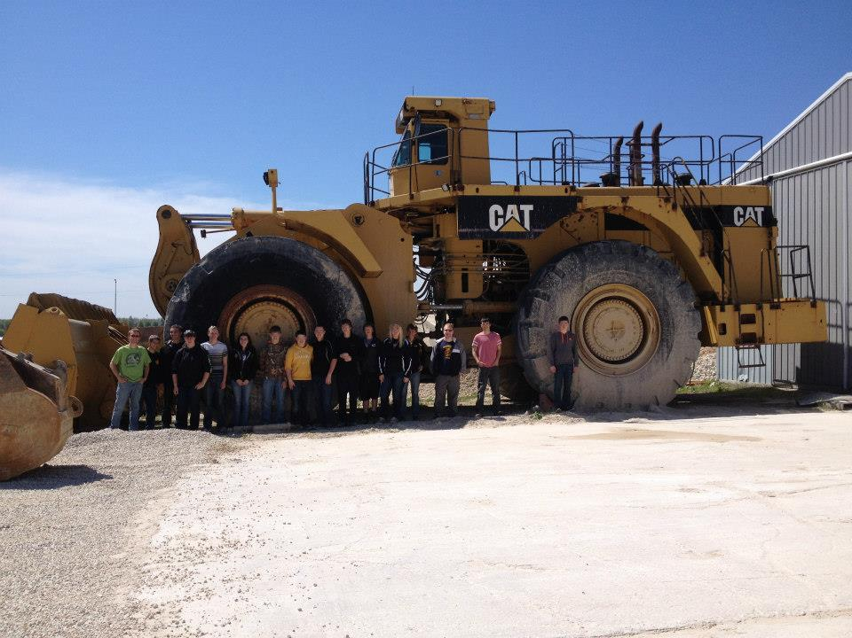

**Online Course Opportunities through iCEV:**

___ Principles of Small Engine

Technology

**Industry Recognized Certifications:**

____ Department of Workforce

Development Certificate of

Proficiency

This is awarded upon successful completion YA experience.

**Capstone Opportunities:**

___ Youth Apprenticeship:

Auto Technician

___ Youth Apprenticeship:

Diesel Technician

See https://www.yamanitowoccounty.com/ for more information