Cluster: **Law, Public Safety, Corrections and Security**

Program of Study:

**Law and Public Safety**

**Related Courses:**

____ **Psychology**

____ **Sociology**

____ Parent and Child

____ Health Promotion and

Wellness

____ Customer Service

____ **CAPP Communications**

____ First Aid and Safety

____ **Microsoft Office I**

____ AP Government

____ **CAPP Spanish**

____ **Written Communications**

Bolded courses have dual credit agreements.

**General Education Dual Credit Courses:**

**4 Year College Offerings:**

___ Honors English

___ Senior Year Math

___ CAPP Communications

___ Psychology

___ Sociology

*To determine how courses will transfer to the university you plan to attend please check: https://www.wisconsin.edu/transfer/wizards/

**Technical College Offerings:**

___ Written Communications

___ College Math

___ Research and Inquiry

___ Psychology

___ Sociology

*Some credits may not be awarded until you enroll at a Technical College

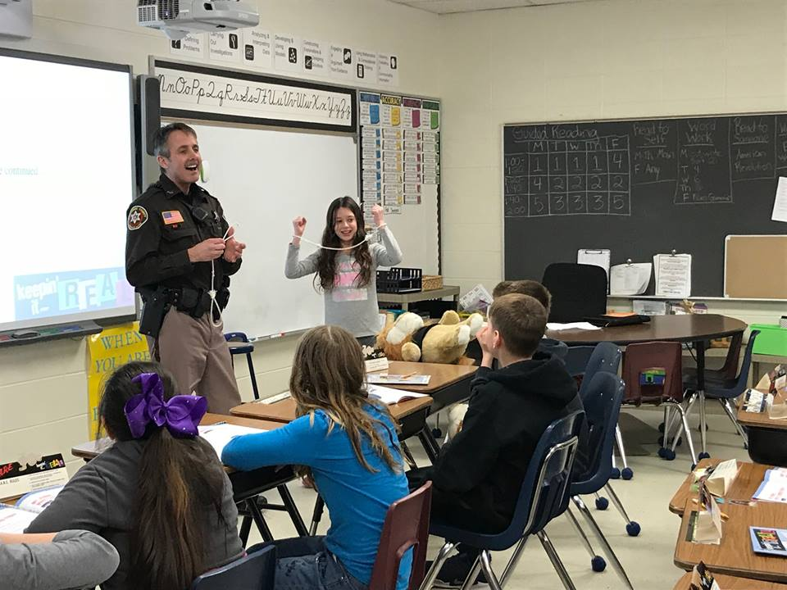

**Advance Placement Exams:**

____ Government and Politics (US)

____ Government and Politics (Comparative)

*Student must pass AP Exam with a score of 3-5

____

**Co-Curricular and Volunteer Opportunities:**

___ Student Government

___ Mishicot Police Department Explorers Program (2019)

___ DNR Junior Safety Instructor

___ Manitowoc County Youth Diversions Program