Cluster: **Government and Public Administration**

Program of Study:

**Government and Public Administration**

**Related Courses:**

____ AP Government

____ AP Human Geography

____ **Psychology**

____ **Sociology**

____ **CAPP Spanish**

____ **Customer Service**

____ **Leadership an**

**Professionalism**

____ **CAPP Communications**

____ **Written Communications**

____ **Microsoft Office I**

Bolded courses have dual credit agreements.

**General Education Dual Credit Courses:**

**4 Year College Offerings:**

___ **Honors English**

___ **Senior Year Math**

___ **CAPP Communications**

___ **Psychology**

___ **Sociology**

*To determine how courses will transfer to the university you plan to attend please check: https://www.wisconsin.edu/transfer/wizards/

**Technical College Offerings:**

___ **Written Communications**

___ **College Math**

___ **Research and Inquiry**

___ **Psychology**

___ **Sociology**

*Some credits may not be awarded until you enroll at a Technical College

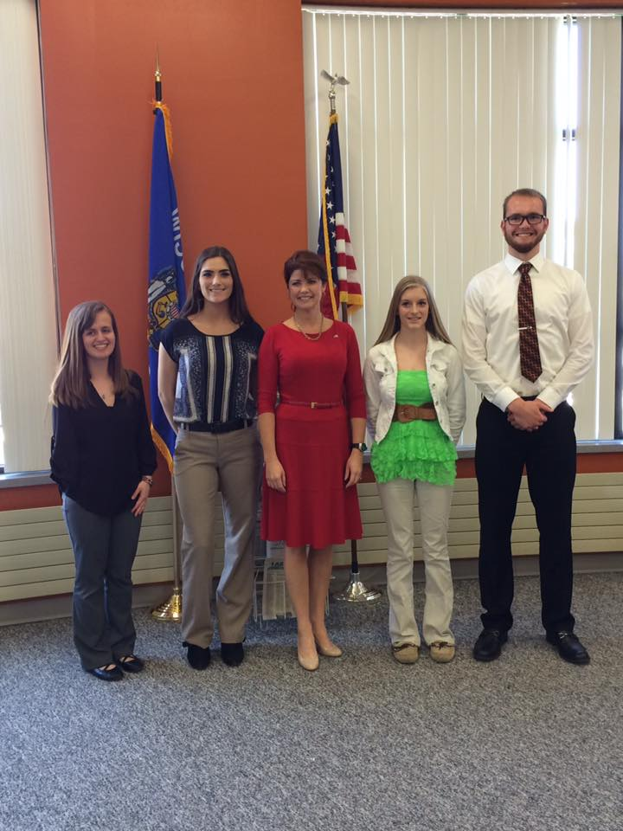

**Advance Placement Exams:**

____ Government and Politics (US)

____ Government and Politics (Comparative)

____ Human Geography

*Student must pass AP Exam with a score of 3-5

____

**Co-Curricular and Volunteer Opportunities:**

___ Student Government

___ Manitowoc County Youth Diversions Program