Cluster: **Agriculture/Food/Natural Resources**

Program of Study:

**Food Science**

**Related Courses:**

____ Intro to Agriculture

____ Foods

____ Culinary Arts I

____ Culinary Arts II

____ Food Science & Technology

____ Chemistry

____ **Intro to Horticulture**

Bolded courses have dual credit agreements.

**General Education Dual Credit Courses:**

**4 Year College Offerings:**

___ **Honors English**

___ **Math Senior Year**

___ **CAPP Communications**

___ **Psychology**

___ **Sociology**

*To determine how courses will transfer to the university you plan to attend please check: https://www.wisconsin.edu/transfer/wizards/

**Technical College Offerings:**

___ **Written Communications**

___ **College Math**

___ **Research and Inquiry**

___ **Psychology**

___ **Sociology**

*Some credits may not be awarded until you enroll at a Technical College

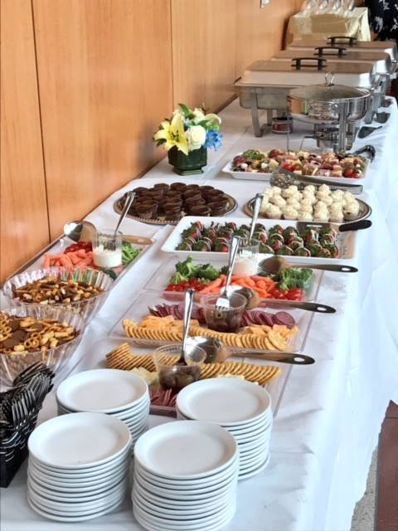

**Online Course Opportunities through iCEV:**

___ Culinary Meat Selection and

Cookery

___ Food Safety and Science

___ Meat Evaluation

**Co-Curricular and Volunteer Opportunities:**

___ FFA

___ FCCLA

___ 4-H

**Industry Recognized Certifications:**

____ Department of Workforce

Development Certificate of

Proficiency

This is awarded upon successful completion of YA experience.

**Capstone Opportunities:**

___ Youth Apprenticeship:

Hospitality, Lodging, and

Tourism

See https://www.yamanitowoccounty.com/ for more information