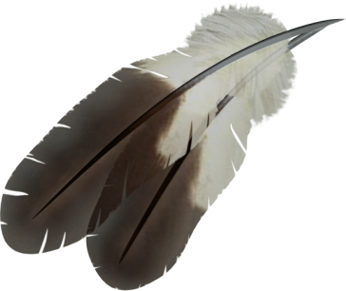
Turkey Trot & Pay to Play
Cache 5th & 6th Grade Center
The Cache 5th & 6th Grade PTO will host a Turkey Trot Walk/Run. The students will participate in a 2 mile event to show support as Fit Kids against hunger. They can bring 1 canned food item to donate and participate. This will take place in the morning.
The remainder of the day we will have a “PAY to PLAY”. Students can pay $10.00 to play short creative games that require concentration and lots of energy! They will also receive 2 tickets for items in the concession.
T-shirts are available until November 7, 2018. Cost is $10.00 per shirt.
When: NOVEMBER 16 ~ Turkey Trot (Bring a canned food item)
Pay to Play ~ Cost: $10.00 per student to participate & 2 Tickets for Concession. All concession items will be $1. Students may purchase additional items. T-shirt $10.00 (optional) Due by NOVEMBER 7
