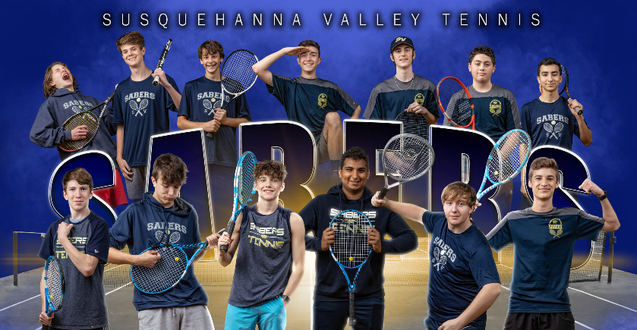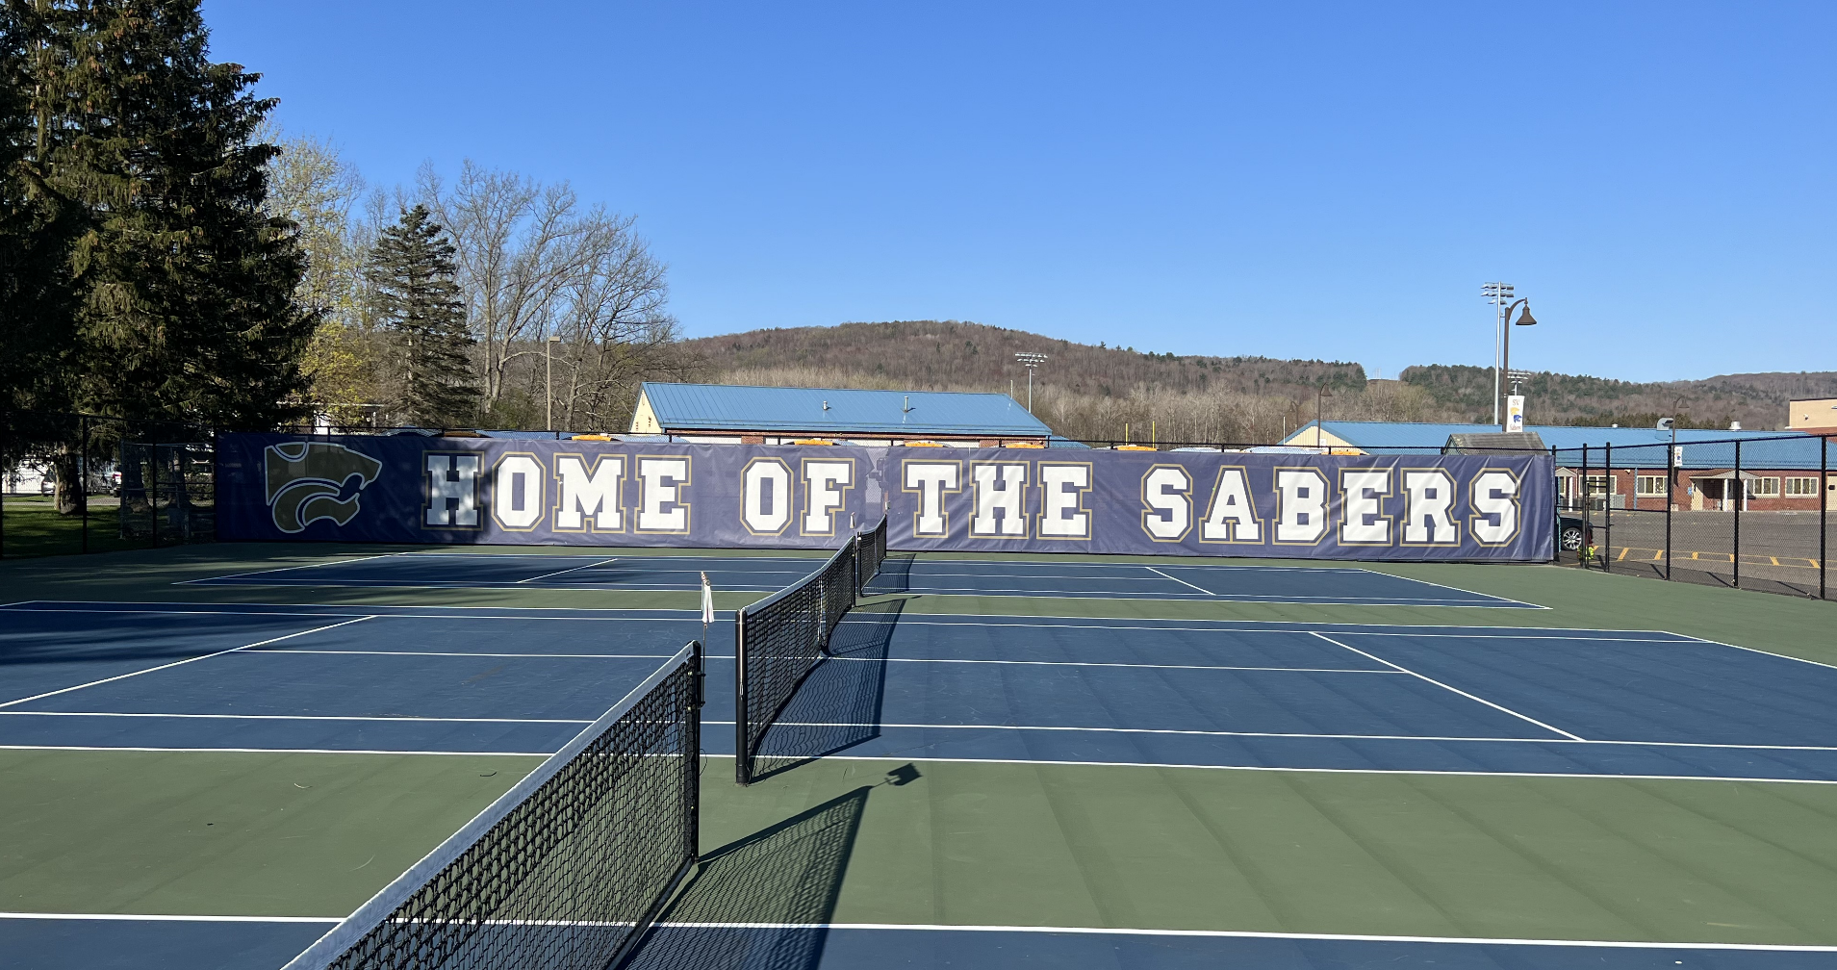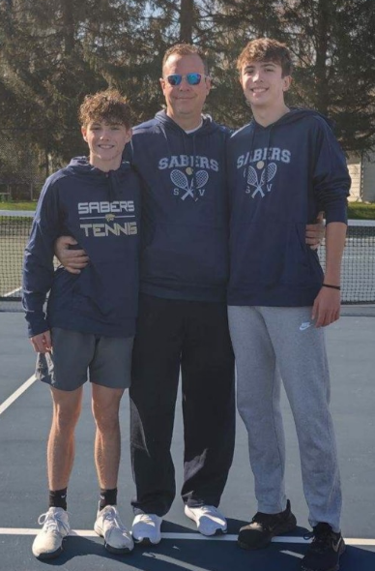

The SV Boys Varsity Tennis Team finished a perfect regular season at 12-0.  The SABERS were led by Sophomore #1 singles player Isaac Spottek (12-0), and Senior Dan Davies (11-0).  Samar Dhillon (Sophomore) and Jimi Cook (Sophomore) rounded out singles play with an impressive 19-3 combined record.  The SABERS were led by first doubles team Senior Dan Leighton and Sophomore Evan Bronson.  Justin Pencek, Chris Henderson, Drew Burkhart, Sam Pauline and Nassar Al-Khalidi all saw action at Doubles this year.

The SABERS will host Union Endicott in the STAC Semi Final on Thursday and then will host the Section 4 Division 2 team championship on Tuesday.  The SABERS look forward to Sectional play beginning at the end of the week with Isaac entering the tournament at the #1 seed in Class C singles.

Go SABERS!