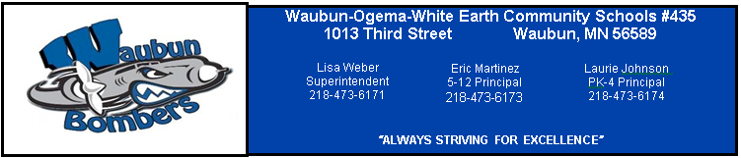
District Office
1013 3rd Street
Waubun, MN 56589
218-473-6171
www.waubun.k12.mn.us

Lisa Weber, Superintendent

Michelle Heisler, Business Manager

Board Members

Mr. Allan Haugo, Chair
1087 310th Street
Waubun, MN 56589

Mr. Joseph McArthur, Vice Chair
24225 350th Street
Ogema, MN 56569

Mrs. Christie Haverkamp, Clerk
38223 Cty Hwy 34
Ogema, MN 56569

Mrs. Stacy Bly, Treasurer
1704 310th Street
Waubun, MN 56589

Mr. Mark Rothschadl, Director
39194 Cty Rd 111
Waubun, MN 56589

Mr. Jon Syverson, Director
3127 240th Avenue
Waubun, MN 56589

Mr. John Zima, Director
27639 Cty Rd 112
Waubun, MN 56569
MEETING OF THE BOARD OF EDUCATION
INDEPENDENT SCHOOL DISTRICT NO. #435
Special
Reorganization Meeting
Wednesday, January 6, 2016
Waubun Media Center
6:00

A G E N D A
1.0 CALL TO ORDER

2.0 ROLL CALL

3.0 PLEDGE OF ALLEGIANCE

4.0 APPROVAL OF THE AGENDA (Action Item)

5.0 PUBLIC COMMENT
A five minute time limit will be allowed for public comment. Please inform the Board Chair or Superintendent prior to the meeting that you wish to address the board.

6.0 NEW BUSINESS
6.1 Election of Officers (Action Item)
6.2 Committee Assignments (As Presented)
6.3 Set Official Meeting Date, Time and Place (Action)
6.4 Designation of Official Depositories (Action)
6.5 Contacts Designation of Official Legal Counsel and Contracts (Action)
6.6 Designation of Official Newspaper (Action)
6.7 Authorization of Signatures (Action)
6.8 Set 2016 Board Member Compensation (Action)
7.0 ADJOURNMENT

