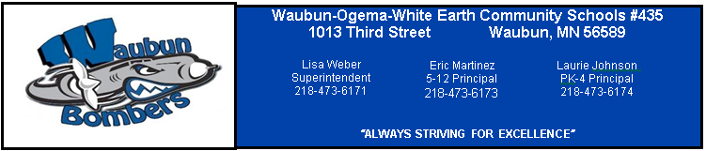
Minutes
MEETING OF THE BOARD OF EDUCATION
INDEPENDENT SCHOOL DISTRICT NO. #435
Special
Impact Aid Meeting
Wednesday, January 18, 2017
Waubun Media Center
6:00PM

Chairperson Christie Haverkamp called the meeting to order __6:06_ P.M.

Roll Call: Present: Christie Haverkamp, Allan Haugo, Stacy Bly, John Zima,
Mark Rotschadl, Jon Syverson and Terry Dorman
Absent:

3.0 Motion by Stacy Bly, seconded by Allan Haugo, to approve the Special Meeting Agenda – Impact Aid, for January 18, 2017, as presented.
Motion Carried.

4.0 New Business
4.1 Impact Aid – Information was given by Michelle Heisler that the final numbers have been completed and we are up a total of 54 students from 373 last year to 427 this year. The BIA has completed their review and verification. We are waiting for the Tribal Officials review, verification, and signature. The application deadline is Tuesday, January 31, 2017.

A Presentation of the Educational Programs and Opportunities was given by Patti DeGroat.

4.2 Motion by John Zima, seconded by Mark Rotschadl, to approve Policy 612.2 - Indian Policies & Procedures as presented.
Motion Carried.
6.0 Motion by Stacy Bly, seconded by John Zima to adjourn the meeting at 6:19 P.M.
Motion Carried.

______________________________________
Clerk

