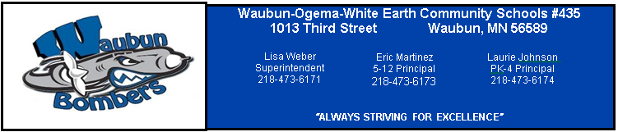
District Office
1013 3rd Street
Waubun, MN 56589
218-473-6171
www.waubun.k12.mn.us

Lisa Weber, Superintendent

Michelle Heisler, Business Manager
Board Members
Mrs. Christie Haverkamp, Chair
38223 Cty. Hwy 34
Ogema, MN 56569

Mr. Allan Haugo, Vice Chair
1087 310th Street
Waubun, MN 56589

Mrs. Stacy Bly, Clerk
1704 310th Street
Waubun, MN 56589

Mr. John Zima, Treasurer
27639 Cty Rd 112
Waubun, MN 56569

Mr. Mark Rothschadl, Director
39194 Cty Rd 111
Waubun, MN 56589

Mr. Jon Syverson, Director
3127 240th Avenue
Waubun, MN 56589

Mr. Terry Dorman, Director
35358 250th Avenue
Ogema, MN 56569

MEETING OF THE BOARD OF EDUCATION
INDEPENDENT SCHOOL DISTRICT NO. #435
Wednesday, August 22, 2018
District Office
Special School Board Meeting
Resolution calling General Election
7:30 AM
AGENDA

1.0 CALL TO ORDER
2.0 ROLL CALL
3.0 PLEDGE OF ALLEGIANCE
4.0 APPROVAL OF THE AGENDA (Action Item)
5.0 New Business 5.1 Approve the Notice of the General Election

6.0

7.0 Future Consideration for School Board:

8.0 Adjournment

