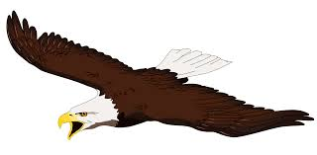

**An important Habit of Highly Successful Students**

Success in school looks very different for each student, but the one factor that all successful students have in common is the ability to “put first things first”. Meaning, what are your priorities?

School is difficult enough with state standards and benchmarks, standardized testing and local assessments, and even applying our knowledge in the classroom to make learning meaningful. Education is not hand feeding answers, but providing content knowledge to draw from in order to apply critical thinking skills, which is often very difficult for students to get a grasp of. This is where education has taken us. Therefore, student learning and success does not resemble what it did 10 years ago. However, the one common factor, over time, for successful students is the ability to “put first things first” and this is how you do it.

* Spend time on things that are most important
* Say “No” to things you know you should not do
* Set priorities, make a schedule, and follow your plan
* Be disciplined in attitude and behavior
* Be organized

______________________________________________________________________

**New District Website**

Just a friendly reminder that parents / student can review teacher’s lesson plans, on the ***new district webpage***, to be aware of daily work, projects, and quizzes and test information. ***On the new website***, click on the Menu icon, then scroll down to High School Staff Directory. Click on the teacher, then their email and a link to their homework webpage is there. This is helpful when a student is absent from school or just can remember what they did in class. The lesson plans are updated by Monday at noon and may be modified as the week goes on due to assessment data and re-teaching opportunities. Please contact the teacher when necessary to get clarification or more details regarding assignments.

_______________________________________________________________________

**There’s an App for that!**

Go to Google Play or Apple Store and search for Deckerville Schools (an Eagle icon should pop) and download the free app for push notifications and info at your fingertips.

Connelly’s Words of Wisdom

October Issue

EAGLE TIMES

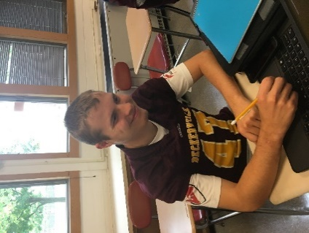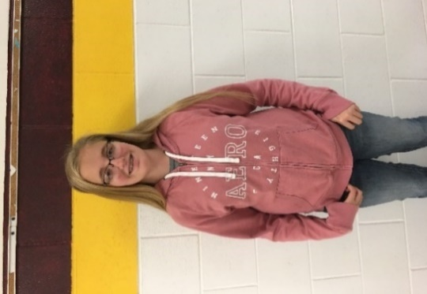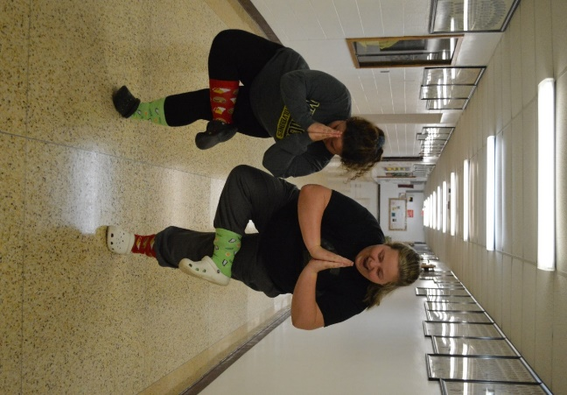

**Band Members of the Month**

**by: Little Feet**

Alyssa Johnson has worked very hard on band pieces, and she has been recruited to play in the high school marching band.

Tyler Howard has shown incredible improvement over the last four years in band, due to his work ethic. Tyler has become a great leader.

Capture the Moment

by: Sunflower

The school year can be stressful with sports, homework and extra-curricular activities. However, it is always important to make time for yourself. This month your fellow class mates, Tori Jones and Katelyn Park, encourage you to your Zen.

Daintree Rainforest, Australia: Take a walk through the forest that holds exotic tropical fruit and wildlife.

Hamilton Islands, Australia: Exquisite coral reefs, teeming with marine life.

Maui Hawaii: Great area to watch whales on the horizon.

Bahamas: Calm, turquoise waters that are perfect for scuba diving.

Anchorage, Alaska: Alaska’s biggest city with beautiful views and great places to stay.

***5 Places to be Right Now by: Shorty***

In 1492-Christopher Columbus’s expedition made landfall on a Caribbean Island called San Salvador.

1609-the Children’s novel Three Blind Mice was published in London.

1792- The first Columbus Day celebration was held in New York City.

1871-President Grant commanded the KKK.

1892- The first Pledge of Allegiance was introduced.

1906- The Chicago Cubs beat the Detroit Tigers 4-0 and tied the World Series 1-1.

***On This Day by: Banana17***

There is much happening in the month of October (besides pumpkin flavored everything)! First of all, its college application month, and students are encouraged to apply to at least one college they are interested in attending. They should be talking to family and friends about the pros and cons of different colleges and how going to college fits (or doesn’t fit) into their post-secondary plans. Students should be thinking about just what those post high school plans will be!

One way to investigate this it to join us for Sanilac County College Night on October 22nd from 6:00 – 7:30 p.m. at the Sandusky Junior/Senior High School gymnasium. There will be representatives from universities and colleges, as well as, technical schools and those in the cosmetology field. Members of different military branches will be present to answer questions, and there will be information on financial aid. Also, students who attend can put their name in a drawing for a chance to win a $500 scholarship!

Juniors and Seniors brought home information this week about how they can go on one of three different college trips. On Thursday, October 25th, there will be a visit to Saginaw Valley State University. On Friday, October 26th there will be a visit to the University of MI-Flint, and Monday, October 29th there will be a visit to St. Clair County Community College. There are many more details in the notes that went home. Permission slips, etc., are due back by Wednesday, October 17th!

October 1st was not just the start of bow hunting season – it was also the start of FAFSA season! Any student planning to attend any kind of schooling after high school should fill out FAFSA. There is more information about that in the Student Toolkits seniors received about a week ago. If students or parents have any questions about filing a FAFSA, getting an FSA ID to start the process, applying to colleges, financial aid, or anything else, please don’t hesitate to call or set up a meeting with me. I’m very happy to help!

Sincerely,

Mrs. Ford

School Counselor

Counselor’s Report

Answer on back page!

**Ingredients:**

* **2 loaves frozen bread dough**
* **½ cup melted butter**
* **1 cup. brown sugar**
* **2T.milk**
* **1/2 tsp cinnamon**
* **1 small package of butterscotch pudding**
* **Chopped nuts**

**Directions:**

**Thaw bread (don’t allow to rise). Sprinkle nuts on bottom. Cut dough into pieces and put them in a pan. Beat butter, brown sugar, milk, cinnamon and pudding until smooth. Pour over bread dough. Let rise 2 ½-3hrs. Bake at 350 degrees for 30 minutes. Let cool 15 minutes and turn onto cookie sheet.**

**October Sweet Treat: Caramel Rolls!**

**By: Rapunzel**

Top Ten Songs by: Princess

1: Girls Like You- Maroon 5

2: I Like It- Cardi B

3: No Brainer- DJ Khaled

4: No Tears Left to Cry- Ariana Grande

5: In My Feelings- Drake

6: One Kiss- Dua Lupa

7: The Middle- Maren Morris

8: Lucid Dreams- Juice Wrld

9: Back To You- Selena Gomez

10: Youngblood- 5 Seconds of Summer

Guess The Teacher! by: Tiger Lilly

1. What is one of your hidden talents?

Being fluent in satire.

1. What is one of your dream pets?

A horse.

1. What kind of driver were you when you got your license?

I was very cautious, but I had a lead foot.

1. Is there a quote that you live your life by?

If you’re not first, you’re last. ~Ricky Bobby

1. What’s the best/ worst thing about being a teacher or staff member?

Students/students

1. What do you think is the worst thing about the school system today?

People who do not give their best effort all the time. “Slackers, McFly. Slackers!”

1. Is there a different topic that you’d rather teach?

No, I love my job, but check back with me in three years.

1. What is one thing that students might not know about you?

I am a grandma and I’m very sarcastic.

1. What is your dream vacation?

My dream vacation is to travel to Ireland because I heard it is a magical place.

Outrageous US Laws by: Skittles20

* In Alabama, bear wrestling matches are prohibited.
* In Alaska, moose may not be viewed from an airplane.
* In Connecticut, it’s illegal for a barber to hum while cutting your hair.
* In Georgia, no one may carry an ice cream cone in their back pocket if it is Sunday.
* In New Hampshire, it is illegal to collect and take seaweed from a beach, but only at night.

Remember folks, behind every dumb law, there’s a dumb story!

The 2018-2019 High School yearbooks are now available to purchase online. Follow the instructions below:

1. Go to the Deckerville website – http://deckerville.k12.mi.us
2. Click on the link “yearbook purchase” under either the high school tab.
3. This tab will redirect you to the Josten web site.
4. High School tab
5. If purchasing just the yearbook click the yearbook $45.00 tab.
6. Add the number of yearbooks you would like to order to the cart.
7. Fill out your name and payment options. The email option is also available.
8. Hit the checkout tab.

The yearbook will be sent to the school along with the other yearbook orders.

**You may order an elementary yearbooks the same way, just go through the elementary tab. The Elementary yearbook will arrive in June 2019.**

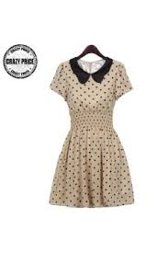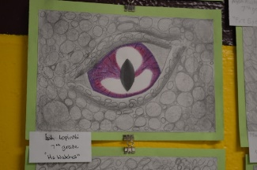

Fashion Trends by: Bean

Many of today’s fashion trends revolve around the retro. High waisted pants and bright patterns worn by teens today is a close resemblance to fashion worn in the late 80’s and throughout the 90’s. The 80’s, 90’s and late 60’s fachion is beginning to make a comeback with wired glasses, and rounded collars aswell.

Artist of the Month by: Stormi

Leah Lopinski is not only a great artist, she also goes above and beyond to make sure her artwork is like no others. She is also very good student. Good job Leah.

Knee Slappers by: Gean

Why did the cookie go to the hospital?

Because he felt a little crummy!

Why couldn’t Dracula’s wife sleep?

Because of his coffin!

What do you get when you cross and snowman and a vampire?

Frostbite!

Why was the baby strawberry crying?

Because his mom and dad were in a jam!

What’s the difference between a guitar and a fish?

You can’t tuna fish!

Rachel /5

Maria 5/5

**What’s something Rachel can’t live without?**

**Maria: Her kitty’s**

**Rachel: My kitty’s**

**What’s Rachel’s favorite candy?**

**Maria: Swedish Fish**

**Rachel: Swedish Fish**

**What’s Rachel’s least favorite thing to do?**

**Maria: She hates to drive**

**Rachel: I hate driving**

**What’s a weird quirk about Rachel?**

**Maria: She likes pickles on pizza**

**Rachel: I love pickles on my pizza**

**What’s the best memory you and Rachel have?**

**Maria: Camping**

**Rachel: Definitely camping**

**What’s something Maria can’t live without?**

**Rachel: Her boyfriend**

**Maria: Josh (my boyfriend)**

**What’s Maria’s favorite candy?**

**Rachel: Dark chocolate Kit-Kat**

**Maria: Dark chocolate Kit-Kat**

**What’s Maria’s least favorite thing to do?**

**Rachel: Watch TV**

**Maria: Watch TV**

**What’s a weird quirk about Maria?**

**Rachel: She doesn’t like meat!**

**Maria: People think it’s weird I don’t eat meat!**

**What’s the best memory you and Maria have?**

**Rachel: Camping together**

**Maria: Camping**

Get To Know Your Foreigners by: Merida

1. What is the hardest English word to say/understand

    A:”I can’t say literally”

1. What is your favorite American food?

    A:”Give me Reese’s and I’m happy”

1. What is one thing from home you wish you had here?

    A:”Of course I miss my friends and family, but most importantly my bed, because well...you have to lay in it to understand”

1. What is the weirdest American tradition/thing we do that you’ve encountered?

    A:”Rachel Jo Brown”

1. What sports are popular in your country?

    A:”Soccer is the most popular in Germany, but I personally don’t like it”

1. What’s your favorite food from home, and what is it?

    A:”Well I love burgers, so there’s not that much of a difference”

1. What are seasons like at home?

    A:”Pretty much alike, only it isn’t that cold in winter. We still have snow, but not every year”

1. So far, what is your favorite place in the United States?

    A:”The football field”

1. Do you speak any other languages besides English and German?

    A:”Besides English and German, I also speak Turkish”

1. What was your most embarrassing moment so far?

    A:”Getting my ankles broken in the homecoming game”

                                         -Batuhan Giray

                                              “Batu”

***Who Knows Who Best?***

***By: Suga***

Guess the Teacher:

Monica

**Top Books and Movies by: Gumdrop**

Top 5 Movies

1. **Incredibles 2**- The Incredibles were trying to bring back the name of supers.

2. **To All the Boys I’ve Loved Before**- Lara Jean secretly wrote love letters to every boy she ever liked, and one day they were found.

3. **Deadpool 2**- Deadpool tries to save a boy from Cable.

4. **Love, Simon**- Simon has a hard time coming out to his family and friends.

5. **Avengers Infinity War**- All superheroes come together to try and defeat Loki and his allies.

**Horoscopes by: Pinocchio**

Aquarius (January 20th ~ February 18th): If you want your crush to notice you, kiss your notebook five times and spin around in circles before bed tonight!

Pisces (February 19th ~ March 20th): Don’t know what to do with all your extra time? Go online and binge watch The Office for the eighteenth time.

Aries (March 19th ~ April 19th): Trying to avoid nasty April fool’s pranks? Plan your pranks now so you can get everyone before they get you.

Taurus (April 20th ~ May 20th): Stuck in a procrastination pit? Go out and find an adventurous opportunity to clear you mind.

Gemini (May 21st ~ June 20th): If better test grades is what you’re looking for, forget studying! Take as many online quizzes as you can to boost your guessing skills.

Cancer (June 21st~ July 22nd): When prom rolls around, be sure to ask someone quick! They’re sure to say yes.

Leo (July 23rd ~ August 22nd): Trapped in a creativity jam? Close your eyes, put your pencil to the paper, and scribble as fast as you can for ten seconds.

Virgo (August 23rd ~ September 22nd): If you run around your house five times and go to sleep early, you’ll get find five dollars on your floor in the morning.

Scorpio (October 23rd ~ November 21st): For some extra luck to get heap loads more candy this Halloween, try aiming for the scariest costume.

Sagittarius (November 22nd ~ December 21st): For better luck on your next report, go out and make three people smile.

Capricorn (December 22nd ~ January 19th): Looking to go to the Bahamas this winter break? Stand in the corner of your favorite class and say ‘I wish’ three times.

Top 5 Books

1. **Paper Towns**- When Margo is sick of her fake life, she committed suicide and left Quentin and his friends with a map to Paper Town and a note reading “If you go to Paper Town, you will never return.”

2. **Looking for Alaska**- Miles Halter (Pudge) finds love in an all- aspiring Alaska Young in Culver Creek. When the unthinkable happens, Chip (the Colonel) and Pudge must find out what happened to Alaska that night they saw her.

3. **Me and Earl and the Dying Girl**- A teen who befriends a classmate who had just been diagnosed with leukemia.

4. **The Secrets You Keep**- A terrifying, twisty, psychological thriller about a women who begins to fear that her husband isn’t who she thought her was.

5. **Everything I Never Told You**- It was a regular morning for the Lee family, but little did they know, the unthinkable had happened. Their daughter Lydia was dead.