Youth Suicide Prevention and Awareness Policy

Learning is the key to success in a changing world.

GLENWOOD R-VIII
SCHOOL DISTRICT

417-256-4849
www.glenwood.k12.mo.us

“Home of the Mustangs”

INDEX

Youth Suicide Prevention and Awareness Model Policy | Page 4
Crisis Response Team | Page 4
Crisis Response Procedures | Page 5
Procedures for Parental Involvement | Page 7
Confidentiality | Page 8
School and Community Resources | Page 8
Responding to Incidents Impacting the School | Page 9
Staff Education on Suicide Prevention and Response Protocol | Page 9
Suicide Prevention Education for Students | Page 10
Publication of Policy | Page 10
Appendix
Appendix A- DESE Suggested Guidelines for Training/Professional Development | Page 11
Appendix B- Chart of Evidence-Based and Research Based Programs | Page 12
Appendix C- Available Community Resources | Page 13
Appendix D- Definitions | Page 16

The Missouri Department of Elementary and Secondary Education (DESE), pursuant to Section 170.048, RSMo, developed a model policy for suicide awareness and prevention. The department utilized a variety of organizations with expertise in youth and suicide prevention to develop the model policy. The model policy includes resources that were used and can be used for related training and professional development.

This model policy serves as a template for the Glenwood R-VIII School District in developing a suicide awareness and prevention policy to meet the requirements of Section 170.048, RSMo. The policy was adapted and customized to best address and meet the needs of Glenwood’s school community. This model meets the following state requirements:

- By July 1, 2018, each district shall adopt a policy for youth suicide awareness and prevention, including plans for how the district will provide for the training and education of its district employees.

- Each district's policy shall address, but not be limited to, the following:
  - Strategies that can help identify students who are at possible risk of suicide;
  - Strategies and protocols for helping students at possible risk of suicide; and
  - Protocols for responding to a suicide death.

Glenwood R-VIII

Youth Suicide Prevention and Awareness Model Policy

Pursuant to Section 170.048, RSMo, the following model policy has been drafted by Missouri Department of Elementary and Secondary Education (DESE), customized, and adopted by the Glenwood R-VIII School District.

Purpose statement: Suicide is a leading cause of death in youth ages 10-24 in Missouri and is a public health concern impacting all Missouri citizens. Glenwood is committed to maintaining a safe environment to protect the health, safety and welfare of students.
This policy will outline key protocol and procedures for this district in educating employees and students on the actions and resources necessary to prevent suicide and to promote student well-being. This policy is being adopted pursuant to Section 170.048, RSMo

The district will address suicide awareness and prevention through the following policy components:

- Crisis Response Team
- Crisis response procedures
- Procedures for parent involvement
- Community resources available to students, parents, patrons and employees
- Responding to suicidal behavior or death by suicide in the school community
- Suicide prevention and response protocol education for staff
- Suicide prevention education for students
- Publication of policy

1. Crisis Response Team

The district’s Crisis Response Team will include administrators, counselors, the school nurse, and teachers and/or community members as appropriate. The Crisis Response Team will be responsible for implementation of the district’s response plan.

The district will use an evidence based/informed tool for determining whether a student is at risk of suicide or is having a suicide crisis. The Crisis Response Team will receive training and coaching in using this tool to assist in making these determinations and appropriately responding.

Team Member | Position in District
Wayne Stewart | Superintendent
Denny Melvin | Building Principal
Lynn Tackitt | Curriculum Director
Karen Moffis | Special Education Director
Mariah Hayes | School Counselor
Jaquita Perkins | School Nurse
Christy Frazier | Teacher
Stacy Kutter | Teacher
Allison Reef | Teacher

Evidence Based Tool Used: SOS Signs of Suicide

2. Crisis Response Procedures
Student suicidal behaviors are not confidential and may be revealed to the student’s parents, guardians, school personnel or other appropriate authority when the health, welfare or safety of the student is at risk.
Any school employee who has a reasonable belief that a student may be at risk for suicide or witnesses any attempt towards self-injury will notify a member of the crisis response team, the building administrator or his/her designee.
If a student suicide behavior is made known to any school employee and a member of the crisis response team, the building administrator or his/her designee is not available, the employee will notify the student’s parent/guardian, the National Suicide Prevention Lifeline (800-273-8255) or local law enforcement in an emergency situation. As soon as practical, the employee will notify the building designee or principal.
The following steps will be employed in response to any risk of student suicide:
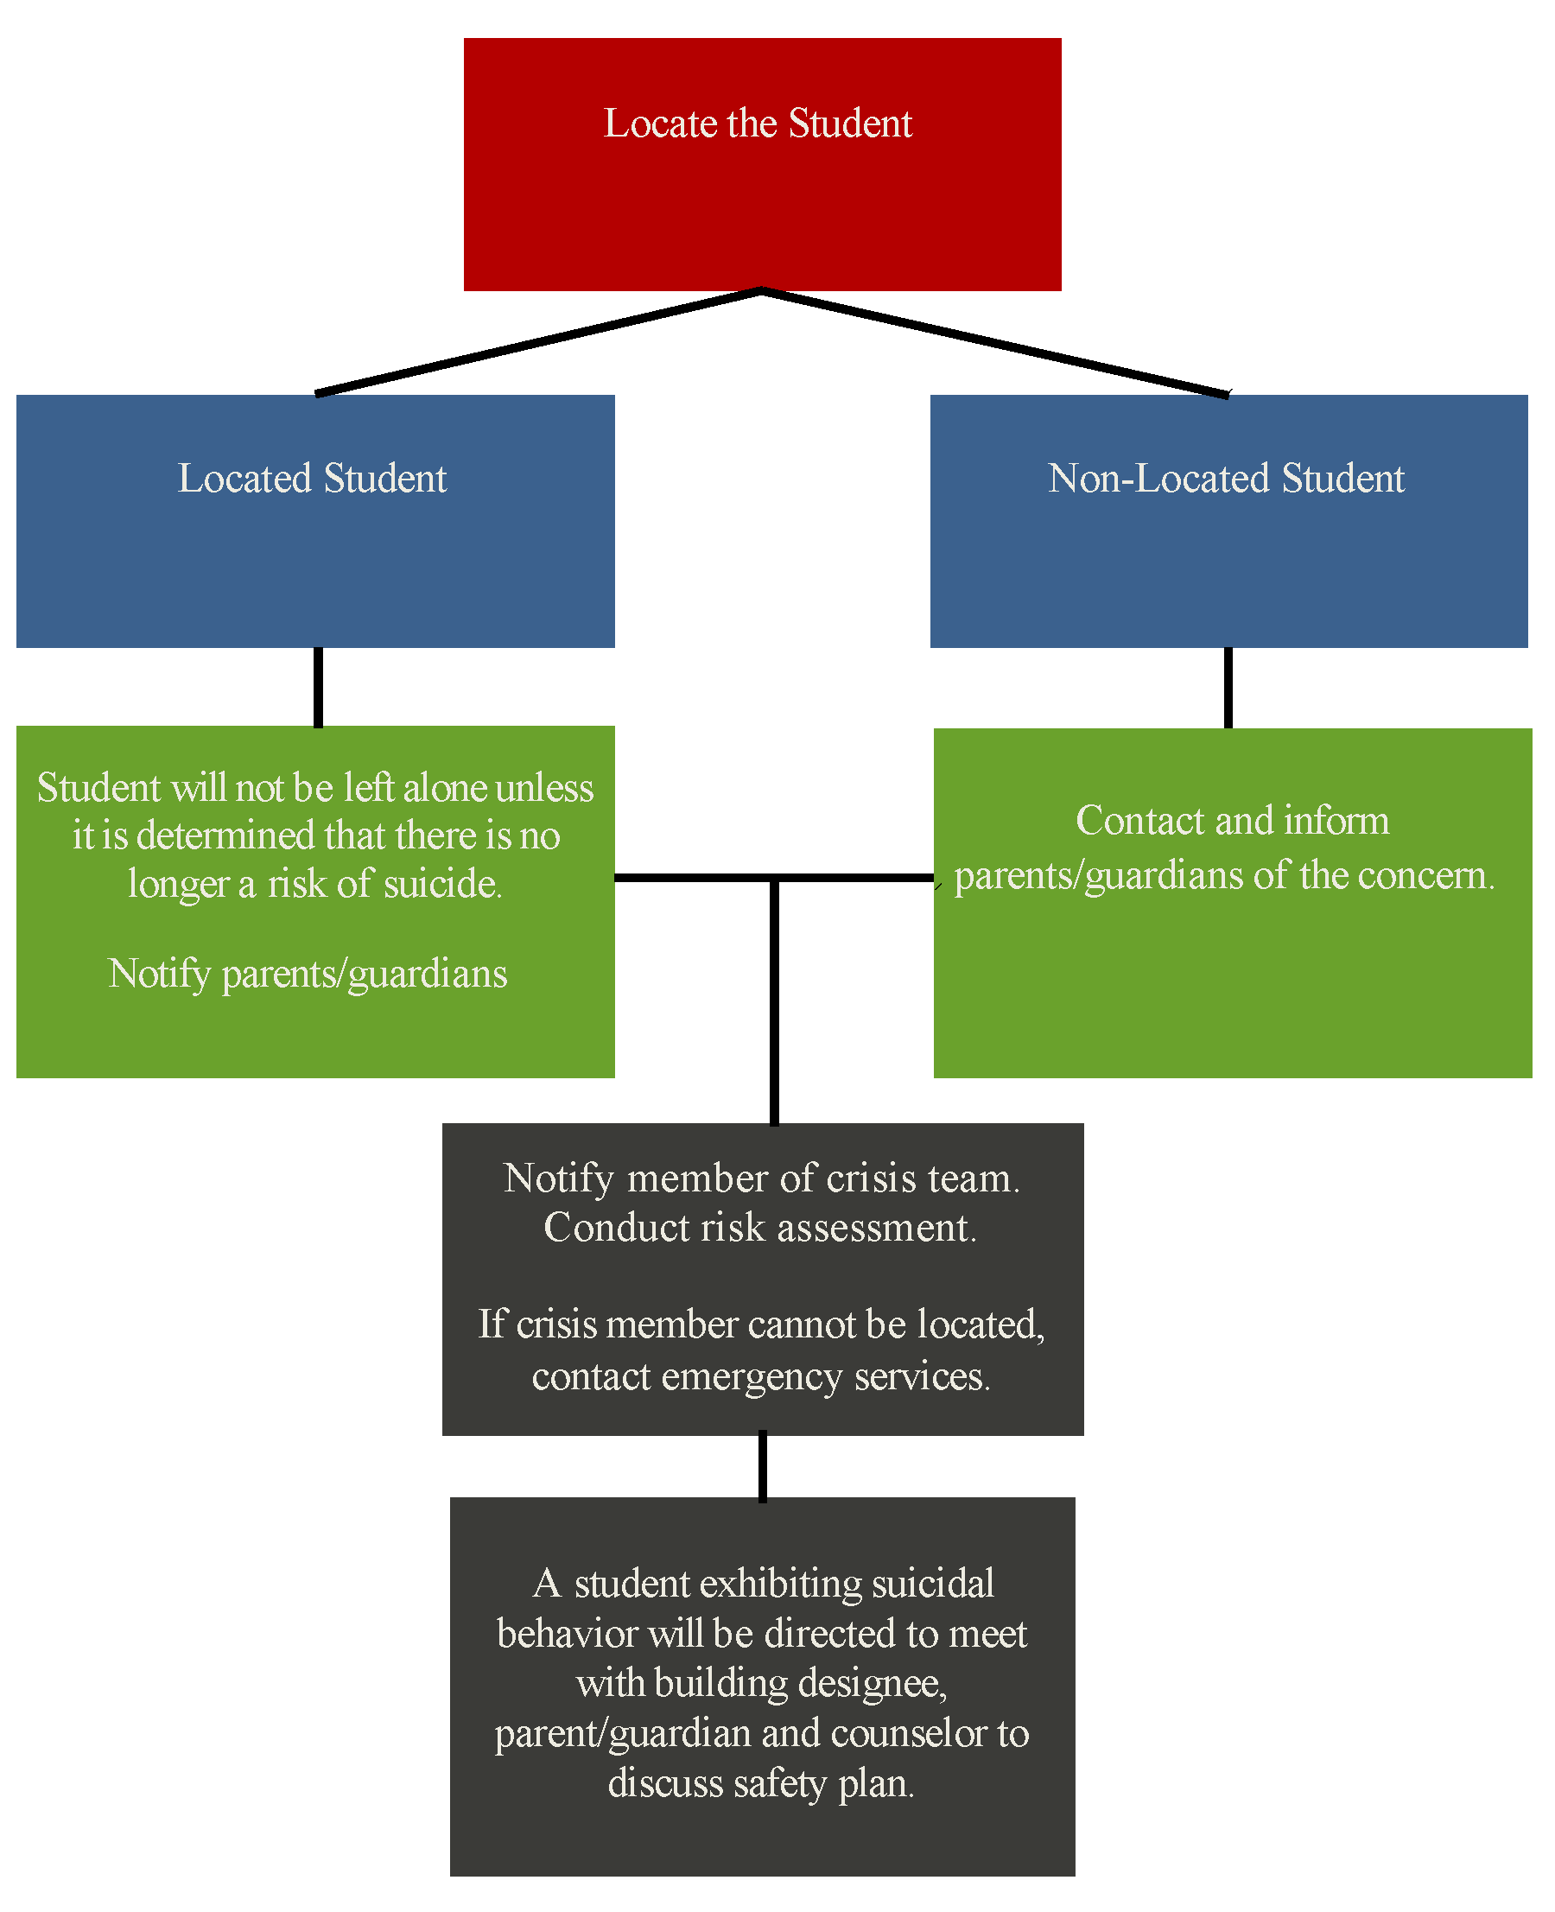

Students Who May Be at Risk of Suicide
Any district employee who has a reasonable belief that a student may be at risk of suicide, even if the student is not having a suicide crisis as defined in this policy, will take the following steps:

- Make every effort to locate the student immediately, and do not leave the student unattended.

- Notify a Crisis Response Team member as soon as possible. If the employee cannot reach any of the Crisis Response Team members, the employee will contact the student's parent/guardian. If the parent/guardian is also unavailable, or at the parent's/guardian's request, the employee will contact emergency services or the National Suicide Prevention Lifeline (800-273-8255). As soon as practical, the employee will notify a member of the Crisis Response Team.

When a Crisis Response Team member receives notification that a student may be at risk of suicide, he or she will take the following steps:

  - If the student cannot be located or leaves after being located, a Crisis Response Team member will contact the parent/guardian to explain the district's concern.

  - If the student has been located, a Crisis Response Team member will use an evidence-based/informed tool to determine whether the student is at risk of suicide and take the appropriate response. Regardless of the determination, a member of the Crisis Response Team will contact the student's parent/guardian to discuss the concern.

  - If it is determined that the student may be at risk of suicide, a Crisis Response Team member will meet with the student and his or her parents/guardians to discuss support and safety systems, available resources, coping skills and collaborative ways to support the student.

3. Procedures for Parent Involvement
A member of the crisis response team, the building administrator or his/her designee shall reach out to the parents/guardians of a student identified as being at risk of suicide to consult with them about the risk assessment of their student, to make them aware of community resources, and to discuss how to best support the student’s mental well-being and safety.
If the parent refuses to cooperate or if there is any doubt regarding the student’s safety, local mental service providers and/or law enforcement may need to be engaged, and a report may need to be made to the Child Abuse and Neglect Hotline.
Contact with a parent concerning risk of suicide will be documented in writing.

Confidentiality

Employees are required to share with the Crisis Response Team any information that may be relevant in determining whether a student is at risk of suicide, is having a suicide crisis or is otherwise at risk of harm. Employees are prohibited from promising students that information shared by the student will be kept secret when the information is relevant to the student's safety or the safety of another person.

Release of a student's individually identifiable education records will be made in accordance with the Family Educational Rights and Privacy Act (FERPA). In accordance with FERPA, information contained in a student's education records may be revealed at any time to the student's parents/guardians and school personnel who have a legitimate interest in the information. Education records may be shared with other appropriate persons when necessary to protect the health, welfare, or safety of the student or others.

4. School and Community Resources
A student exhibiting suicidal behavior will be directed to meet with the building designee, their parent/guardian and counselor to discuss support and safety systems, available resources, coping skills and a safety plan as necessary.
The district will, in collaboration with local organizations and the Missouri Department of Mental Health, identify local, state and national resources and organizations that can provide information or support to students and families. A basic list of resources can be found on the Department of Mental Health website and the district will strive to develop its own list of local resources to be made readily available.
The district will, in collaboration with local organizations and the Missouri Department of Mental Health, identify local, state and national resources and organizations that can provide information or support to students and families. Copies of or links to resources will be available to all students and families on the district's website and at the school.

A member of the Crisis Response Team will periodically follow up with students and parents/guardians of students who have been identified as being at risk of suicide or who have had a suicide crisis to offer additional assistance.

Local Resources | Agency Contact Information
Behavioral Health Care-OMC | 417 257-6762
Families First, Kim Barnes, LCSW | 417 293-8568
Caring Connection, Christy Hoover, LPC | 417 293-6273
Missouri Children’s Division-Howell County | 855-373-5636

Additional Resources listed in Appendix C

5. Responding to Suicidal Behavior or Death in the School Community
When the school community is impacted by suicidal behavior or a death by suicide, the district will confer with their crisis response teams and, when appropriate, confer with local community resources and professionals to identify and make available supports that may help the school community understand and process the behavior and/or death.
The crisis response team, the building administrator or his/her designee will determine appropriate procedures for informing the school community of a death by suicide and the supports that will be offered. Staff and students who need immediate attention following a death by suicide will be provided support and resources as determined necessary.

6. Suicide Prevention and Response Protocol Education for Staff
All district employees will receive information annually regarding this policy and the district’s protocol for suicide awareness, prevention and response. The importance of suicide prevention, recognition of suicide protective and risk factors, strategies to strengthen school connectedness and building specific response procedures will be highlighted.
Such information shall include the following:
- Current trends in youth mental health, wellbeing and suicide prevention and awareness
- Strategies to encourage students to seek help for themselves and other students
- Warning signs that indicate a student may be at risk of suicide
- The impact of mental health issues and substance abuse
- Communication to students regarding concerns about safety and that asking for help can save a life
- Understanding limitations and boundaries for giving help and techniques to practice self-care
- Identification of key school personnel who are comfortable, confident and competent to help students at risk of escalated distress and suicide

All district staff will participate in professional development regarding suicide awareness and prevention.
Professional Development Training | Date Completed
Safe School Training & Quiz (All District Personnel)
Suicide Prevention and Awareness
Professional Development Workshop-Counselor Led. All District Personnel in attendance.
Response Training
Suicide Prevention/Awareness Training
Policy reviewed by entire district personnel
Procedures/Questions and Answers
Teacher In-Service (Jason Foundation Training) Mrs. Hayes

7. Suicide Prevention Education for Students
Starting no later than fifth grade, students will receive age appropriate information and instruction on suicide awareness and prevention. Information and instruction may be offered in health education, by the counseling staff or in other curricula as may be appropriate.
- Information about mental health, well-being and suicide prevention and awareness
- Promotion of a climate that encourages peer referral and which emphasizes school connectedness
- Recognition of the signs that they or peers are at risk for suicide
- Identification of issues that may lead to suicide including depression, anxiety, anger, and drug/alcohol dependency
- Directive to not make promises of confidence when they are concerned about peer suicide
- Identification of a trusted adult on campus with whom students can discuss concerns about suicide

Student Education | Curriculum/Lesson Plans Used | Person Responsible | Dates
Counselor Push-In Schedule 5th through 8th Grade (Monthly) | Signs of Suicide Program | Mariah Hayes | Monthly during September-May
Health Curriculum |  | Kevin Browning | Fall 2018
PE Curriculum |  | Browning/ Kutter | Monthly September-May

Lessons will be documented on a yearly basis as to topic of lesson and date in which information was covered.

8. Publication of Policy
The district will notify employees, students and parents of this policy by posting the policy and related procedures and documents on the district’s website and discussing this policy during employee training as detailed herein. July 2018

APPENDIX

Appendix A- DESE Suggested Guidelines for training/professional development

Protective Factors for Suicide
Protective factors buffer individuals from suicidal thoughts and behavior. To date, protective factors have not been studied as extensively or rigorously as risk factors. Identifying and understanding protective factors are, however, equally as important as researching risk factors.
- Effective clinical care for mental, physical and substance abuse disorders
- Easy access to a variety of clinical interventions and support for seeking help
- Family and community support (connectedness)
- Support from ongoing medical and mental health care relationships
- Skills in problem solving, conflict resolution and nonviolent ways of handling disputes
- Cultural and religious beliefs that discourage suicide and support instincts for self- preservation

Risk Factors for Suicide
A combination of individual, relationship, community, and societal factors contribute to the risk of suicide. Risk factors are those characteristics associated with suicide they might not be direct causes.
- Family history of suicide
- Family history of child maltreatment
- Previous suicide attempt(s)
- History of mental disorders, particularly clinical depression
- History of alcohol and substance abuse
- Feelings of hopelessness
- Impulsive or aggressive tendencies
- Cultural and religious beliefs (e.g., belief that suicide is a noble resolution of a personal dilemma)
- Local epidemics of suicide
- Isolation, a feeling of being cut off from other people
- Barriers to accessing mental health treatment
- Loss (relational, social, work or financial)
- Physical illness
- Easy access to lethal methods
- Unwillingness to seek help because of the stigma attached to mental health and substance abuse disorders or to suicidal thoughts

Centers for Disease Control - Risk and Protective Factors

Suicide Prevention Training (Department of Mental Health) https://dmh.mo.gov/mentalillness/suicide/training.html

Appendix B- Chart of Evidence-Based and Research Based Programs
 | Signs of Suicide (SOS) | Lifelines * | More Than Sad | Talk Saves Lives | Question Persuade Refer (QPR)* | Youth Mental Health First Aid
Audience | Universal student, middle, high school, parent and staff modules | Whole school | Youth in grades 6-12 | Anyone over age 15 | Adult gatekeepers  Includes special course for school health professionals focused on youth | Adult gatekeepers  (parents/caregivers, teachers, coaches, religious leaders, medical staff, etc.)  Information focused on ages 12-  18
Costs | $500 for SOS kit, $1000 for implementer training, limited funding available through Missouri Department of Mental  Health (MDMH) | $500 for curriculum,  $1000 for training | Free and downloadable from American  Foundation for Suicide Prevention (AFSP): optional videos and manuals available for $60  and $100 | Free | Starts at $30 per person; group training rates available; online training available  School professional course $79 | $150 per person, funding available through MDMH
Materials | Video, slides for presentation, BSAD depression screen and “self-ID” slip assessments for outcomes | Manuals, CD-ROMS, Videos | Downloadable materials for facilitators and participants: videos | Professional talk that can be requested from AFSP or that is given to the community on a regular basis | Online training materials, brochures and books available for download and purchase | Course materials
Time | Student – 1 classroom period Staff - 1-2 hours | 4-6 hours, meant to fit into class lesson plans | Approximately 1 hour | Varies | Gatekeeper training as short as 1 hour: more in-depth available | 8 hour course: can be split into 2 days
Evidence  of  outcomes | Evidence-based: reduced suicide attempts, improved attitudes about mental health, 10% of students come forward for help at end of presentation | Research-Based: improved attitudes about suicide and suicide prevention | Materials are research based: formal evaluation in process | Materials are research based | Research-based:  increased declarative knowledge, increased active listening skills, increased ability to make referrals | Evidence-based: improvement in recognition of symptoms, knowledge of mental health treatments and resources, confidence in providing mental health help
Internal or External trainer | External: can be internal if implementer training is taken | Internal for curriculum, external for training of trainer | Internal | External | External | External
Special features | Gives youth a tool for helping self and others through the A.C.T.  technique. (ACKNOWLEDGE  the signs of suicide, respond with CARE, and TELL a responsible adult.) | Three modules: whole school community students, staff and parents, module for staff focused on at- risk youth and postvention | Teacher materials: “complies with teacher education suicide prevention requirements in many states” | Talks with special  focus available, such  as GLBT community | A special tool for adults likened to CPR for suicide prevention | Developed and disseminated by Missouri Department of Mental Health
*Currently classified as Legacy program under National Registry of Evidence-based Programs and Practices (NREPP) as program has not been re-reviewed under NREPP’s new criteria for evidence-based.
These resources were derived from the collective work of members of the Legislative Workgroup. Listing these resources and information does not constitute endorsement by the Department of Elementary and Secondary Education.

Appendix C- Available Community Resources

**Inclusion on this list does not constitute an endorsement or recommendation by Glenwood R-VIII School District. This list is provided as a service to the families of this district.**

National Suicide Prevention Lifeline 1.800.273.8255 (TALK)
TTY: 1-800-799-4889 (hearing impaired)
The national network of local crisis centers that provides free and confidential emotional support to people in suicidal crisis or emotional distress 24 hours a day, 7 days a week. http://suicidepreventionlifeline.org

Access Crisis Intervention: ACI
Regional telephone hotlines staffed by mental health professionals who can respond to your crisis 24 hours per day, 7 days per week. They will talk with you about your crisis and help you determine what further help is needed, for example, a telephone conversation to provide understanding and support, a face-to-face intervention, an appointment the next day with a mental health professional, or perhaps an alternative service that best meets your needs. They may give you other resources or services within your community to provide you with ongoing care following your crisis. All calls are strictly confidential. MOCARS operated through Ozarks Medical Center – Behavioral Health. MCCARS Hotline 1-800-356-5395

Burton Creek Medical Clinic
805 N. Kentucky Ave. (417) 256-2111
Megan York, MSW, LCSW
LuAnn McKee, MSW, LCSW
In addition to medical services, Burton Creek Medical Clinic has two in-house therapists who are able to serve children, individuals, and families. Payment options include Medicaid, Medicare, private insurance, self-pay, and sliding fee scale for those who qualify.

Catherine Newton, LCSW, LLC.
OZBI 408 Washington Ave. West Plains, Mo. (417) 247-9888 or (417) 255-8783
Catherine Newton, LCSW
Catherine Newton provides therapy services at the Ozarks Small Business Incubator. She serves multiple client groups. Please call for payment option information.

Curtis Counseling, LLC.
1880 E. Maricopa Ave. Ozark, Mo. (417) 252-1942
Laura Curtis, MS, LPC
Laura Curtis proves counseling services to improve the quality of life for families experiencing problematic behaviors relating to, but not limited to, ADHD, Attachment Disorders, divorce and custodial issues, issues related to foster care, and other behavioral issues. She currently serves individuals, children, families, and groups. Current payment options are self-pay and sliding fee scale.

Diversified Consulting and Mediation, LLC.
3407 Division Dr. (417) 256-0224
Ada Evans, MSW, LCSW
Ada Evans provides therapy for children, couples, and families. She offers family mediation services related to custody, visitation, parenting responsibilities, and some parenting classes. Payment options include self-pay and limited Medicaid.

Families First
Kim Barnes, MSW, LCSW (417) 293-8568
Ms. Barnes provides therapeutic services to children, individuals, and families. She also provides some limited in-home counseling. Payment options include Medicaid, Medicare, insurance, self-pay, and some sliding fee scale.

Howell County Sheriff’s Office
1106 Missouri Ave (417) 256-2544
417-256-4102 (non-emergency)

Mahan Therapy Services
3407 Division Dr. West Plains, Mo. (417) 256-1243 or (417) 293-8151
Elizabeth Mahan, MSW, LCSW
Ms. Mahan provides therapy on a part time basis to children, individuals, and families. She accept self-pay or reimbursement through the Employee Assistance Program (EAP).

Midwest Counseling and Assessment
OZBI 412 Washington Ave. West Plains, Mo. (417) 255-8790
Jenny Long, PsyD. Licensed Psychologist
Jessica Foster, LPC-S
This group offers a variety of counseling, assessment, and e-therapy services. Please call for payment option information.

Mental Health Guidance and Counseling
1208 Porter Wagoner Blvd. #5 (417) 256-4104
Matthew Green, MS, LPC
Mr. Green provides counseling and therapeutic services to individuals, couples, and families. Payment options include Medicaid, Medicare, private insurance, self-pay, and sliding fee scale for those who qualify.

New Horizons Counseling, LLC.
2627 St. Rt. U Willow Springs, Mo. – Temporary Address (417) 372-7155
Dominica Kiefer, MS, LPC
Ms. Kiefer provides counseling services to children, individuals, couples, and families. Payment options include self-pay and sliding fee scale with insurance and Medicaid/Medicare rights in application.

Ozarks Medical Center- Hospital
1100 North Kentucky Ave. (417) 256-9111

Ozarks Medical Center – Behavioral Health Care
1211 Porter Wagoner Blvd. (417) 257-6762
Community based services for mental health needs including counseling, medication services, and case management services for adults and children. Services are available through intake. Payment options include Medicaid, Medicare, private insurance, and self-pay on a sliding fee scale. Other services may be available depending on the need of the client.

Southern Missouri Community Health Center
1137 Independence Dr. West Plains, Mo. (417) 255-8464
Elizabeth Mahan, MSW, LCSW
Joseph Hackworth, MSW, LCSW
Southern Missouri Community Health Center currently has two in-house therapists to address mental health needs. Payment options for both therapists include Medicaid, Medicare, private insurance, self-pay, and a sliding fee scale for those who qualify.

West Plains Police Department
1912 Holiday Lane (417) 256-2244

Appendix D- Definitions

Evidence-based programs—Programs that have undergone scientific evaluation and have proven to be effective.

Mental health—The capacity of individuals to interact with one another and the environment in ways that promote subjective well-being, optimal development and use of mental abilities (cognitive, affective, and relational).

Non-suicidal self-injury—Self-injury with no suicidal intent. Same as non-suicidal self-directed violence.

Risk factors—Factors that make it more likely that individuals will develop a disorder. Risk factors may encompass biological, psychological or social factors in the individual, family and environment.

Suicidal self-directed violence—Behavior that is self-directed and deliberately results in injury or the potential for injury to oneself. There is evidence, whether implicit or explicit, of suicidal intent.

Suicidal ideation—Thoughts of engaging in suicide-related behavior.

Suicidal intent—There is evidence (explicit and/or implicit) that at the time of injury the individual intended to kill him or herself or wished to die and that the individual understood the probable consequences of his or her actions.

Suicidal plan—A thought regarding a self-initiated action that facilitates self-harm behavior or a suicide attempt often including an organized manner of engaging in suicidal behavior such as a description of a time frame and method.

Suicide—Death caused by self-directed injurious behavior with any intent to die as a result of the behavior.

Suicide attempt—A nonfatal self-directed potentially injurious behavior with any intent to die as a result of the behavior. A suicide attempt may or may not result in injury.

Suicidal behaviors—Acts and/or preparation toward making a suicide attempt, suicide attempts, and deaths by suicide.

Suicide crisis—A suicide crisis, suicidal crisis, or potential suicide is a situation in which a person is attempting to kill him or herself or is seriously contemplating or planning to do so. It is considered a medical emergency requiring immediate suicide intervention and emergency medical treatment.

