Dear Johnson Families:

Get ready! The Scholastic Book Fair is coming our way (YAY!). Choosing their own books empowers kids and inspires them to become Bolder, Prouder, and Stronger Readers. AND—as always—every book they buy earns rewards for our school.

Here’s what you need to know about the Fair, which will take place in our Media Center. The week looks like this:
PREVIEW DAYS: Monday, October17 – During school hours
Tuesday, October 18 – During school hours
PURCHASE DAYS: Wednesday, October 19 – During school hours
Thursday, October 20 – During school hours
Friday, October 21 – from 9:30 – 11:30
FAMILY NIGHT: Tuesday, October 18 – from 4:30 pm – 7:00 pm

This year, say goodbye to cash and hello to eWallet—your child’s digital payment account. Before the Fair, set up eWallet for worry-free, cash-free purchases. Anyone can contribute! Share each child’s eWallet so friends and family can add funds and give your kids more books to enjoy.

If you can’t make it to the Fair, then shop at our school’s Online Book Fair. All orders ship directly to your home, and shipping is free for book orders over $25. Your online orders will also benefit our school.

We also need volunteers to run our Book Fair. If you would like to volunteer please use QR code below.

Happy reading,
Josh Gignac Jill Mondrush
Principal Media Technician (Book Teacher)

Online Book Fair Volunteer Sign up
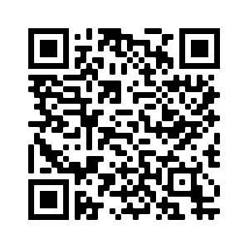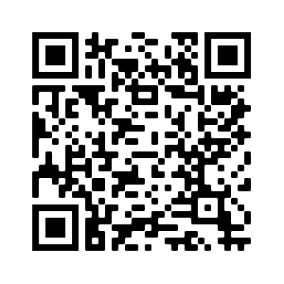

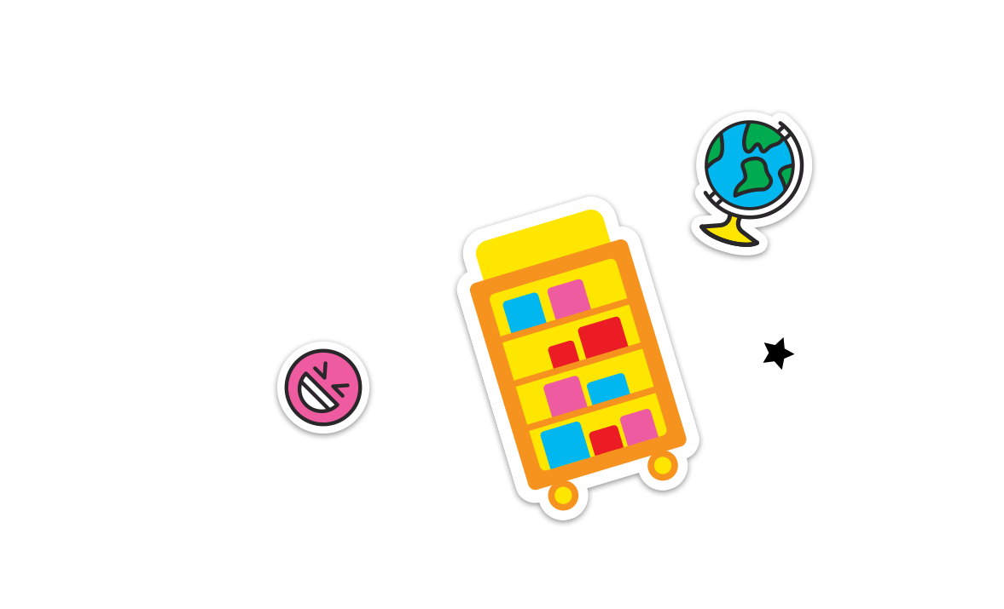
Permission to reproduce this item is granted by Scholastic Book Fairs®.
©2022 Scholastic Inc. All rights reserved. 2580250 F22 • 2580301

