Lancaster County Public Schools
October 2018 Lunch Menu for;
Lancaster Primary, Middle, & High School
Monday | Tuesday | Wednesday | Thursday | Friday
1)WG Corn Dog Nuggets  Carrots  Potato Wedges  Sliced Apples  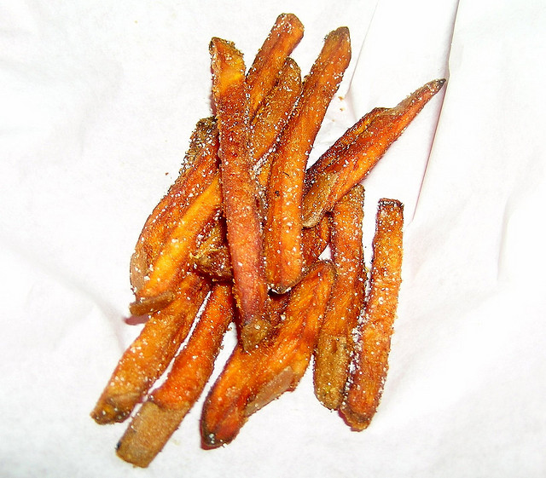 | 2) WG Chicken Nuggets  Green Beans  Mixed Fruits  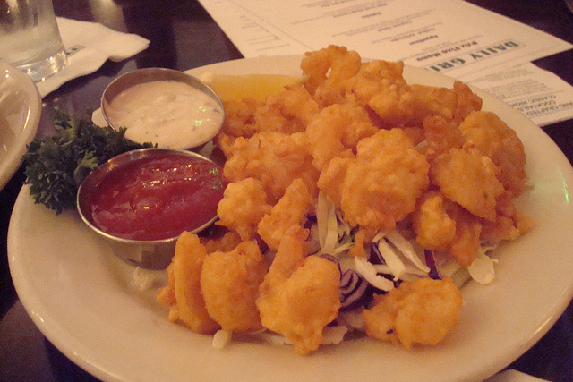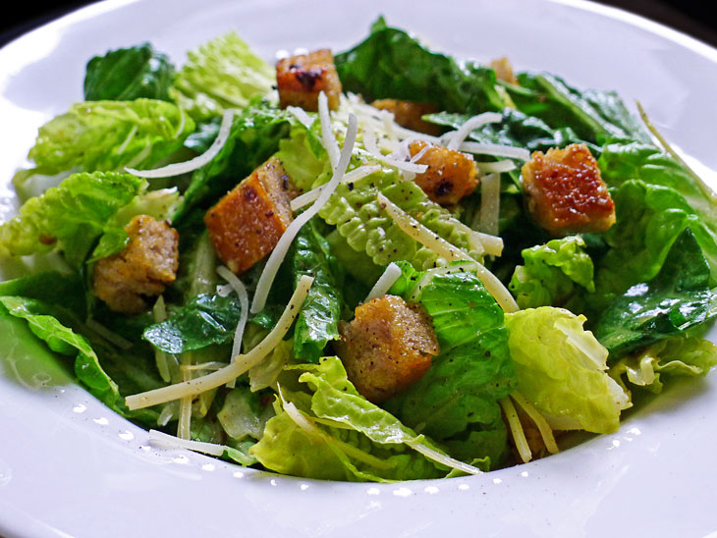 | 3) WG Pepperoni Pizza  Corn  Strawberry cup  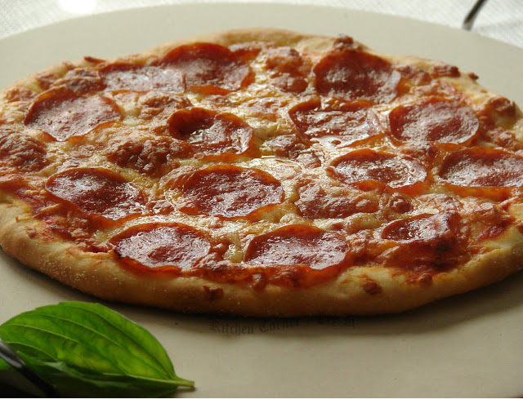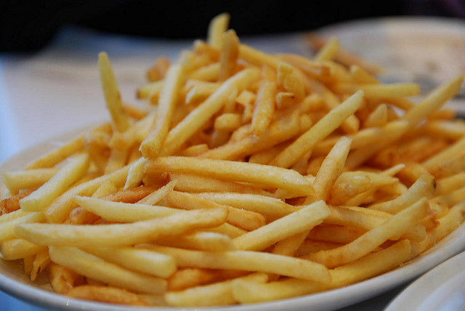 | 4) WG Baked Spaghetti  Broccoli  Pears  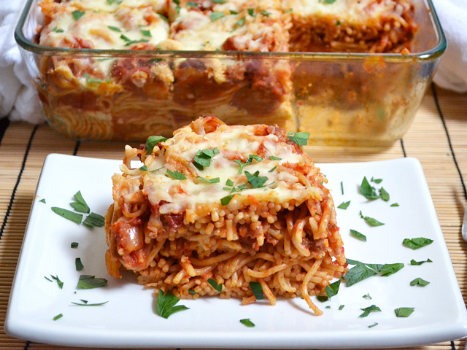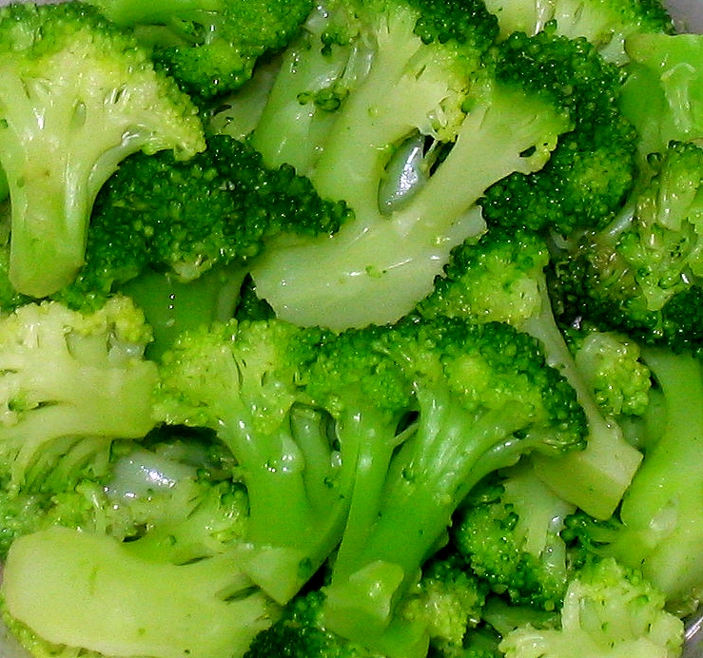 | 5) Cheeseburger/ WG bun  Baked Beans  Fresh Fruit  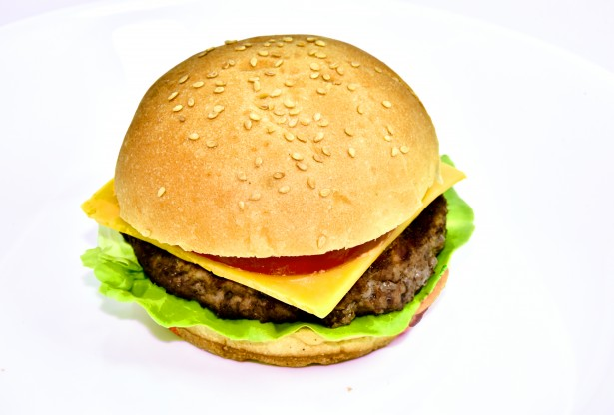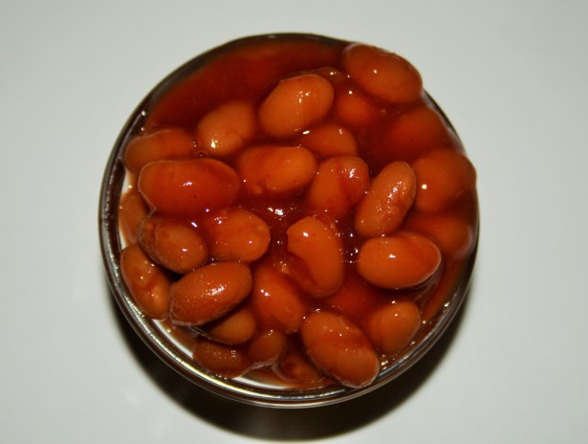
8) No school  Columbus Day  Holiday | 9) Chicken Patty  WG Bun  Potato Tots  Peas  Sliced Apples  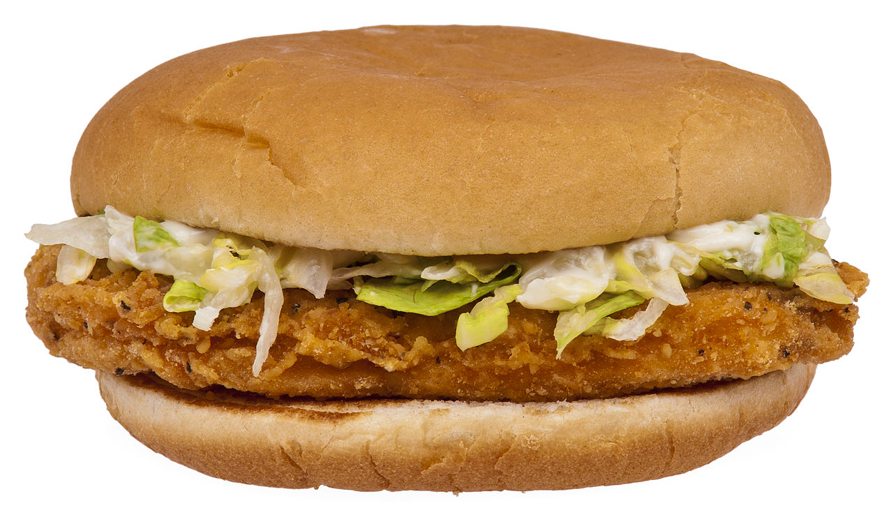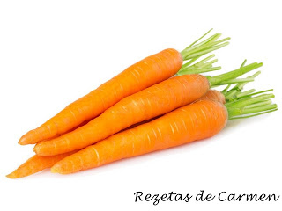 | 10) WG Pepperoni Pizza  Stuffed Crust  Green Beans  Peaches   | 11) Meat Loaf  WG Roll  Mashed Potatoes  Strawberry cup  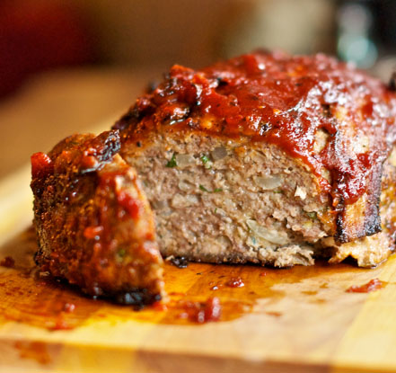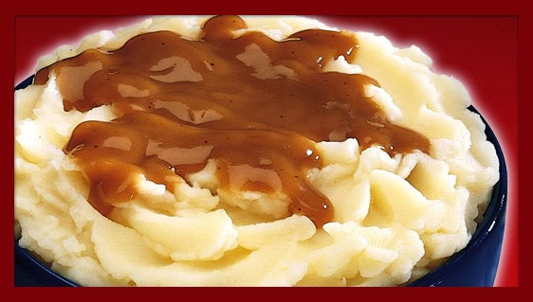 | 12) Steak & Cheese  WG Bun  Baked Beans  Fresh Fruit  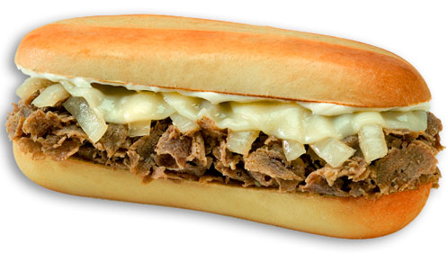
15) WG Corn Dog stick  Sweet Potatoes  Peaches  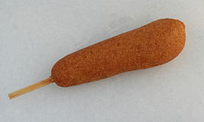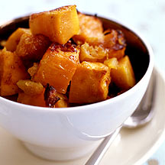 | 16) Turkey Taco  Tortilla Chips  Corn  Mixed Fruit  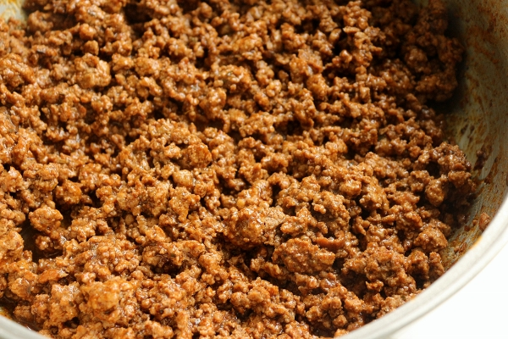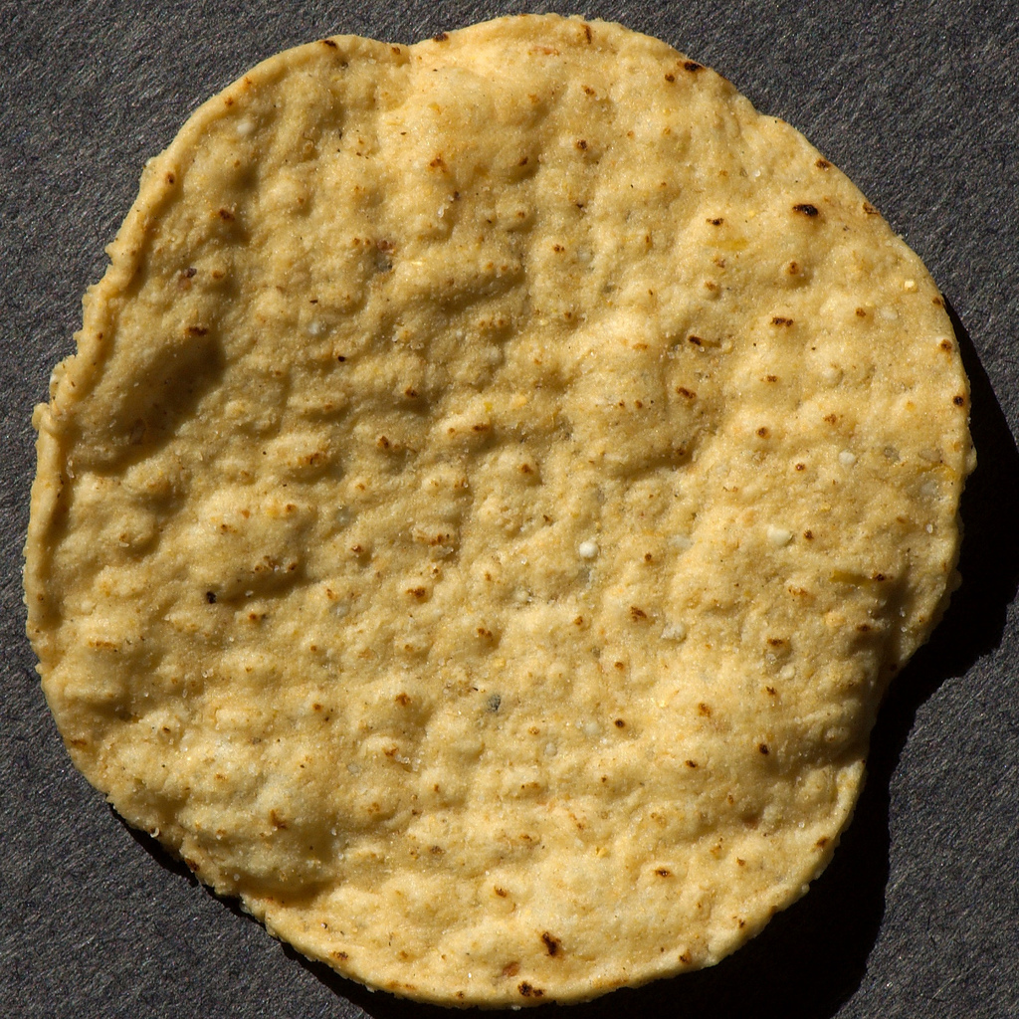 | 17) WG Turkey Sausage  Pizza  Green Beans  Pineapple Chunks  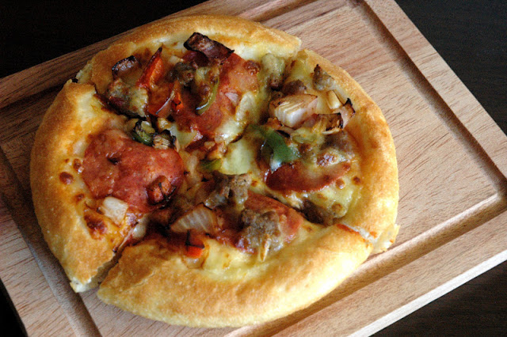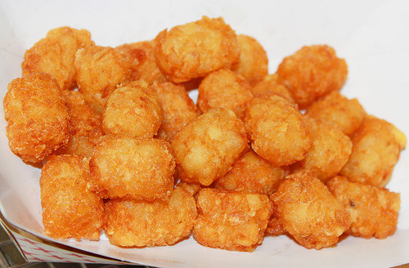 | 18) WG Chicken Nuggets  Peas  Applesauce  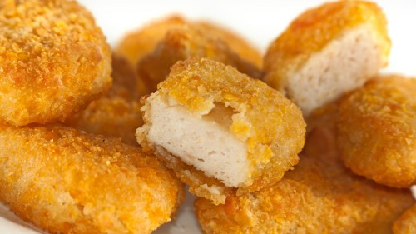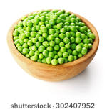 | 19) Cheeseburger on a  WG Bun  Baked Beans  Fresh Fruit
22) Turkey Hot Dog  WG Bun  Sweet Potato Waffles  Mixed Fruit  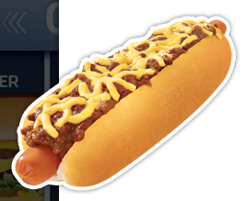 | 23) WG Chicken Patty  WG Bun  Potato Wedges  Applesauce  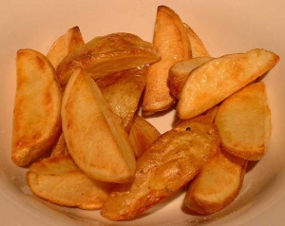 | 24) WG Cheese Pizza  Side Salad  Jell-O w/Fruit  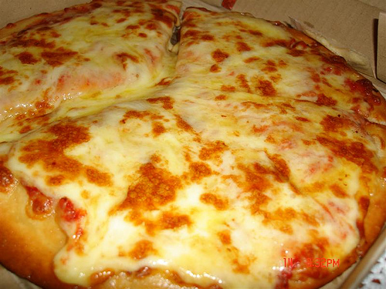 | 25) Orange Chicken  WG Rice  Broccoli  Pineapple   | 26) Steak & Cheese  WG Bun  Baked Beans  Fresh Fruit
29) Beef Rib Patty BBQ  WG Bun  Potato Smiles  Jell-O w/ Fruit  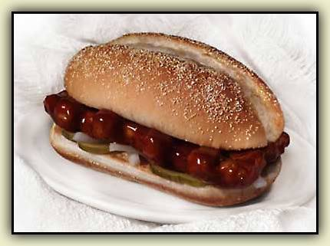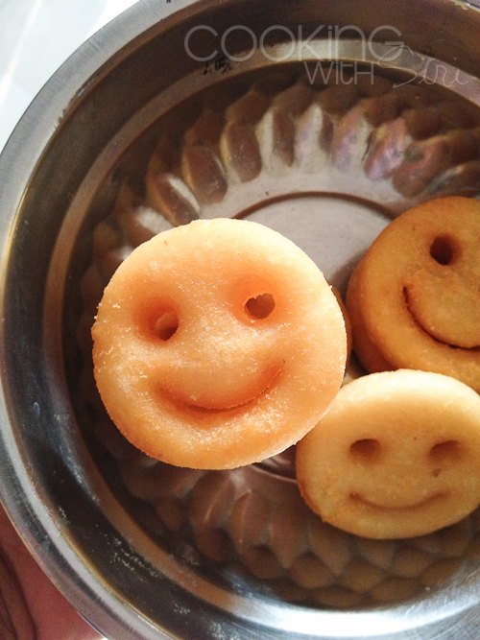 | 30) WG Chicken Tenders  Broccoli  Applesauce  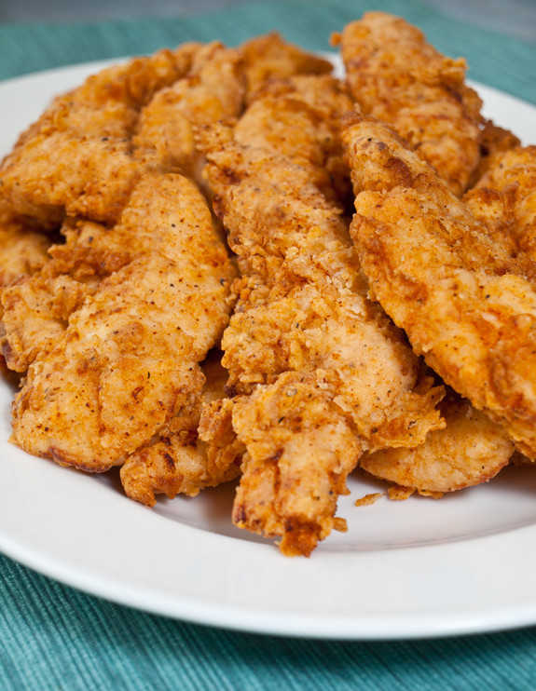 | 31) Cheeseburger on a  WG Bun  Baked Beans  Peaches
WHAT IS OFFER V SERVE, & REIMBURSEABLE MEALS?
*WE OFFER FIVE COMPONENTS FOR LUNCH; A MEAT/MEAT ALTERNATE, A VEGETABLE, A FRUIT, A WG BREAD/GRAIN, AND MILK.
STUDENT CAN CHOOSE ALL FIVE, OR THEY CAN CHOOSE 4, OR 3 COMPONENTS, BUT 1 MUST BE A FRUIT, AND OR VEGETABLE.
A REIMBURSEABLE MEAL IS THREE, OR MORE OF THESE COMPONENTS, ONE OF THEM MUST BE A FRUIT AND OR VEGETABLE. PRIMARY & MIDDLE SCHOOL STUDENTS MAY REQUEST ¾ CUPS OF VEGETABLES DAILY; HIGH SCHOOL STUDENTS MAY REQUEST 1 CUP OF VEGETABLES DAILY.
AN EXAMPLE OF A REIMBURSEABLE MEAL: (A CHEESEBURGER, ½ or 1cup of BROCCOLI IS A REIMBURSEABLE MEAL).
ANOTHER EXAMPLE IS; (CHICKEN TENDERS 1/2 or 1 cup of MIXED FRUIT, and MILK IS A REIMBURSEABLE MEAL).
ANOTHER EXAMPLE: (A SLICE OF PEPPERONI PIZZA, 1 cup of ROMINE, SPINACH SALAD IS A REIMBURSEABLE MEAL).
ANOTHER EXAMPLE: (CHICKEN NUGGETS, A WG ROLL 3/4 or 1 cup of CORN, and MILK, IS A REIMBURSEABLE MEAL).
ANOTHER EXAMPLE :( HOT DOG on a WG BUN, ¾ or 11/4 cup of CARROTS, & ½ or 1 cup of APPLESAUCE, IS A REIMBURSEABLE MEAL)
*THE LARGER PORTIONS ARE REQUIRED AT THE HIGH SCHOOL LEVEL.*
(***Condiments for lunch; Catsup, Mayonnaise, Honey Mustard, Barbeque sauce, Mustard & Dressing***)
NOTE:
Due to the menu being done in advance, product shortages, or items being out of stock at the warehouse;
***THE MENU IS SUBJECT TO CHANGE WITHOUT NOTICE***
In accordance with Federal civil rights law and U.S. Department of Agriculture (USDA) civil rights regulations and policies, the USDA, its Agencies, offices, and employees, and institutions participating in or administering USDA programs are prohibited from discriminating based on race, color, national origin, sex, disability, age, or reprisal or retaliation for prior civil rights activity in any program or activity conducted or funded by USDA.
Persons with disabilities who require alternative means of communication for program information (e.g. Braille, large print, audiotape, American Sign Language, etc.), should contact the Agency (State or local) where they applied for benefits. Individuals who are deaf, hard of hearing or have speech disabilities may contact USDA through the Federal Relay Service at (800) 877-8339. Additionally, program information may be made available in languages other than English.
To file a program complaint of discrimination, complete the USDA Program Discrimination Complaint Form, (AD-3027) found online at: http://www.ascr.usda.gov/complaint_filing_cust.html, and at any USDA office, or write a letter addressed to USDA and provide in the letter all of the information requested in the form. To request a copy of the complaint form, call (866) 632-9992. Submit your completed form or letter to USDA by:
(1) mail: U.S. Department of Agriculture, Office of the Assistant Secretary for Civil Rights, 1400 Independence Avenue, SW, Washington, D.C. 20250-9410;
(2) fax: (202) 690-7442; or
(3) email: program.intake@usda.gov.
This institution is an equal opportunity provider.

