LOCAL SCHOLARSHIP OPPORTUNITIES

Learn More & Apply
Permian Basin Area Foundation manages more than 80 scholarship funds. To view the most current scholarship information and to complete an online application, visit the Foundation’s website, www.pbaf.org, beginning January 1, 2019.

Deadlines
The majority of Foundation scholarships have a deadline of March 31, 2019.
Please visit the website and check specific deadline dates for each scholarship.
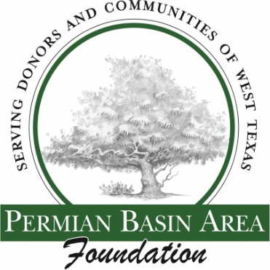
Permian Basin Area Foundation
www.pbaf.org
432.617.3213

