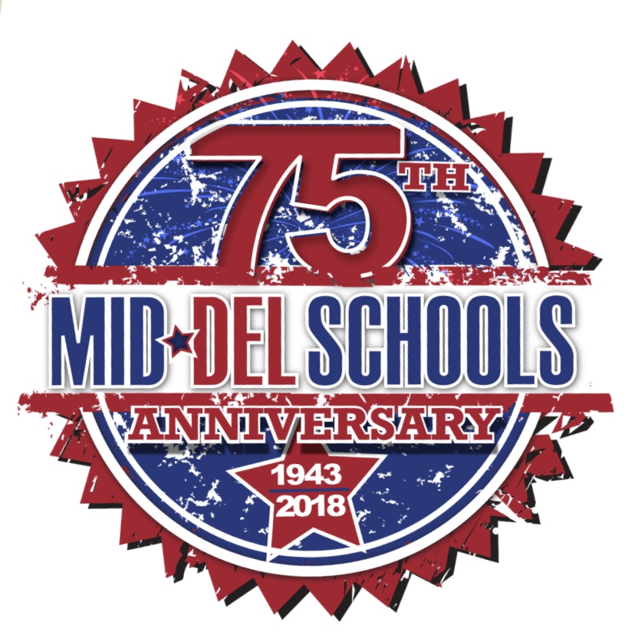

September 2018
Calendar

Monday | Tuesday | Wednesday | Thursday | Friday
 |  |  |  | 1
3  Labor Day  No School | 4 | 5  Natural Notes Practice | 6  Boy Scout Info Night  @6pm in Café  4th and 5th grade  BOTBALL APPS Due Today! | 7  Popcorn Day!  Natural Notes Practice  CA vs. Del City (A)
10  Natural Notes Practice | 11 | 12  Natural Notes Practice | 13 | 14  Natural Notes Practice  Constitution Day  Wear Red/White/Blue  CA vs. Shawnee (H)  Titan Teammate
17  NO SCHOOL  Teachers Meetings | 18  Candy Bar Kick Off  Fundraiser  Sell Candy Bars from September 19th – October 9th  Money due by Oct. 9th | 19  Natural Notes Practice  Candy Bar Boxes sent home today! | 20 | 21  Popcorn Day!  Natural Notes Practice  CA vs. Guymon (A)
24  Natural Notes Practice | 25 | 26  Natural Notes Practice | 27  Tiger Rally @ 9:30  CA Spirit Assembly  Wear CA/SC shirt | 28  Natural Notes Practice  CA Homecoming Parade @ 1pm  CA vs. Piedmont (H)

