MEMORIAL SCHOOL
BREAKFAST IN THE CLASSROOM
(BIC)

GUIDE BOOK FOR TEACHERS, PARENTS AND STUDENTS!

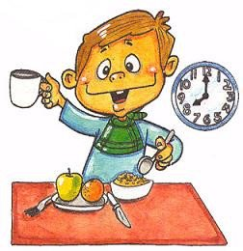

“WHY IS EATING BREAKFAST SO IMPORTANT FOR STUDENTS”

First…A child’s body uses nutrients to run their organs.
Second…A child’s body uses nutrients to GROW!
Third…Any nutrients left over after that are used for LEARNING and SOCIAL development.
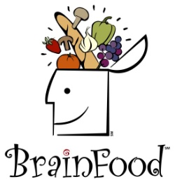

It is very important that students EAT BREAKFAST EVERYDAY so they will have enough nutrients in their bodies to BEHAVE well and ACHIEVE good grades. Students need to get the right kinds of nutrition in their bodies EVERY MORNING, not just on days they need to take a test!

Eat at least 3 or 4 FOOD GROUPS for breakfast!
A Well-Balanced Breakfast is when we eat all 4 FOOD GROUPS for Breakfast!

Milk…No-fat and 1% Fat milk
Grains…Including…cereal, muffins, granola, bagels
Fruit…such as…apples, bananas, pears, raisins, peaches, strawberries
Protein…such as…cheese, yogurt, or eggs

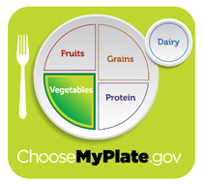

Sometimes, it is difficult for students to eat a well-balanced meal before school.
Here are some of the reasons WHY we want to serve Breakfast in the Classroom (BIC) at Memorial School.

- Kids have to catch the bus VERY early in the morning.
- Parents have to get to work early and some students attend day care.
- Some students don’t want to eat early in the morning when they first get up.
- It’s hard (and not very safe) to eat in the car, and students are not allowed to eat on the bus.
- Hanging out with friends is more fun to students than eating.
- Students don’t have hands available to eat—carrying projects, books, instruments, sport bag etc.
- KIDS ARE TOO SLEEPY!

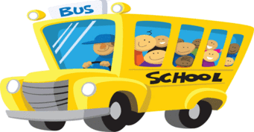

REMEMBER…When students EAT TOGETHER they LEARN about each other. When students KNOW EACH OTHER better, they WORK TOGETHER better. When they WORK TOGETHER better, they ACHIEVE TOGETHER better!

Taking Breakfast…It’s as simple as…
- Grab a breakfast bag plus a milk and/or fruit.
- Teacher or student will need to check off name on attendance roster.
- ENJOY A Healthy Breakfast!

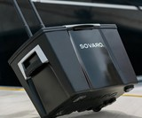

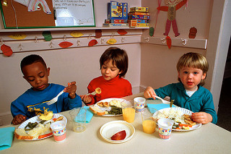

Some Kids eat…

At their Desk…
Or at a Group Work Table…
Some may also do school work or work together in small groups.

Set Up Breakfast in your Classroom…
- Set up BIC Cooler (near entrance to room), Attendance Roster & Pencil, and a “Share Bin” or “Snack Bin” on your designated “Breakfast Service Table/Area”.
- Have a designated area for your BIC trash barrel.

It’s Time to Clean Up!
- Close juice and milk and/or juice tight!
- Put trash in breakfast bag.
- Check floor for any trash…pick up.
- Throw in BIC trash barrel.
- Wipe any spills, clean table/desk area, and wipe hands.

Didn’t Eat Everything?...
- Donate UNOPENED food to the “share bin” or “snack bin” (cereal, bagels, muffins, raisins, crackers, apples, bananas)
- Unopened Perishables (milk, juice, cheese, egg items, yogurt) go back into the BIC cooler. (If you have a cold storage area in your POD feel free to store there).

*Have a BIC Cooler “parking station” outside your entrance when breakfast is done. Put attendance roster in BIC Cooler!

TEACHER REMINDERS…
1 child + 1 meal = 1 check mark

Double check your accuracy. Please check student names on the attendance roster as they take one meal in the breakfast bag, one milk and/or one fruit.
Suggestion…check for accuracy when students are finishing and cleaning up.

THIS IS VERY IMPORTANT…the attendance roster goes in the BIC Cooler when you are done. Have cooler in the “parking station” outside your entrance for pick up.

As routines are established students can be given jobs of cleaning, checking for trash and/or spills, and placing the BIC cooler in the “parking station”
**Also, first floor classrooms can consider assigning a job to students to take the BIC cooler back to the café. (Fleming, Mizhir, Leblanc, Bailey, Boucher, ALL Room).

How can we SAFELY use leftover FOOD from the SHARE BIN?!

“SHARE BIN” food is for KIDS!
*Use it for a SNACK at school.
*Use if for a SNACK after school.
*Students can take it home as part of dinner.

Empty the “SHARE BIN”/” SNACK BIN” at the end of each week to avoid FOOD WASTE and ATTRACTING PESTS!

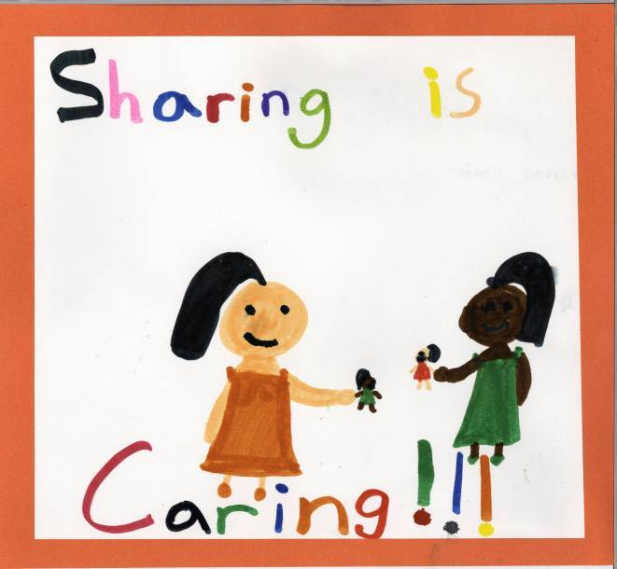

THANK YOU FOR SUPPORTING OUR STUDENTS AND THE “BREAKFAST IN THE CLASSROOM PROGRAM” AT MEMORIAL SCHOOL.

