ANNUAL NOTIFICATION TO PARENTS, STUDENTS AND EMPLOYEES OF THE NEW ENGLAND PUBLIC SCHOOL DISTRICT
2018-2019

In 1986 Congress enacted the Asbestos Hazard Emergency Response Act (AHERA) to require all private and public schools to identify Asbestos Containing Materials (ACBM) in their school buildings and take appropriate actions to control the release of asbestos fibers. In 1987, the US Environmental Protection Agency (EPA) finalized a regulatory program, which enforces the AHERA mandate. These regulations are incorporated within the AHERA Rule (40 C.F.R. Part 763, Subpart E).

In compliance with the AHERA Rule, the New England Public School District had its school buildings inspected by an asbestos inspector, accredited by the State of North Dakota on April 3, 2018. During that inspection, areas of suspect ACBM were identified and the type, condition and locations of these ACBM were noted. Samples were taken of some or all of the suspect ACBM. Laboratory analysis of these samples confirmed the presence or absence of ACBM. Suspect ACBM not sampled and analyzed were assumed to contain asbestos. Confirmed and/or assumed ACBM currently remain in certain locations in our school building. These materials and their locations are identified in the schools Management Plan located in the District Office.

Upon confirmation of the presence of ACBM, an asbestos management planner, accredited by the State of North Dakota, developed an Asbestos Management Plan for each of the school buildings within our District. The Asbestos Management Plan includes a description of the measures currently being taken to ensure that the ACBM remaining in our school buildings are maintained in a condition that will not pose a threat to the health of our students and employees. The plan describes past response actions taken to abate ACBM, as well as response actions planned for the future. Information is provided on the periodical monitoring of the condition of ACBM remaining in our school buildings through periodic inspections. In addition, asbestos awareness training is provided for all maintenance and custodial staff to ensure compliance with regulatory requirements.

A copy of the Asbestos Management Plan is available for your review in the School District’s administrative Office during regular office hours. The Superintendent is the assigned designated Asbestos Program Coordinator for the School District. Please direct all inquires regarding the plan to the Superintendent, Kelly Koppinger.

Sincerely,
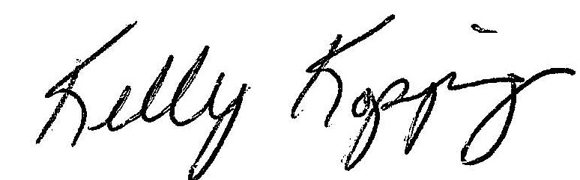

Kelly Koppinger

