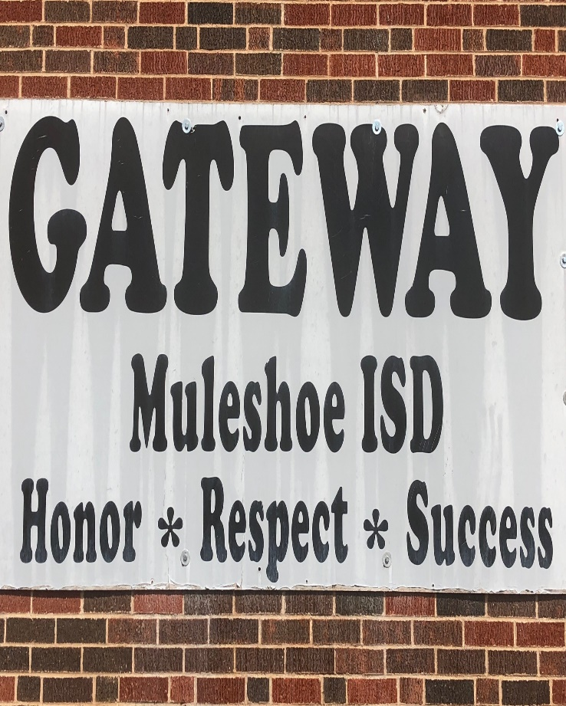  Muleshoe ISd  Gateway alternative placement  514 East Ave G  Muleshoe, texas  806-272-7350 | MULSESHOE ISD Gateway Alternative Placement student-Parent Handbook 2018-2019  Dear Student and Parent: This Handbook is designed to help you understand the general nature and purpose of Gateway and to provide you with information regarding procedures, rules and regulations of the program.

Summary

The purpose of the GAP is to assist you in achieving goals/ skills, which will lead to successful adjustment of the student at the home campus.

Specific objectives of an assignment to the GAP Center are:
- Offer professional help to correct students’ inappropriate behavior.
- Work with school personnel to identify and correct factors which adversely affect the education of children.
- Eliminate the environmental distractions that may influence the student toward negative/ inappropriate behavior.
- Provide a continuous instructional program focusing on TEKS Objectives and STAAR.

Please be aware that the GAP Program is designed to assist your student to provide him/her with the necessary help to integrate them back to their campus. When both students and families are committed and involved, it is possible for tremendous gains to be realized at home and in the classroom.

Table of Contents

Muleshoe Independent School District Gateway Alternative Placement 4
Goals 6
Objectives 6
Muleshoe Independent School District GAP Admissions 6
Student Dress Code for GAP 2018-2019 School Year 6
All clothing must be student’s proper size. 6
Personal hygiene 6
Student Entering GAP 7
Muleshoe ISD Gateway Alternative Program General Information 7
Assignments 7
Attendance/ Tardy Policy 7
Backpacks, purses and other personal items 7
Cameras 7
Cooperative Behavior 7
Doctor’s Notes 7
Driving to school 7
Electronics Communications Systems 7
Electronic Devices 8
Metal Detectors Wand 8
Outside Food and Drinks 8
Physical Training 8
Restroom Breaks 8
Student Drop Off 8
Suspension 8
Trespassing 8
GATEWAY ALTERNATIVE PLACEMENT CONTRACT 9
Calendar/ Bell Schedule 10

Muleshoe Independent School District Gateway Alternative Placement

Gateway Alternative Placement is committed to providing each student with quality education program and committed to those rights of students recognized and protected under state and federal law.
The District requires that the school environment be free of disruptions and distractions that interfere with teaching and learning activities. The District sets expectations for appropriate behaviors that contribute in a positive way to the school and community. In order for the District to ensure that students develop their fullest potential in educational experiences, there must be proper balance between rights and responsibilities.

Good discipline and the teaching of self-discipline is the ultimate goal of any discipline management system. The District operates on the premises that every student has the right to learn and every teacher has the right to teach. If students are to develop into responsible citizens for tomorrow, each student must learn the art of self-discipline today. Students must exhibit such behavior as:

- Positive self-concept
- Cooperative attitude
- Attitude of respect toward individuals
- Appropriate expression, opinions and ideas
- Responsibility for their own action
- Self-motivation
- Guidance of their own behavior
- Consideration
- Attentiveness
- Self-Control

It is the District’s responsibility to implement a program for teaching and supervisory control when students do not exhibit appropriate behavior. A plan to ensure constructive measures and essential rules must be developed.

The Muleshoe Independent School District’s Gateway Alternative Placement (GAP) is a campus program designed to assist students with problems which interfere with their education or which disrupt the educational process of the regular campus. Effective and acceptable learning channels for academics and social growth are sought and utilized in an effort to assist these students. It is the belief of the GAP adjustments as well as repetitive unacceptable behaviors will decrease through adequate training of the student’s needs. Through the provision of a relevant and supportive program, students will learn to cope with and overcome obstacles to learning and to social adjustment. This program is utilized when serious persistent misbehavior continues or when the offense warrants immediate long-term placement.

Goals

- To provide a strict, controlled climate so students can develop awareness of the need for self-discipline and self-control that will enable them to cope with everyday problems encountered by other students.
- To provide a continuous instructional arrangement to maintain or improve the student’s present academic level of achievement.
- To aid the student in establishing an awareness and acceptance of responsibility for his or her own actions.

Objectives

- Place a student in an off-campus setting where appropriate assistance may be provided to correct that student’s inappropriate behavior.
- Coordinate the efforts of school district personnel and other youth serving agencies in working with students and parents in identifying and correcting factors which adversely affect the education of children.
- Offer counseling services that stress student responsibility for all personal behavior and actions.
- Eliminate the environmental distractions that may influence the student toward negative or inappropriate behavior.
- Provide a continuous instructional program.

Muleshoe Independent School District GAP Admissions

The first step in the admission process to the GAP is a meeting with the student and the parents. Information about the GAP placement will be discussed at this meeting and all parties will sign the GAP Contract. This is an important step to establish the student, parent, and staff commitment to the GAP assignment.

Placement in GAP: Is the discretion of campus administrator; all students will be reviewed periodically for early release.

The following link is to the GAP Student Handbook on line: http://www.muleshoeisd.net

The GAP handbook must be followed by all students. Any student not adhering to the regulations and policies of the GAP will be considered for JJAEP or expulsion.

Student Dress Code for GAP 2018-2019 School Year
Students have a responsibility to come to school each day neatly groomed and dressed appropriately with the GAP shirt that will be provided by Gateway Alternative Placement. The GAP dress code is established to teach hygiene, instill discipline, prevent disruption, avoid safety hazards and provide a positive learning environment. Mr. Vela or designee has discretion in determining the appropriateness of dress and will be determined by the GAP campus dress code. If Mr. Vela or designee determines that the dress or grooming of a student is inappropriate, or does not have the appropriate shirt. The student will be allowed to correct the dress code violation and the established disciplinary procedures will be followed. If the dress code is not corrected the student will be sent home and the day will not count.

All clothing must be student’s proper size.
Other:
- No jewelry, or other body piercing articles.
- Outerwear will be searched and hung up when the student enters.
- No layers of pants, shorts, etc.
- Pockets will be emptied and all personal effects will be locked up during the school day.

Personal hygiene
- Good hygiene is a must.

If a student enters with any prohibited articles the parent or guardian will be required to come to GAP and pick up the item. Parent may be required to bring correct attire for all violations, if necessary.

Student Entering GAP

All students must maintain 100% completion of their academic work. Proper uniform shirt must be worn each day they attend GAP.
Students do not receive additional credit during lunch, but credit may be deducted for behavior and/or social misbehavior.

Muleshoe ISD Gateway Alternative Program General Information
Assignments will come from your home campus. These assignments will be made by each of your home campus teachers. You are required to complete these assignments and give them to your GAP teacher. These completed assignments will be returned to your home campus teachers for grading. If you do not receive assignments from your campus teachers the GAP administrator or teacher will assign work to each student without assignments.
Attendance/ Tardy Policy when students are absent, or tardy the parent is asked to call 806-272-7355 before 7:45 to inform GAP staff. Attendance is required. Students arriving after 8:00 will not be allowed in without a Doctor’s Note or a court date. Students receiving excessive unexcused absences will be turned over to the attendance officer and the court system. Students are also subject to the attendance for compulsory attendance law, which requires them to attend school at least 90% of the time in order to receive credit for coursework.
Backpacks, purses and other personal items are prohibited on the GAP campus.
Cameras are used to monitor activity on campus. This is one tool used to ensure student safety.
Cooperative Behavior is required while in GAP. You will cooperate fully with the GAP staff as well as other district personnel assigned to assist you. Refusal to comply with the directions of staff is considered a serious act of misconduct which violates GAP procedures “Serious or persistent misconduct violating the student code of conduct while placed in GAP.” TEC 37.007(c) Failure to follow the rules may result in suspension or expulsion.
Doctor’s Notes When your child is under the care of a doctor, you should get a note from the doctor covering the days of absence. THE DOCTOR’S NOTE MUST BE TURNED IN IMMEDIATELY UPON RETURN TO SCHOOL OR WITHIN TWO (2) DAYS AFTER THE STUDENT RETURNS TO SCHOOL. Turning in a doctor’s note for a missed day does not negate the absence from required days of placement. Students will be required to make up the day of GAP.
Driving to school– Any student driving themselves to school must supply a student parking tag.

Electronics Communications Systems
Internet communications have become an ever-increasing part of our society and become more a part of the tools of education each year. We allow the students, with parent approval, to surf the web as long as the rules are followed. Students have access to hundreds of databases, libraries and computer services from all over the world.

With this educational opportunity comes responsibility. It is important that both the parent and student read the District policy, administrative regulations and agreement form and ask questions if additional help is needed in understanding the agreement. Inappropriate system use will result in the suspension of the privilege to use this educational tool.

Students will adhere to District policy at all times. While the District does provide filtering and monitoring to take reasonable steps to restrict access to areas of adult content and other material that student and parents might find objectionable, it is not possible to absolutely prevent such access. It will be the responsibility of the student to follow the rules for appropriate use.
A more complete listing of rules will be included with the permission form for Internet use to be signed by the parent.

Electronic Devices are prohibited on the GAP campus. Cell phones will be locked up with personal belongings. Items will be confiscated and returned to the parent after payment of a $15.00 retrieval fee.
Metal Detectors Wand will be used to scan each student upon arrival at GAP each day. If the student refuses to be scanned, the police department will be called to conduct it.
Outside Food and Drinks –are prohibited at GAP.
Physical Training- will be provided for all grades. 60 minutes each day. Students will have the opportunity to earn the privilege of going outside weather permitting.
Restroom Breaks- will be limited to three times a day at the following times: 9:00 a.m., 12:00 p.m., & 2:00 p.m.
School day is from 7:45 am to 3:15 pm each day, unless otherwise noted.
Student Drop Off - Once students are dropped off they are to go directly to the GAP building.
Student pick up – Parents/guardians may pick up their student at the gateway campus and others may walk home but have to staff off the campus.
Suspension - If a student is suspended three times during their stay at GAP, it qualifies as serious or persistent misbehavior and they will be assigned an additional 10 days at GAP, and on the fourth offense they will be referred to an expulsion committee.
Trespassing - GAP STUDENTS ARE TO BE ONLY ON THE GAP CAMPUS. Students may not be within 300 feet of any other MISD property or attend any MISD school sponsored activities, anywhere, for any reason without prior written consent and approval from both the GAP principal and the principal from the home campus.

GATEWAY ALTERNATIVE PLACEMENT CONTRACT

I , enter into the following contract with the GATEWAY ATLTERNATIVE PLACEMENT, the GAP for the Muleshoe Independent School District. I understand the following to be a binding agreement. I will do my best to fulfill the following objectives and understand both the positive and negative consequences.

I understand that I will not be allowed to attend any school functions or return to my referring school until I have completed my contract with the GAP. I understand that if my referral occurred during the final six (6) weeks, my enrollment at the GAP could continue into the next school year if I have not completed my contract. I understand that if I leave MISD prior to the completion of this contract I will be required to return to GAP to complete this contract before I will be allowed to return back to school at MISD.

ASSIGNMENT DATES:
OBJECTIVES:
- Achieve 70% or better in all classes.
- Follow directions.
- Report daily by 7:45 AM.
- Bring only school related materials.
- Display a respectful, cooperative attitude toward teachers and students at all times.
- Will comply with GAP Dress Code. Initial

CONSEQUENCES:
Positive: Return to campus.
Negative: Extended stay at the GAP or recommendation for expulsion from the home school district.

Student Signature: ______________________________ Date: _____________

Parent/ Guardian Signature: _______________________ Date: _____________

Parent/ Guardian Signature: _______________________ Date: _____________

GAP Staff Signature: ____________________________ Date: _____________

Calendar/ Bell Schedule
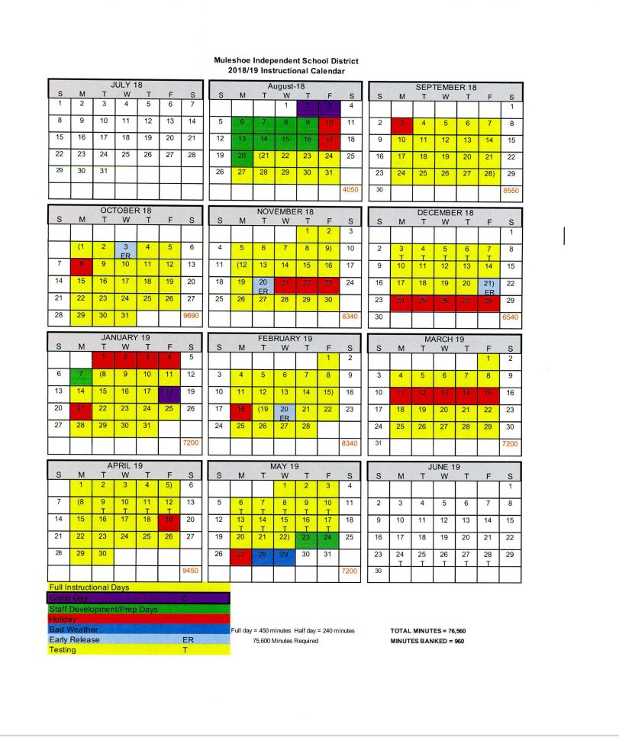

GAP Bell Schedule

