Total Body Fitness & HS Physical Education: Day Three
Coach Cannon
Monday-Friday 8:00 a.m. to noon

300

Exercises in Chipper Format (do all reps before moving to next exercise)

- V Ups- 25
- Burpees- 50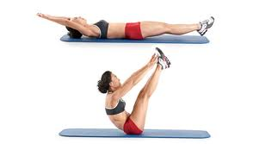
- Push Ups- 50
- Box Jumps- 50
- Russian Twists- 50
- Mountain Climbers.- 50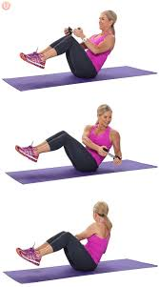
- V Ups- 25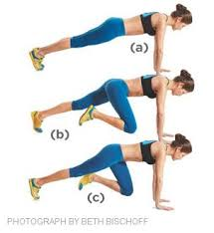

Total Time it takes you to get it done:

