Total Body Fitness & HS Physical Education:Day One
Coach Cannon
Monday-Friday 8:00 a.m. to noon

Do each exercise to rep number completion (chipper format) and move to the following exercise.

- Deadlift x 50
- Push Ups x 50
- Step Ups x 100
- Dips x 50
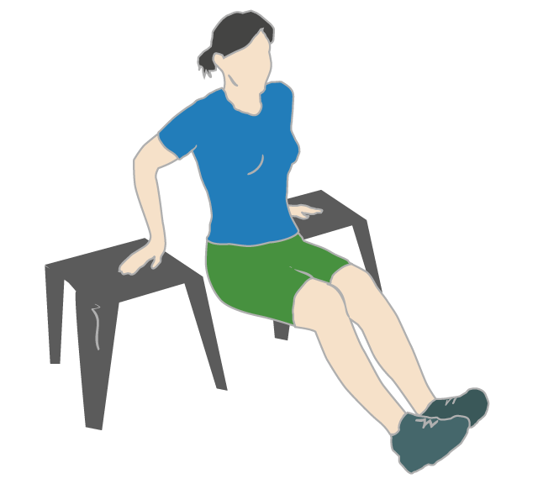
- Atomic Sit Up x 50
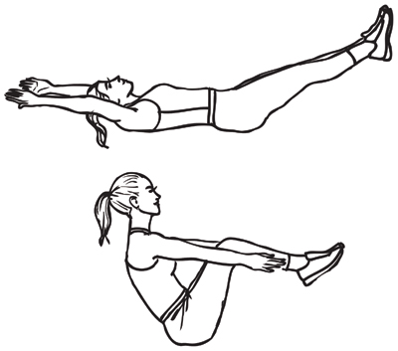
Total time:

