Physical Science AMI Packet

Directions: Assignments for your 5th or 7th hour class are listed below. You will complete the assignment based on the day(s) we are out of school. There are pages within this packet with instructions for each day as well as space for the assignment to be completed. Each completed assignment counts as one AMI credit. The assignment(s) that are completed must be turned in upon the return back to school.

- Day 1: Research a scientist.

- Day 2: True or False.

- Day 3: Input and Output of Energy.

- Day 4: What's the Word?

- Day 5: Identify variables of experiment.

Day 1: Research a Scientist

Research a scientist that has made a significant contribution to physical science. Describe the scientist, what he discovered, and how his discovery worked.

Day 2: True or False

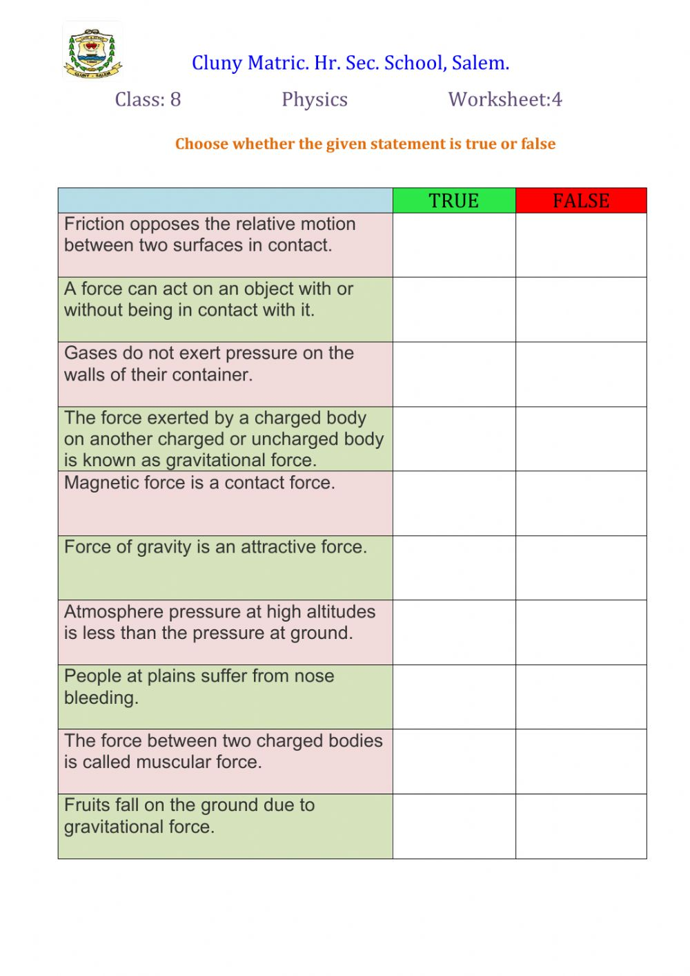
Day 3: Input and Output of Energy

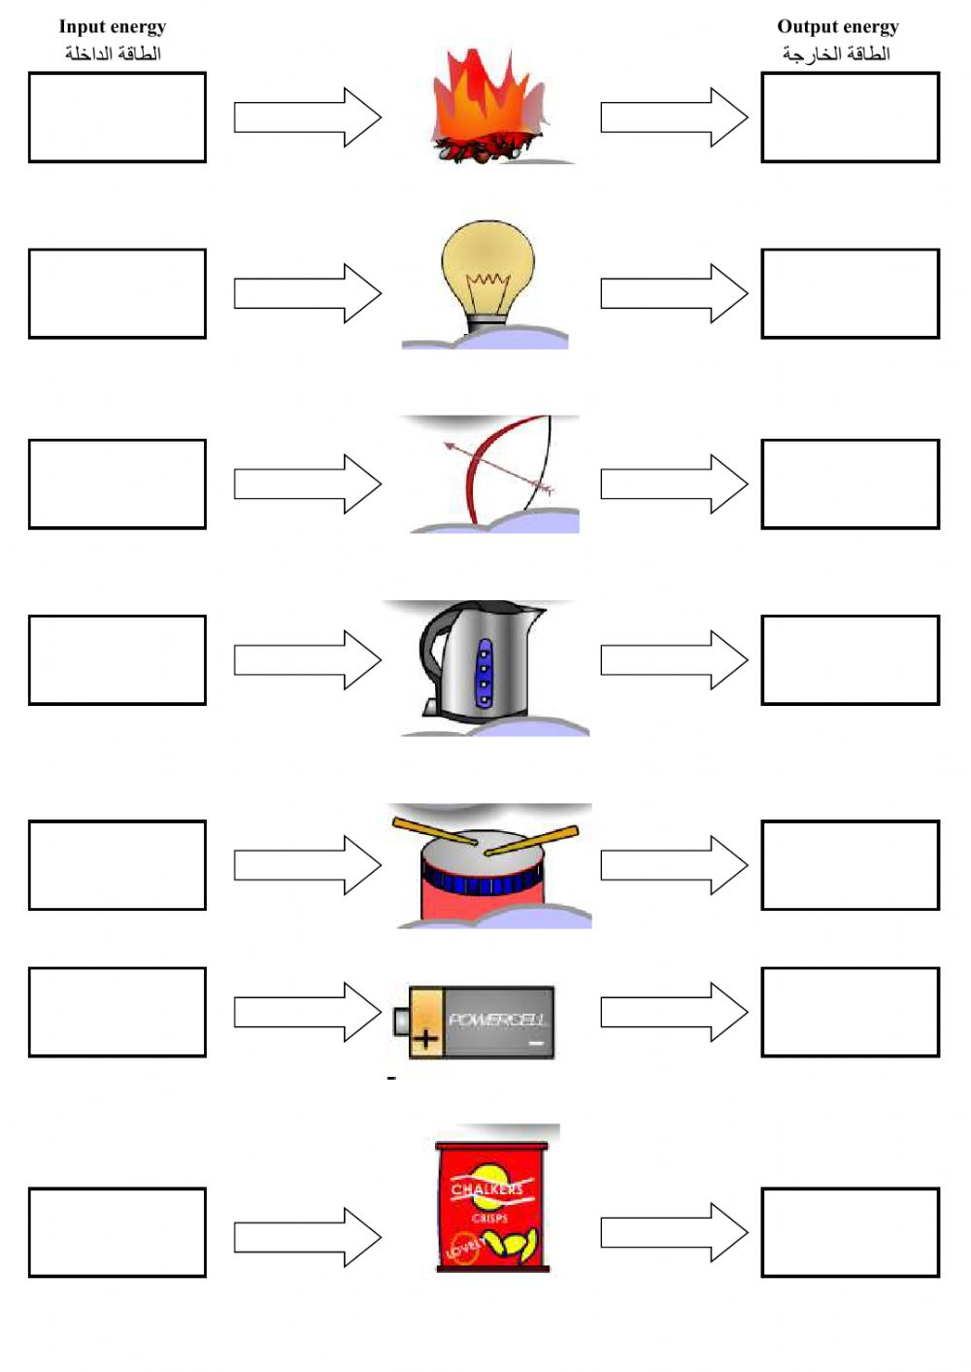

Day 4: What's the Word

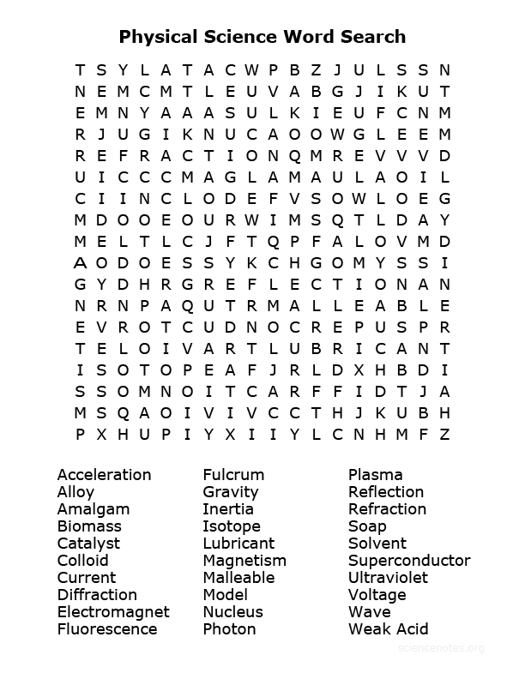

Day 5: Scientific Method

You are conducting an experiment, using the scientific method to explain the following.

Research question:

Hypothesis:

Independent variable:

Dependent variable:

How will you test:

What do you think your results will be:

Was your hypothesis supported or not supported:

What is your next step:

