Biology II AMI Packet

Directions: Assignments for your 3rd hour class are listed below. You will complete the assignment based on the day(s) we are out of school. There are pages within this packet with instructions for each day as well as space for the assignment to be completed. Each completed assignment counts as one AMI credit. The assignment(s) that are completed must be turned upon the return back to school.

- Day 1: Research a scientist.

- Day 2: Cell Boundaries.

- Day 3: Draw and Label.

- Day 4: Parts of a Plant.

- Day 5: Name these Structures.

Day 1: Research a Scientist

Research a scientist that has made significant contributions to the field of biology. In a paragraph, tell me the scientist, what was his contribution to science and how did it work.

Day 2: Cell Boundaries

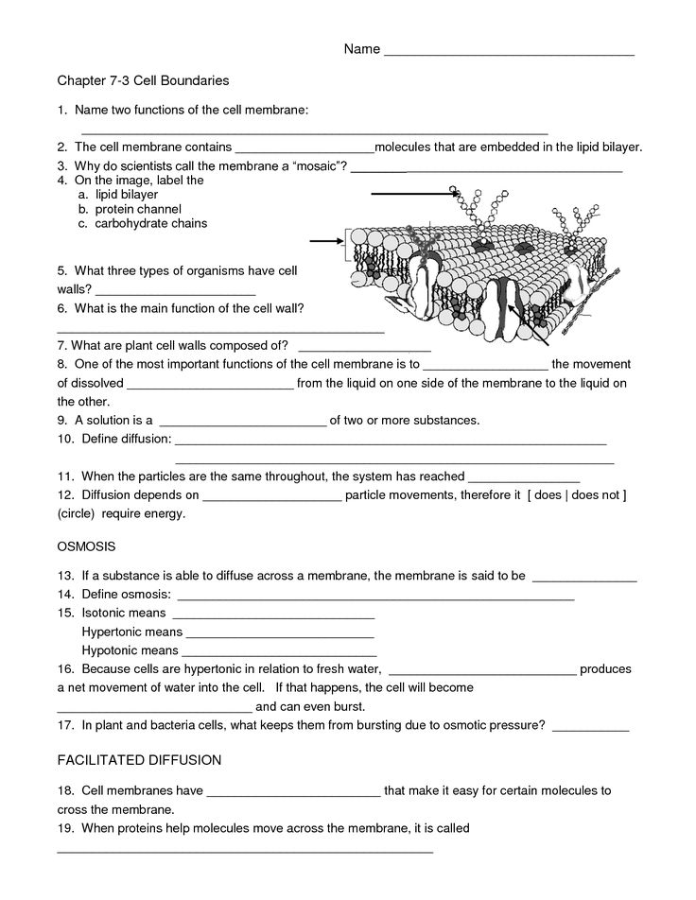
Day 3: Draw and Label

Draw and label a prokaryotic cell, adenovirus, and an amoeba.

Day 4: Parts of a Plant

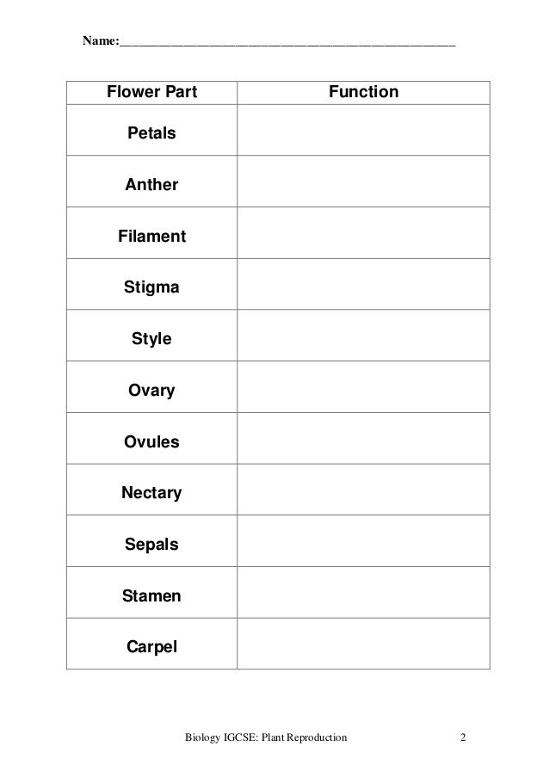

Day 5: Name these Structures.

