Anatomy & Physiology AMI Packet

Directions: Assignments for your 6th hour class are listed below. You will complete the assignment based on the day(s) we are out of school. There are pages within this packet with instructions for each day as well as space for the assignment to be completed. Each completed assignment counts as one AMI credit. The assignment(s) that are completed must be turned upon the return back to school.

- Day 1: Research a scientist.

- Day 2: Identify the Structures.

- Day 3: Flow of Blood.

- Day 4: Identify the Leg Muscles.

- Day 5: Why structure affects function.

Day 1: Research a Scientist

Research a scientist that has made a significant contribution to anatomy. Include the scientist, significant contribution to the field, broad explanation of how it works.

Day 2: Identify the Structures

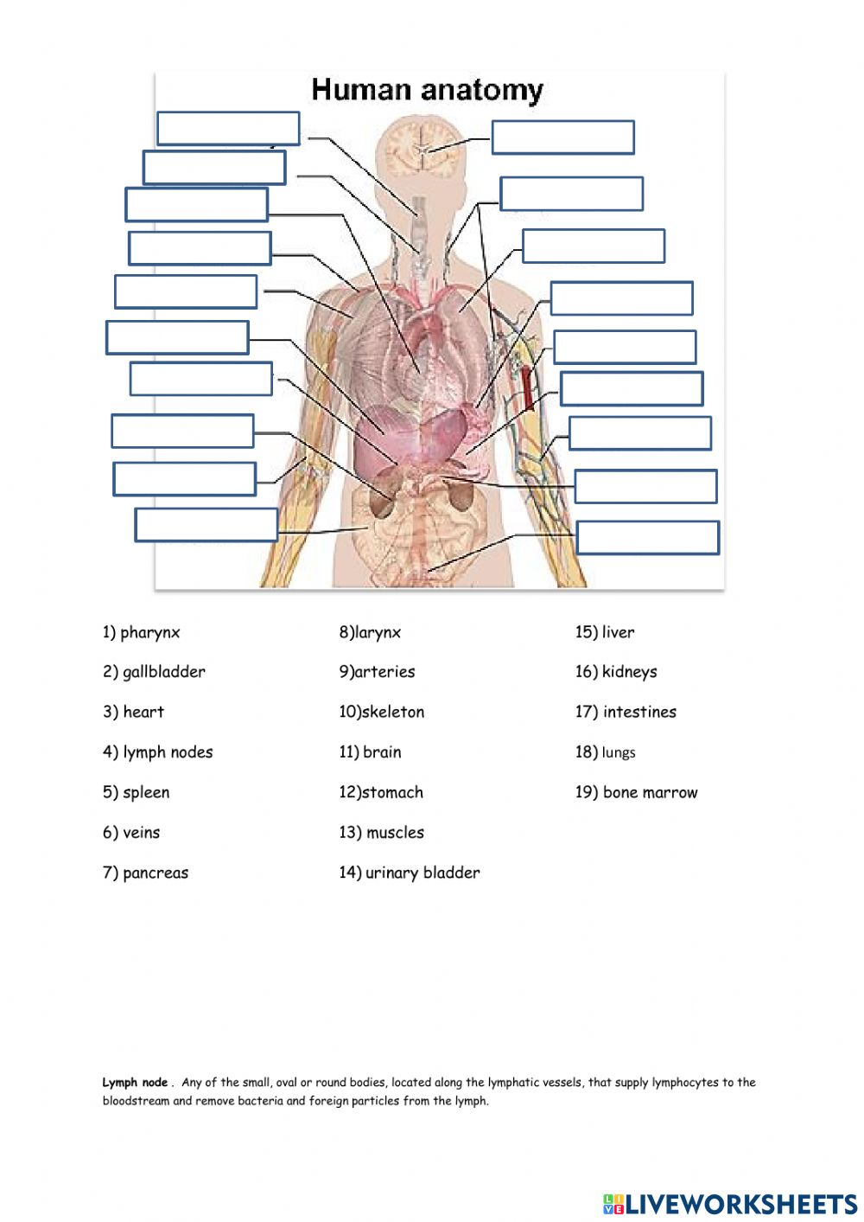
Day 3: Flow of Blood

Explain the flow of blood through the heart, including all valves, and chambers. Explain which side is oxygenated and which is deoxygenated.

Day 4: Identify the Leg Muscles
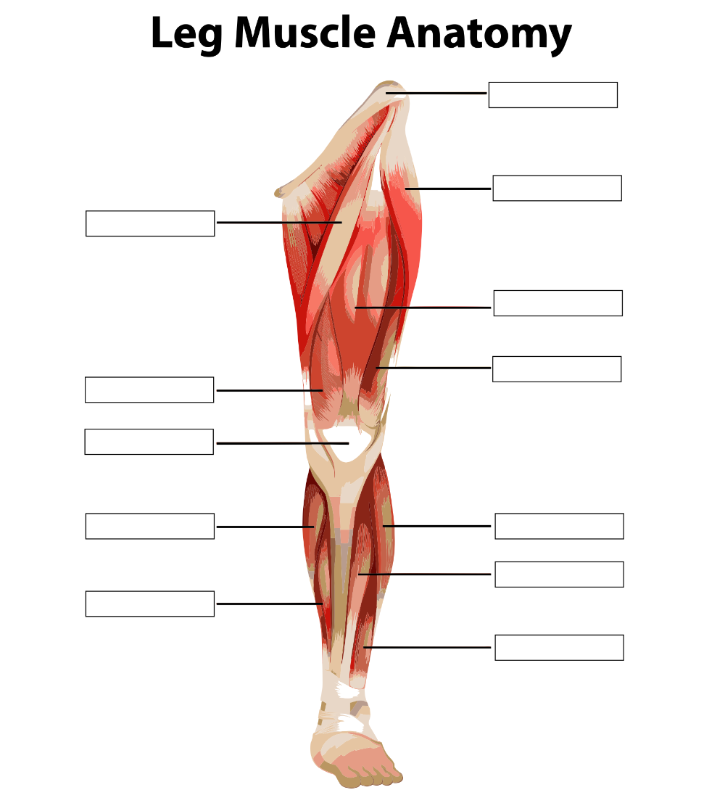

Day 5: How Structure affects Function

Write a brief paragraph with examples explaining how structure of body parts can have an affect on its function.

