EVANS

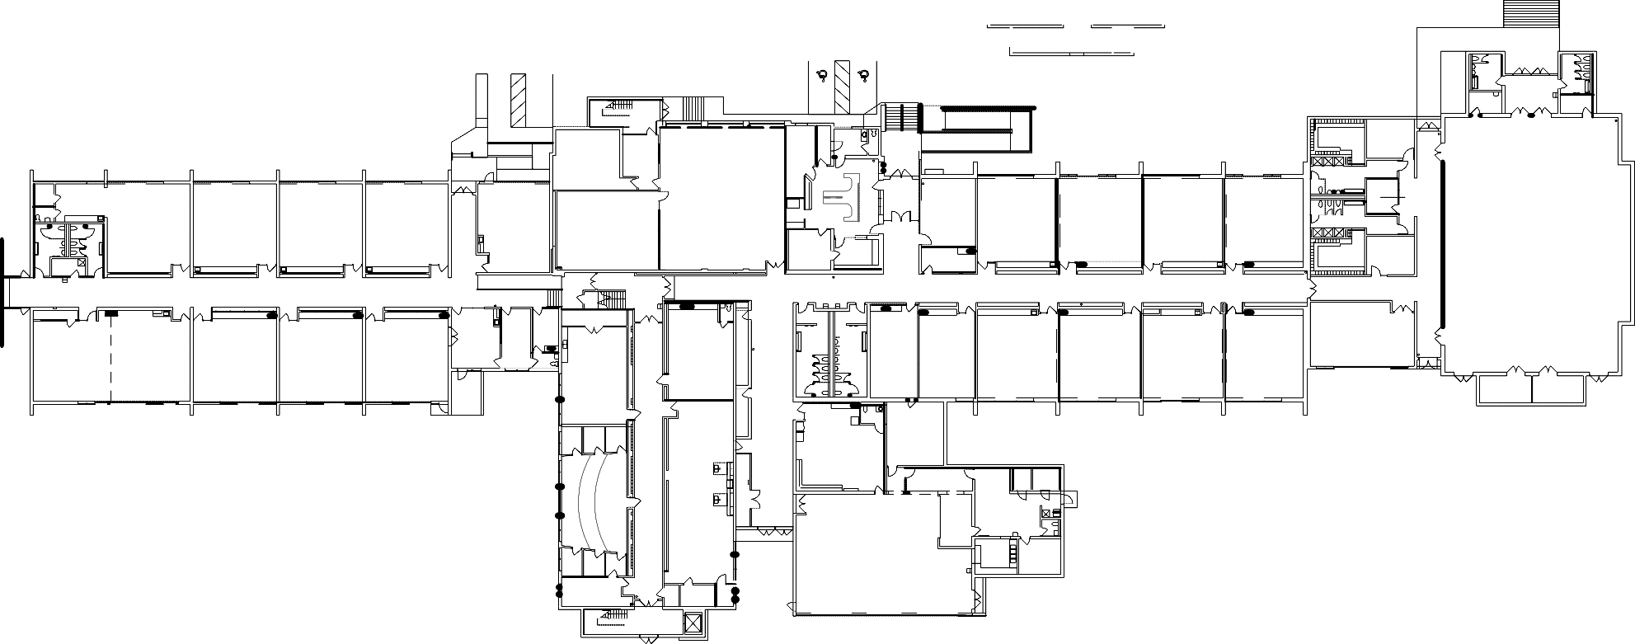
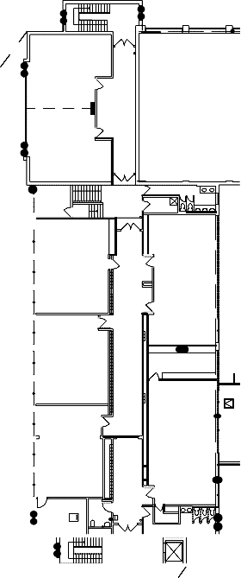
310

ZINGA

308

GROSS
306

PORCARO

304

UHE

305 /307
MAYS

302

HAGEDORN

300

JUNOD

301

BUSINESS
MANAGER
201

NURSE
202

HARKNESS/FARNHAM
221
BETHKE
112

DEEPHOUSE

101

EGGERT

103

BRUNNING/

LONG

105

CHILDCARE

107

ONE YEAR OLD ROOM

109

COMPUTER LAB

111

LIBRARY
(SCHLIEM)

113

OFFICE

200

CUSTODIAN

209

RISSEEUW

213

ZIMMERMAN

215

217

TWOMEY

219

PIEDOT
MALNAR

227

GYMNASIUM

223

LUECK

203

211

MULCAHY

100

MULCAHY

102

GRABOW

104

HEUSINVKELD

106

PRESCHOOL

108

BRANDT

116

TWO YEAR
OLD
ROOM

115

ANDRUS

210

HEEGEMAN

212

PEIRICK

214

BUNKER

216

GOFF

218

WEINKAUF

220

SMALL GYM

222

STORAGE
114
NAP
ROOM
112
INFANT
ROOM
110

GALI

118
PARKS
120

HUFF

117

TEACHER WORKROOM

205

CAFETERIA

208
HACKL
206

KITCHEN

207

