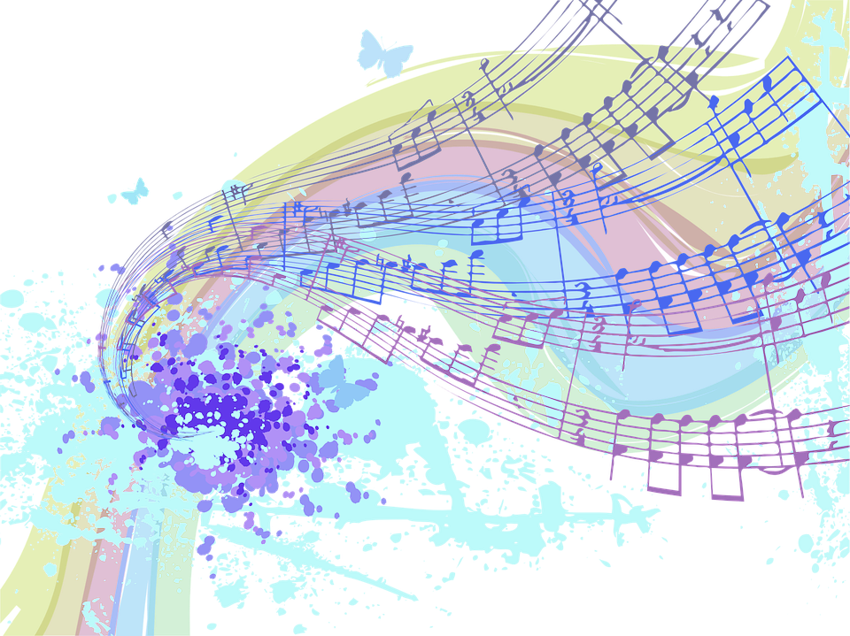

**Howell Wildcat Band Spring Concert**

**Thursday, May 19**

**Fine Arts Center 7:30pm**