PAGE JACKSON ELEMENTARY
  - Pandas Have P.A.W.S.

Notes from the Principal
Happy New Year! We were so excited to welcome our students back from the winter break! We had an exciting month of learning and celebrating. PLEASE makes sure you visit our website, jcswv.org in order to see updates and information regarding visiting Page. When you visit Page Jackson, we ask you bring your I.D. We will check you in our front office. In addition, we are not allowing siblings to attend school activities to include lunch, awards, or individual classroom activities.

PJE Celebrates second quarter with legos
PJE Dates to Watch
February 3 100th day celebration
February 14 Wear Red or Pink
February 17 Early Dismissal
February 20 No School for students Professional Development for Staff

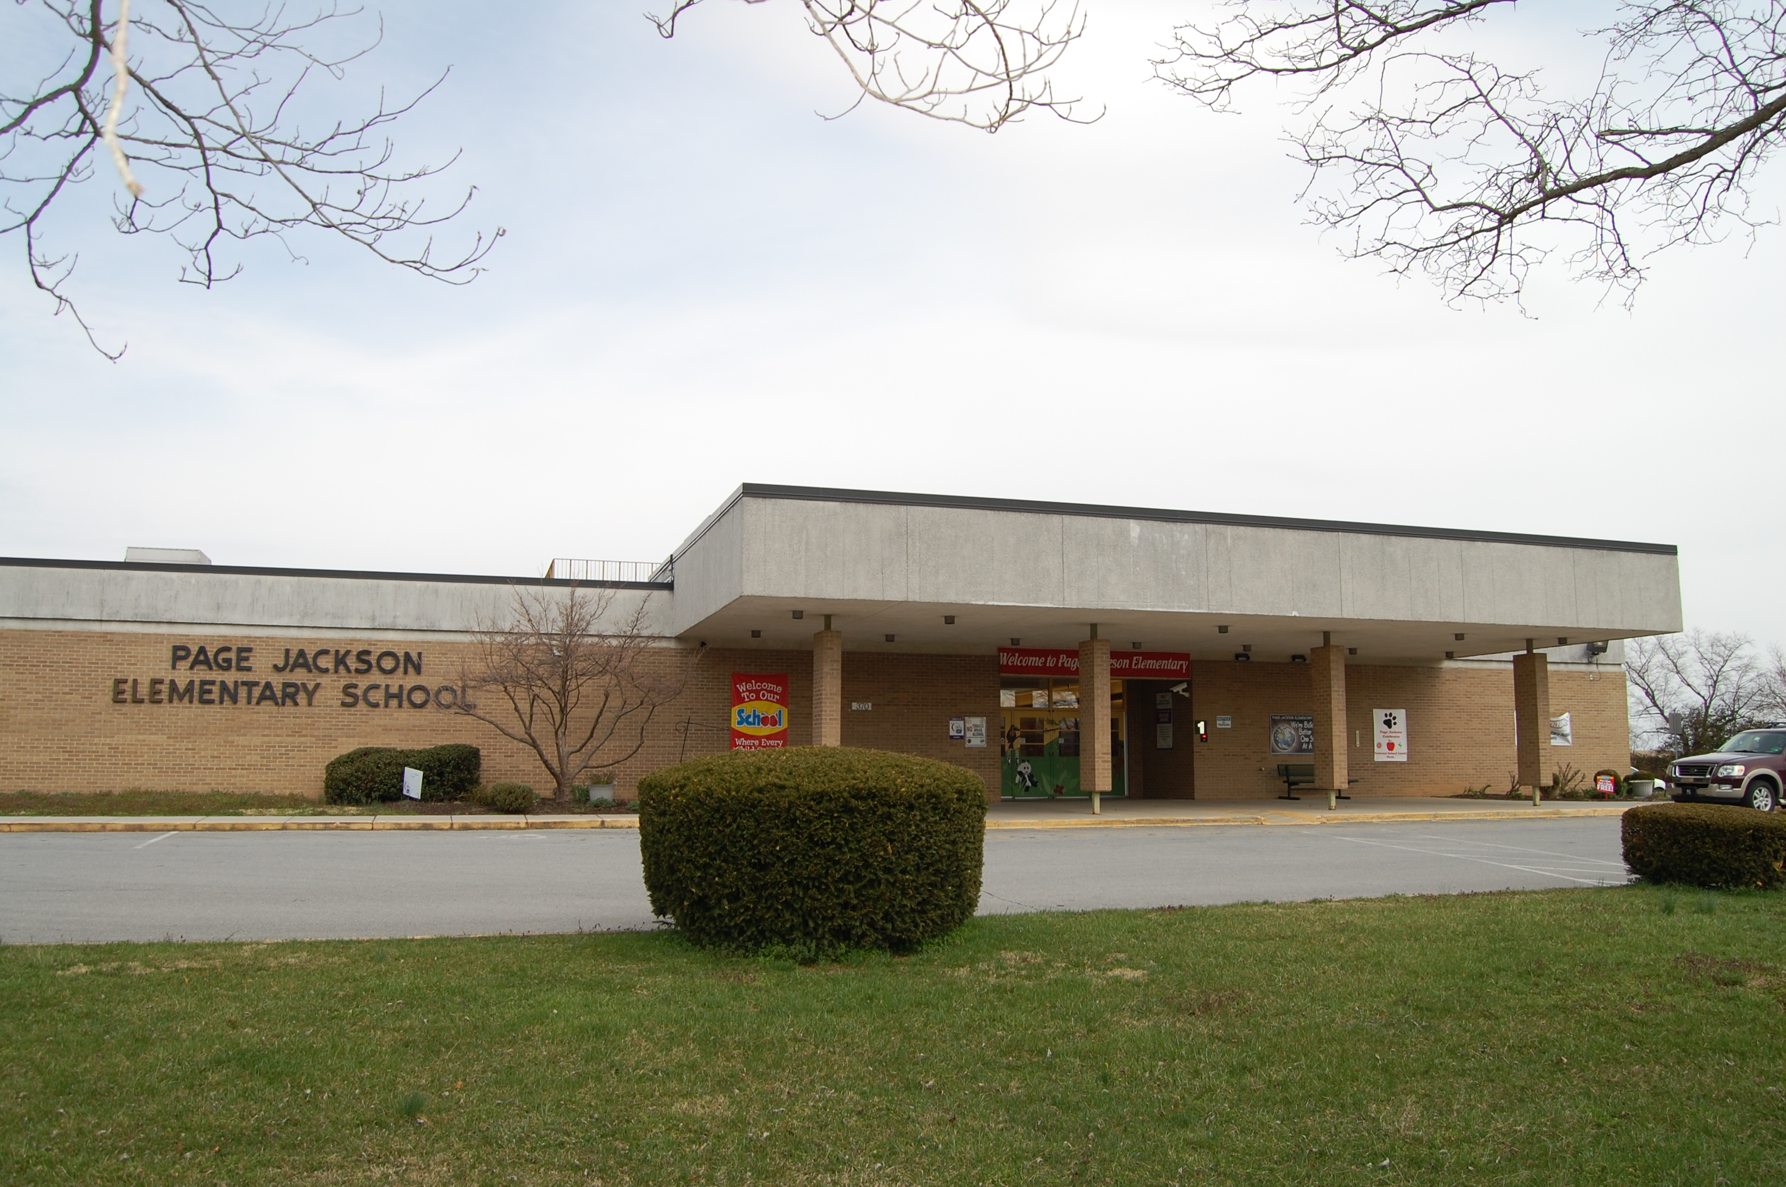

Our students enjoyed building, collaborating, and problem solving.
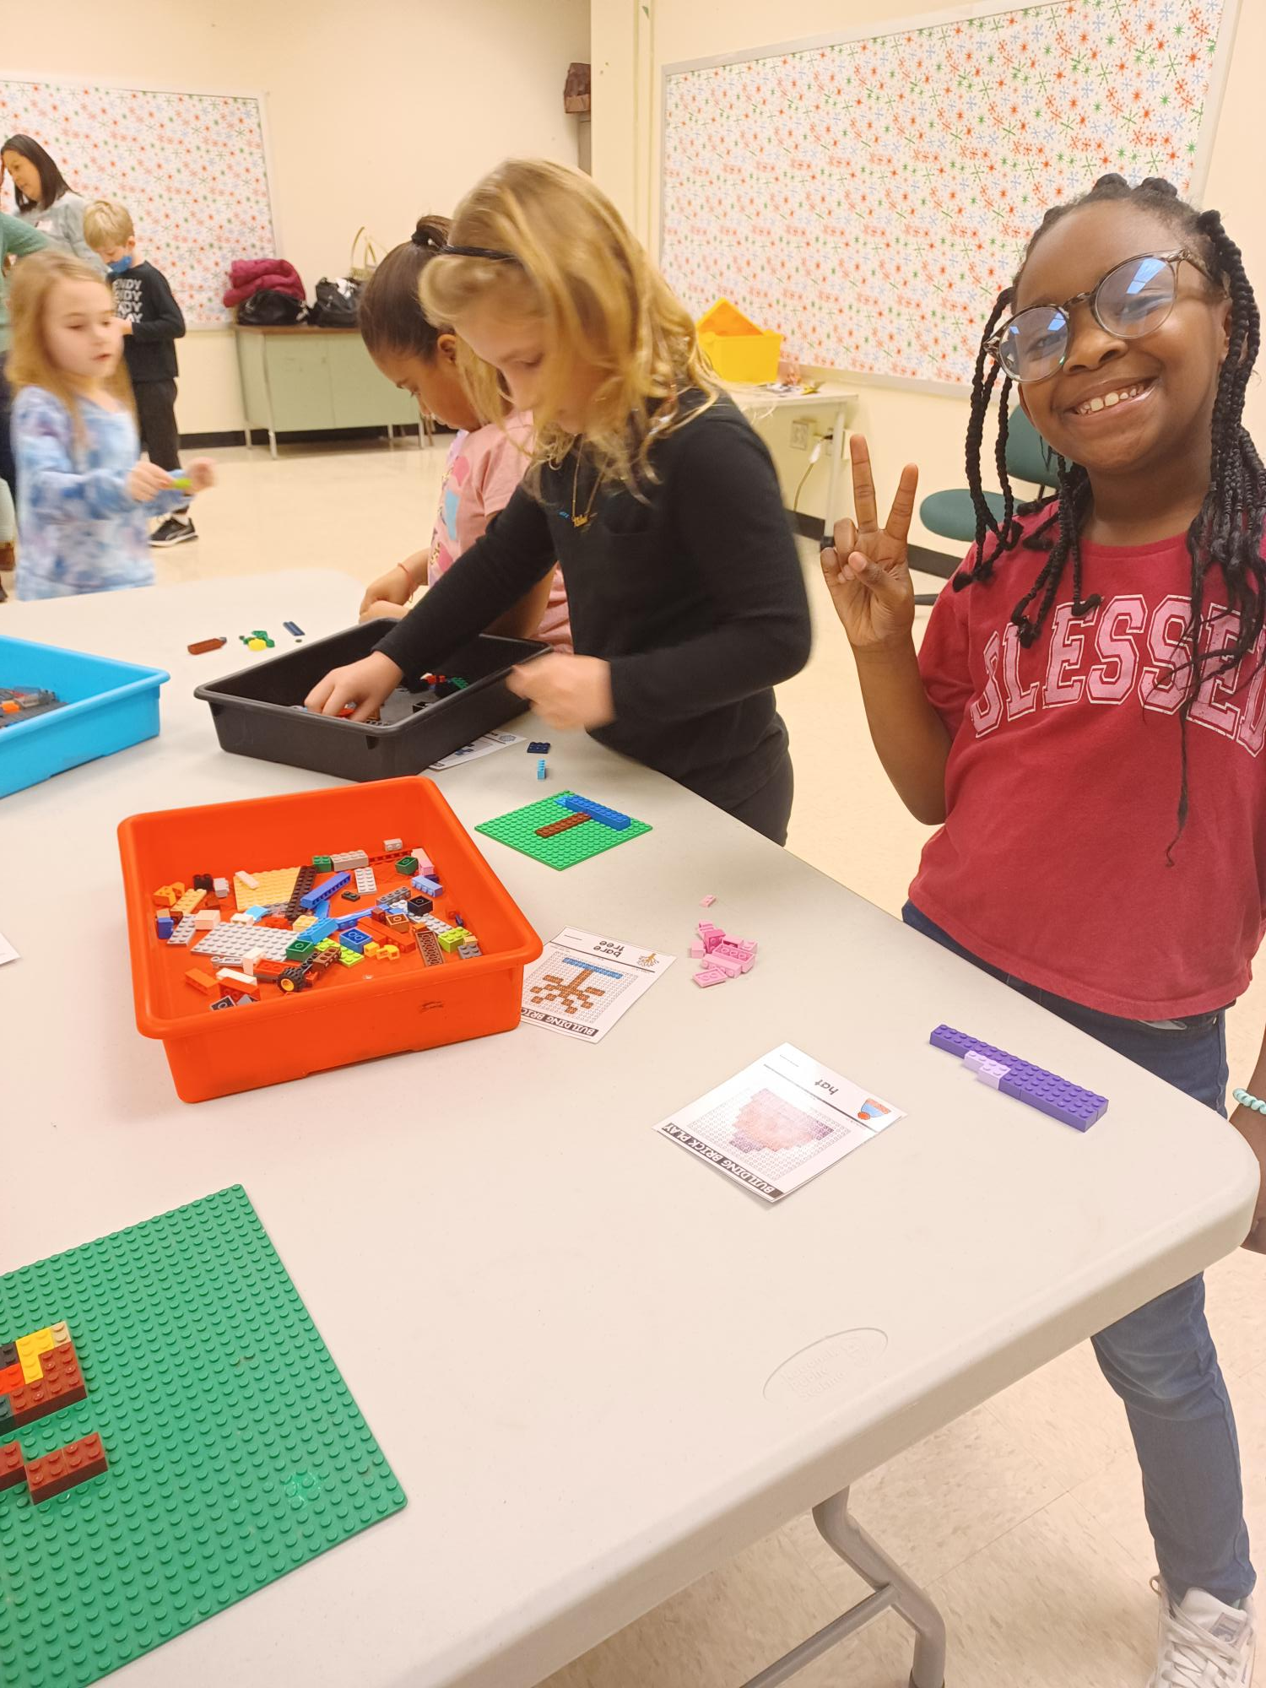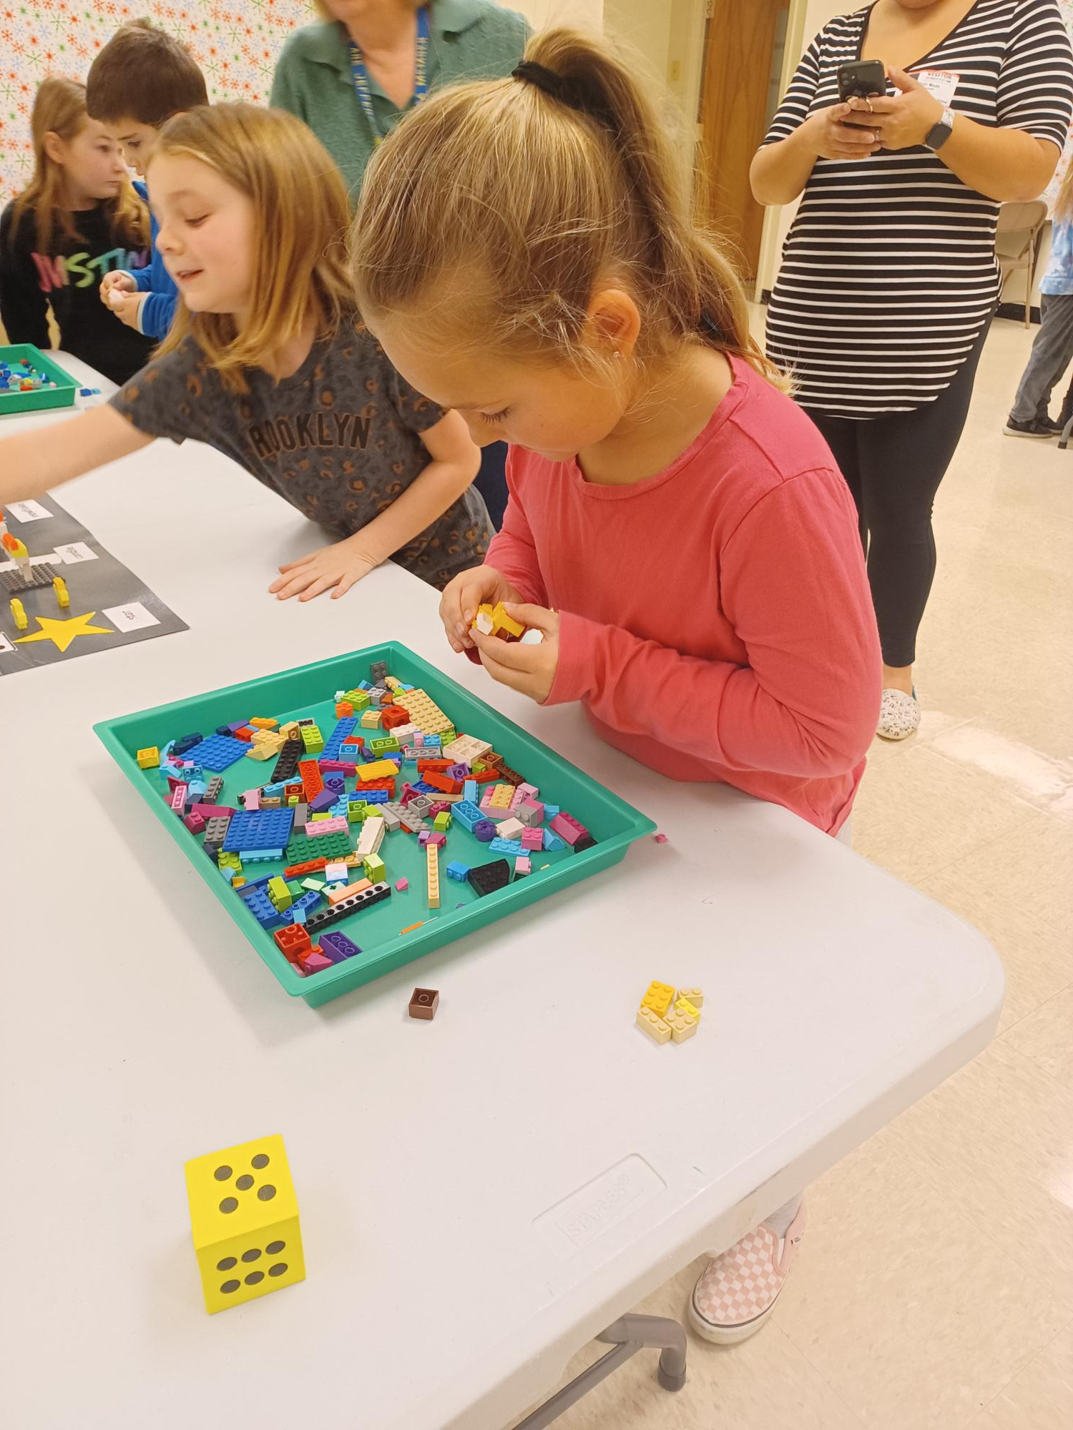

way to go all our paw-sitive student quarter 2 recipients
Thank you to all who attended our Pawsitive Praise assembly! We are so proud of our students for following our PAWS motto!
Persevere, Always are responsible, Work and play safely, and Show respect!
Downloading the JCSWV app is the easiest way to keep up with what’s happening at PJE. You can check out lunch menus, submit absence notes, and see your school bus status right from your phone! Visit www.jcswv.org/app to download and connect.

